# 

**Final Project Report**

**Project: Facilities Management System**

**(Classrooms and Sports Fields,...)**

|  |  |
| --- | --- |
| **……** | |
| **Group Members** | … |
| **Supervisor/Lecturer** | … |

- Hanoi, November 2024 -

**Table of Contents**

**Definition and Acronyms 7**

**I. Project Introduction 9**

1. Overview 9

1.1 Project Information 9

1.2 Project Team 9

1.3 Stakeholders (End-users) 9

2. Product Background 9

3. Existing Systems 9

4. Business Opportunity 10

5. Software Product Vision 10

**II. Project Management Plan 11**

1. Overview 11

1.1 Scope & Estimation 11

1.2 Project Objectives 12

1.2.1. Project management 12

1.2.2. Allocated effort 12

1.3 Project Risks 13

2. Management Approach 14

2.1 Project Process 14

2.2 Quality Management 15

2.3 Training Plan 15

3. Project Deliverables 15

4. Responsibility Assignments 16

4.1.Team & Structures 16

4.2 Roles & Responsibilities 17

5. Communications Plan 17

6. Configuration Management 18

6.1 Document Management 18

6.2 Source Code Management 18

6.3 Tools & Infrastructures 18

**III. Software Requirement Specification 19**

1. Product Overview 19

2. User Requirements 19

2.1 Actors 19

2.2 Use Cases 19

2.2.1 Diagram 19

2.2.2 Descriptions 20

3. Functional Requirements 20

3.1 System Functional Overview 20

3.1.0 Business Flow 20

3.1.1 Screens Flow 21

3.1.1.1 Guest Flow 21

3.1.1.2 Admin Flow 21

3.1.1.3 User Flow 23

3.1.2 Screen Descriptions 23

3.1.3 Screen Authorization 24

3.1.4 Non-Screen Functions 25

3.1.5 In/Out of scope 25

3.2 Feature description 26

3.2.1. Login 26

3.2.2. Logout 26

3.2.3. View Profile 27

3.2.4. Edit Profile 28

3.2.5. View facility list 28

3.2.6. View facilities detail 29

3.2.7. Evaluate 30

3.2.8. Create booking 30

3.2.9. View notification list 31

3.2.10. Chat 32

3.2.11. View booking list 32

3.2.12. Booking processing 33

3.2.13. Block/Unblock Account 34

3.2.14. View Statistic 34

3.2.15. Create Facility 35

3.2.16. Update Facility 36

3.2.17. View facility updating history 37

3.2.18. Active/Inactive facility 37

3.2.19. Create category 38

3.2.20. Update category 39

3.2.21. View category updating history 40

4. Non-Functional Requirements 41

4.1 External Interfaces 41

4.1.1. User interfaces 41

4.2.2 Security interfaces 41

4.2 Quality Attributes 41

4.2.1 Usability 41

4.2.2 Reliability 41

4.2.3 Performance 41

4.2.4 Security 41

5. Requirement Appendix 42

5.1 Business Rules 42

5.2 Application Messages List 42

**IV. Software Design Description 44**

1. System Design 44

1.1 System Architecture 44

1.2 Package Diagram 44

2. Database Design 47

3. Detailed Design 49

3.1 Login 50

3.1.1 Class Diagram 50

3.1.2. Sequence Diagram 51

3.2 Manage User 52

3.2.1 View User 52

3.2.1.1 Class Diagram 52

3.2.1.2 Sequence Diagram 52

3.2.2 Update User 53

3.2.2.1 Class Diagram 53

3.2.2.2 Sequence Diagram 54

3.2.3 View user profile 55

3.2.3.1 Class Diagram 55

3.2.3.2 Sequence Diagram 55

3.2.4 Search Account 56

3.2.4.1 Class Diagram 56

3.2.4.2 Sequence Diagram 56

3.2 Manage Booking 58

3.2.1 View Booking 58

3.2.1.1 Class Diagram 58

3.3.1.2 Sequence Diagram 58

3.2.2 Find booking by user and facility 59

3.2.2.1 Class Diagram 59

3.3.2.3 Sequence Diagram 60

3.2.3 Update Booking 60

3.2.3.1 Class Diagram 60

3.2.3.2 Sequence Diagram 61

3.2.4 Create Booking 61

3.2.4.1 Class Diagram 61

3.2.4.2 Sequence Diagram 62

3.2.5 Status Booking 63

3.2.5.1 Class Diagram 63

3.2.5.2 Sequence Diagram 64

3.2.6 Dashboard by year 64

3.2.6.1 Class Diagram 64

3.2.7 Dashboard by week 66

3.2.7.1 Class Diagram 66

3.3 Manage Facility 67

3.3.1 View Facility 67

3.3.1.1 Class Diagram 67

3.3.1.2 Sequence Diagram 68

3.3.2 Create Facility 68

3.3.2.1 Class Diagram 68

3.3.2.2 Sequence Diagram 69

3.3.3 Update Facility 70

3.3.3.1 Class Diagram 70

3.3.3.2 Sequence Diagram 71

3.3.4 Change Status Facility 72

3.3.4.1 Class Diagram 72

3.3.4.2 Sequence Diagram 73

3.3.5 View Detail Facility 74

3.3.5.1 Class Diagram 74

3.3.5.2 Sequence Diagram 74

3.4 Manage Category 75

3.4.1 View Category 75

3.4.1.1 Class Diagram 75

3.4.1.2 Sequence Diagram 75

3.4.2 Create Category 76

3.4.2.1 Class Diagram 76

3.4.2.2 Sequence Diagram 76

3.4.3 Update Category 77

3.4.3.1 Class Diagram 77

3.4.3.2 Sequence Diagram 77

3.5 Manage Comments 78

3.5.1 View Comment 78

3.5.1.1 Class Diagram 78

3.5.1.2 Sequence Diagram 78

3.5.2 Create Comment 79

3.5.2.1 Class Diagram 79

3.5.2.2 Sequence Diagram 79

3.5.3 Check Comment Permission 79

3.5.3.1 Class Diagram 79

3.5.3.2 Sequence Diagram 80

3.6 Manage Notification 81

3.6.1 View notification 81

3.6.1.1 Class Diagram 81

3.6.1.2 Sequence Diagram 81

3.6.2 Update Notification 82

3.6.2.1 Class Diagram 82

3.6.2.2 Sequence Diagram 82

**V. Software Testing Documentation 83**

1. Scope of Testing 83

1.1. Testing Stages 83

1.2. Range of Testing 84

2. Test Strategy 84

2.1 Testing Types 84

2.2 Test Levels 84

2.3 Supporting Tools 85

3. Test Plan 86

3.1 Human Resources 86

3.2 Test Environment 86

3.3 Test Milestones 86

**VI. Release Package & User Guides 88**

1. Deliverable Package 88

2. Installation Guides 88

2.1 System Requirements 88

2.2 Hosting requirement 88

3. User Manual 88

3.1 Overview 88

3.2 Role User 88

3.3 Admin Role 95

# **Definition and Acronyms**

|  |  |
| --- | --- |
| **Acronym** | **Definition** |
| BA | Business Analysis |
| BR | Business Rule |
| ERD | Entity Relationship Diagram |
| UI | User Interface |
| PM | Project Manager |
| SDD | Software Design Description |
| SPMP | Software Project Management Plan |
| SRS | Software Requirement Specification |
| UC | Use Case |
| FMS | Facilities Management System |
| ST | System Testing |
| UT | Unit Test |
| IT | Integration Testing |
| AT | Acceptance Testing |

# **I. Project Introduction**

## **1. Overview**

### **1.1 Project Information**

* Project name: Facilities Management System
* Project code: FMS
* Group name: SE1733_NJ_G3
* Software type: Web-based Application
* Timeline: 04/09/2024 - 04/11/2024

### **1.2 Project Team**

Table I.1: describes the current booking method at FPT school.

|  |  |  |
| --- | --- | --- |
| Full **Name** | **Role** | **Email** |
| … | Lecturer |  |
| … | Leader | … |
| … | Member | … |
| … | Member | … |
| … | Member | … |

***Table I.1****: Team member*

### **1.3 Stakeholders (End-users)**

|  |  |  |
| --- | --- | --- |
| ***Full Name*** | ***Email*** | **Title** |
| …. |  | Technical support, Product Owner, User |

***Table 1.2:*** *Stakeholders*

## **2. Product Background**

The Facilities Management System was born based on the need of facilities management in FPT Education. FPT Education is very large with 5 campuses and nearly 150,000 students. Facilities in FPT are used and booked everyday which is really hard to manage and follow by using paper. With high demands to manage facilities more effectively, the campuses within the FPT education system require an efficient management system to support their daily operations. This system is developed following the Agile SCRUM model in 9 weeks.

## **3. Existing Systems**

Figure I.3: describes the current booking method at FPT school.

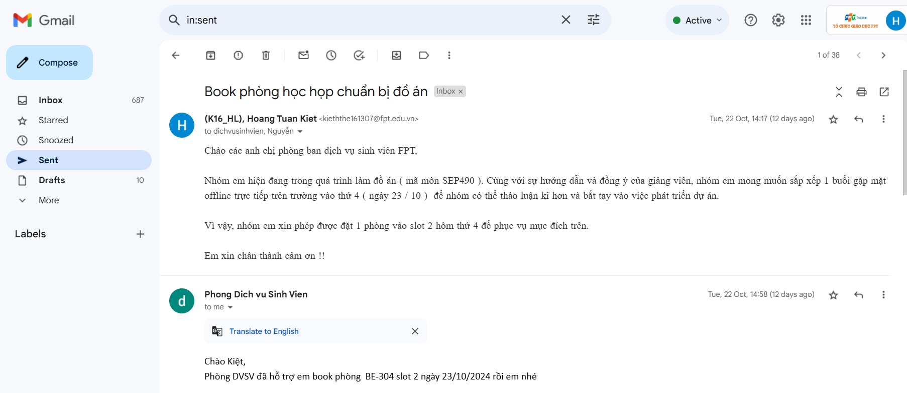

***Figure I.1****: current booking*

Due to the needs of FPTU Hoa Lac students, they need to book rooms and fields on campus to serve some individual/group activities of students. Students often have to come to the school and send emails to the school to book rooms/fields at the school, which leads to students wasting a lot of time when they need to book rooms/fields at the school because they have to wait for a response email or come directly. Due to the high demand for using the facilities, it will be impossible to manage and control overlapping schedules.

## **4. Business Opportunity**

The Facilities Management System is a digital platform that enables organizations to access and monitor the booking activities such as booking soccer field, booking classroom… First, we aim to implement a Facilities Management System at Hoa Lac campus and plan for other campuses. It incorporates various features and tools to streamline the auditing process, tracking compliance and provide actionable insights to improve overall management operation. Moreover, students and teachers can use this system to create booking facilities requests instead of using booking paper.

## 

## **5. Software Product Vision**

The Facilities Management System in FPT Education was created based on the desire of the FPT Education’s facilities management team. The system is a comprehensive solution designed to revolutionize the way schools oversee and maintain their physical infrastructure. This innovative system is crafted to address the intricate web of challenges associated with facility management, providing a seamless platform that streamlines operations, enhances resource utilization, and ensures a well-maintained, secure, and efficient learning environment. With a user-friendly interface, powerful features, and robust functionalities, our system empowers administrators to make informed decisions, allocate resources efficiently, and uphold safety and compliance standards. Facilities managers benefit from streamlined maintenance workflows, optimized scheduling, and real-time monitoring capabilities, ensuring that the school's infrastructure operates at its best.

For the management team (or Admin), they will convert from tracking through paper records to using the system to reduce the use of paper records and be more convenient for management. For administrators, they can manage their user by tracking the user's account instead of using an identification card. For students and teachers, they can make an online booking request in the system and follow the response of staff instead of using paper.

# **II. Project Management Plan**

## **1. Overview**

### **1.1 Scope & Estimation**

Table II.1 The WBS (Work Breakdown Structure) items are categorized into three levels of complexity (Simple, Medium, Complex) and estimate the total effort to complete each item in man-day (1 man-day = 8 working hours)

|  |  |  |  |
| --- | --- | --- | --- |
| **WBS ID** | **WBS Item** | **Complexity** | **Est. Effort (man-days)** |
| **1. Project Management** | | | |
| 1.1 | Project Initiation | Normal | 1 |
| 1.2 | Project Planning | Complex | 2 |
| Total : | | | 3 |
| **2. Project Designing** | | | |
| 2.1 | Gathering and collecting requirement with Team member and Lecture | Normal | 4 |
| 2.2 | Create Project Introduction document | Simple | 1.5 |
| 2.3 | Define project scope and objectives | Complex | 1 |
| 2.4 | Learn about similar Facilities Management System | Normal | 2 |
| 2.5 | Create Project Timeline and Schedule | Normal | 5 |
| 2.6 | Designing Screenflow (Guest, User, Admin) | Normal | 5 |
| 2.8 | Designing basis of layout (Concept, Feature, Requirement) | Complex | 5 |
| 2.9 | Identify and mitigate project risks | Normal | 3 |
| 2.10 | Creating Test Plan | Normal | 2 |
| Total : | | | 28.5 |
| **3. Project Development** | | | |
| 3.1 | Prototyping Project | Complex | 5 |
| 3.2 | Develop product prototype | Complex | 7 |
| 3.3 | Conduct product testing and validation | Complex | 5 |
| 3.4 | Develop front-end design | Complex | 10 |
| 3.5 | Develop back-end functionality | Complex | 35 |
| 3.6 | Implement security measures | Complex | 5 |
| 3.7 | Create Test (IT, UT, ST) along coding | Normal | 10 |
| Total : | | | 77 |
| **4. Quality Assurance & Testing** | | | |
| 4.1 | Conduct functional testing | Normal | 5 |
| 4.2 | Conduct usability testing | Normal | 5 |
| 4.3 | Testing and Fixing bugs | Normal | 5 |
| Total : | | | 15 |
| **Total Estimated Effort (man-days)** | | | **123.5** |

***Table II.1****: Scope & Estimation*

### **1.2 Project Objectives**

#### ***1.2.1. Project management***

Table II.2: describes the project management .

|  |  |
| --- | --- |
| **No** | **Objectives** |
| 1 | Project will release before 04/11/2024 |
| 2 | Deliver screen design after 2 first sprint |
| 3 | Sprint goals are fully completed |
| 4 | Release product reduce 80% manual process |

***Table II.2****: Project management*

#### ***1.2.2. Allocated effort***

Table II.3: describes the allocated effort

|  |  |  |  |
| --- | --- | --- | --- |
| **#** | **Member** | **Weekdays** | **Weekends** |
| 1 | Phạm Đức Mạnh | 2 hours | 4 hours |
| 2 | Hoàng Tuấn Kiệt | 2 hours | 4 hours |
| 3 | Nguyễn Văn An | 2 hours | 4 hours |
| 4 | Dương Thế Toàn | 2 hours | 4 hours |

***Table II.3****: Allocated effort*

### **1.3 Project Risks**

Table II.4 Describe the possible risks of the project

**People Risk** is the Human Factor of the Risks. Risk like a teammate is in sickness, accident, late arrival, Any communication hardness between remember or even stakeholder with team is considered to be a People Risk.

**Process Risk** is the Risk that emerges when working on Project Management. Project Risk like budgeting cost more than its planned, inadequate quality assurance and other related to Project Management.

**System Risk**  associated with technical issues, such as the failure of hardware, software, or network infrastructure that could impact project performance, data integrity, or security.

**External Event Risk** is External events such as natural disasters, pandemics, economic downturns, or geopolitics upheavals can significantly impact project success.

**Legal and Compliance Risk** often associated with legal or regulatory requirements that could impact project outcomes. Legal and compliance risks can arise from issues such as intellectual property infringement, breach of contract, regulatory violations, or environmental risks.

|  |  |  |  |  |
| --- | --- | --- | --- | --- |
| # | Risk Description | Impact | Possibility | Response Plans |
| 1 | Requirement  changes. | Medium | Medium | All members discuss carefully the project requirements before starting  implementation. |
| 2 | Members have argued,conflicted with others, leads to stressful working environments. | Medium | High | Define clear tasks for each member  and agree on ideas before starting work. |
| 3 | Illness or absence of team members so that they cannot complete tasks under deadline | Low | Medium | Members have to notify the team  about illness or absence period and the plan of how to keep up with the work process. |
| 4 | Members lack the knowledge and skills to complete a particular task | High | Medium | Training all members before starting the project. |
| 5 | The library used in the project is no longer supported | Low | Low | Choose a reputable library with active maintenance on GitHub. |

***Table II.4****: Project Risks*

## **2. Management Approach**

### **2.1 Project Process**

Figure II.5 Describe the project process of the project

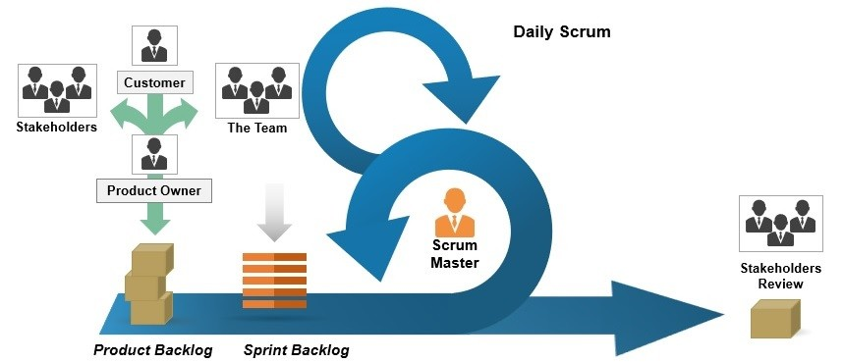

***Figure II.5****: Project Process*

After researching the software development model carefully, the project will use the Agile - Scrum Software Process Model. In an Iterative & Incremental model, Scrum software process model is an agile approach to project management that emphasizes iterative development, flexibility, and collaboration. Scrum is a widely adopted framework because it offers numerous benefits over traditional software development methodologies.

### 

### **2.2 Quality Management**

***2.2.1 Defect Prevention:***

* If any defect is found, the related person must be notified immediately at that time.
* Defects must be carefully evaluated such as "How bad is the defect and can it damage the system?", "How long is the time to fix that defect?".
* The deadline for fixing the defect must be specified clearly.
* There is always a plan to prepare for what could happen at any time.

***2.2.2 Reviewing:***

* The curator must be honest and not biased towards any of the project members. If there is an error, the person must immediately notify the person responsible for the defect.
* Defects should be recorded on the Bug Tracking software with details such as priority.
* The person responsible for defects found must-have solutions to fix the defect as quickly as possible.

### **2.3 Training Plan**

Table II.6 Describe the training plan of the project

| **Training Area** | **Participants** | **When, Duration** | **Waiver Criteria** |
| --- | --- | --- | --- |
| NodeJS | All members | 1 days | Mandatory |
| Meeting Note | All members | 15 minutes | Mandatory |
| Github | All members | 30 minutes | Mandatory |
| MongoDB | All members | 30 minutes | Mandatory |
| NextJS | All members | 1 days | Mandatory |
| Postman | All members | 15 minutes | Mandatory |

***Figure II.6****: Training plan*

## **3. Project Deliverables**

Figure II.7. Describe the project delivery of the project

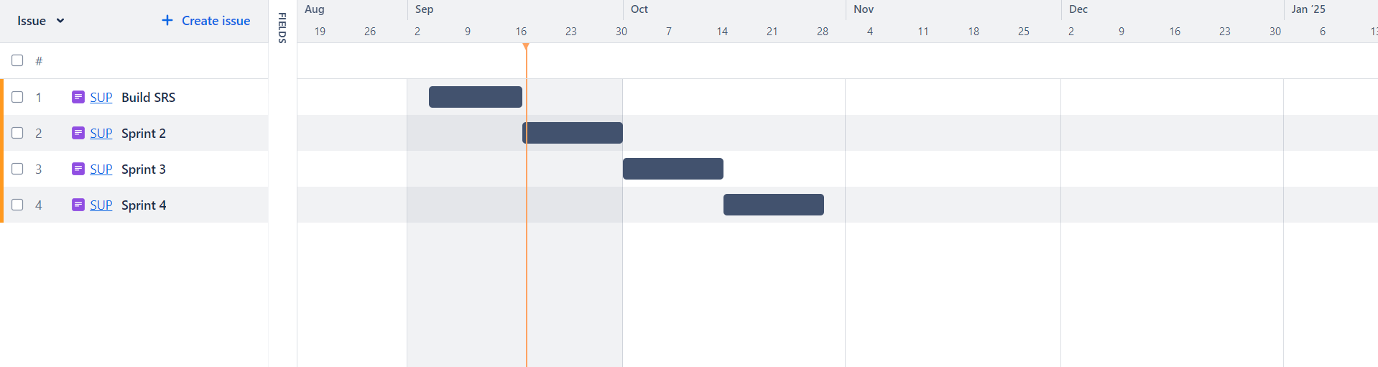

***Figure II.7****: Project Deliver*

Project used Sprint Plan to manage task and estimate for new sprint every week

For more details, click to this [Jira.com](https://fpt-team-rtprlhk3.atlassian.net/jira/plans/1/scenarios/1/timeline?vid=3)

## **4. Responsibility Assignments**

### **4.1.Team & Structures**

Figure II.8 Describe the team & structures of project

### 

***Figure II.8****: Team & Structures*

### **4.2 Roles & Responsibilities**

Table II.9 Describe the roles & responsibility of the project

|  |  |
| --- | --- |
| **Role** | **Responsibility** |
| Project Manager | * Planning, developing schedules, coordinating communication, responsible for keeping the team’s focus on the main goal. * Research and implement UX design for the front-end. |
| BA | * Analyze requirements. * Define scope and create an SRS document. * Design entity relationship diagram. * Define business process flow and object state. * Capture and specifically describe the use case. |
| Technical Leader | * Define high-level architecture based on SRS. * Implement configuration and web server. |
| Front-End / Back-End  Developer | * Involve in coding the product and reviewing the code of other developers. |
| Tester | * Create a template testing document. * Define test strategy, create test case * Implement test cases and log defects. |

***Table II.9****: Roles & Responsibilities*

## **5. Communications Plan**

Figure II.10 Describe the communication plan of the project

|  |  |  |  |  |
| --- | --- | --- | --- | --- |
| **Communication Item** | **Who/ Target** | **Purpose** | **When, Frequency** | **Type, Tool, Method(s)** |
| Team meeting | All team members | Review plan, schedule, code, design, test and document | Once every 3 days | Online - Google meet |
| Weekly meeting with mentor/lecturer | All team members | Gather requirements, review project,  log issue, define next week plan | Tuesday and Friday every week | Offline |
| On-going Assessment Meeting | All team members | Evaluate project after every iteration | Once every 3 weeks | Offline |
| Unscheduled meeting | All team members | Discuss and solve important problems | When someone has  important problems | Online - Google meet |

***Table II.10****: Communications Plan*

## **6. Configuration Management**

### **6.1 Document Management**

Document tools: Microsoft Office 2016, Microsoft Excel 2016, Google Document, Google Sheet

File management: Google Drive

### **6.2 Source Code Management**

Source code is managed by Git on [Github.com](https://github.com/Kieththe161307/Facility-Management-System.git)

### **6.3 Tools & Infrastructures**

Table II.11 Describe the tool & infrastructures of the project

|  |  |
| --- | --- |
| **Category** | **Tools / Infrastructure** |
| **Technology** | NodeJS |
| **Database** | MongoDB |
| **IDEs/Editors** | Visual Studio Code |
| **Diagramming** | DrawIO |
| **Documentation** | Microsoft Office, Google Docs/Sheets/Slides |
| **Version Control** | GitHub(Source Codes), Google Drive (Documents) |
| **Project management** | Jira (Schedule), GitHub (Tasks, Defects) |

***Table II.11****: Tools & Infrastructures*

# **III. Software Requirement Specification**

## **1. Product Overview**

The Facilities Management System was born based on the need of facilities management in FPT Education. FPT Education is very large with 10 campuses and nearly 150,000 students. Facilities in FPT are used and booked everyday which is really hard to manage and follow by using paper. With high demands to manage facilities more effectively, the campuses within the FPT education system require an efficient management system to support their daily operations.

## **2. User Requirements**

### **2.1 Actors**

Table III.1 Describe the project delivery of the project

|  |  |  |
| --- | --- | --- |
| **#** | **Actor** | **Description** |
| 1 | Admin | Administrator of the whole system. Admin takes responsibility managing users and facilities |
| 2 | User | Include students, teachers or any staff of FPT Education |
| 3 | Guest | Guest user |

### 

### 

### 

***Table III.1****: Actors*

### **2.2 Use Cases**

### **2.2.1 Diagram**

Figure III.2 Describe the project delivery of the project

### 

***Figure III.2****: Usecase diagram*

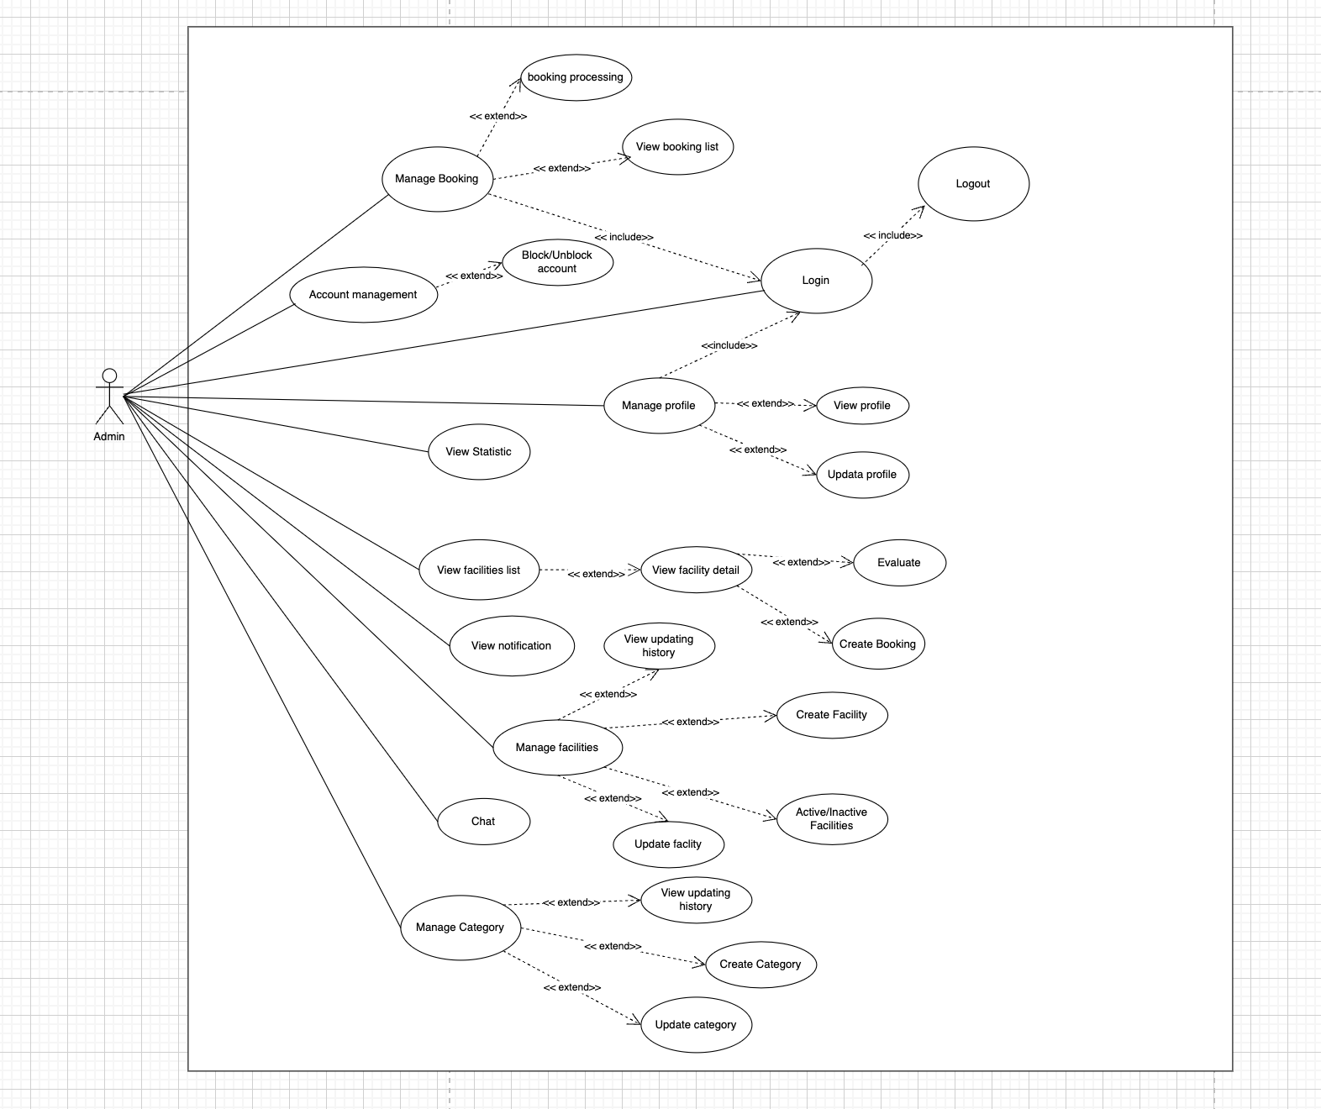

***Figure III.3****: Admin Use Case diagram*

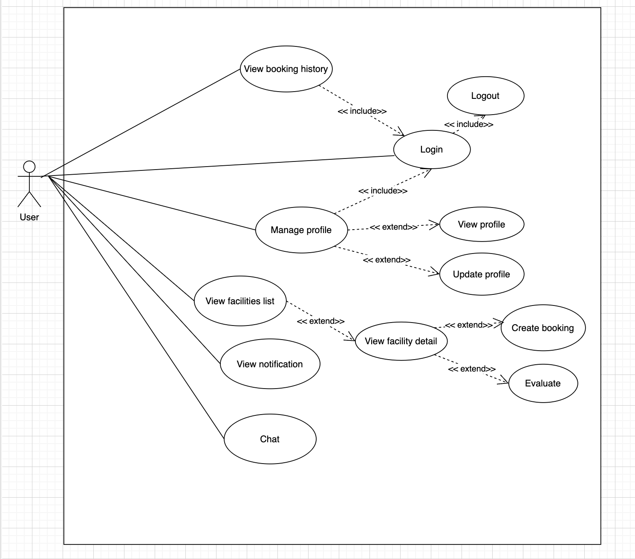

***Figure III.4****: User Use Case diagram*

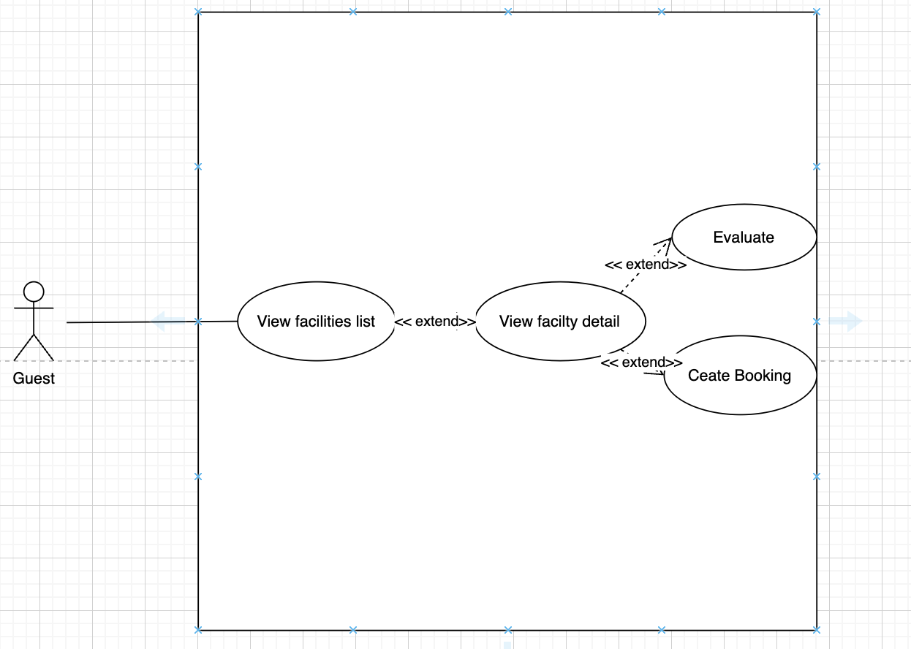

***Figure III.5****: Guest Use Case diagram*

### **2.2.2 Descriptions**

[Figure](https://docs.google.com/document/d/1DDuli0VTmQbUii5wbItkVfbrL2yOgHRSqDVQJc8W8Aw/edit#heading=h.vfr36oj0vfd6) III.6 Describe the functions present in the system and describe the roles used for each function.

| **ID** | **Use Case** | **Actors** | **Use Case Description** |
| --- | --- | --- | --- |
| 01 | Login | User, Admin | User can login to use another features |
| 02 | Logout | User, Admin | User logout system and back to guest's role |
| 03 | View profile | User, Admin | User can view profile’s detail |
| 04 | Update profile | User, Admin | Allow users change their information |
| 05 | View facilities list | User, Admin, Guest | List all of available facilities |
| 06 | View facility detail | User, Admin, Guest | Show information of a specific facility |
| 07 | Evaluate | User, Admin | Allow user vote and comment after they use facility |
| 08 | Create booking | User, Admin | Create a booking request for a facility |
| 09 | View notification list | User, Admin | List all of notifications |
| 10 | Chat | User, Admin | Allow user and admin can send message for each other |
| 11 | View booking list | Admin | Show all of booking request from user |
| 12 | Booking processing | Admin | Execute request from user |
| 13 | Block/Unblock account | Admin | Disable a specific account from the system |
| 14 | View statistic | Admin | Display statistic of system by chart |
| 15 | Create facility | Admin | Create a new facility |
| 16 | Update facility | Admin | Update detail of a specific facility |
| 17 | View facility updating history | Admin | Admin can view history detail of category updating |
| 18 | Active/Inactive facility | Admin | Able/Disable a specific facility from the system |
| 19 | Create category | Admin | Create a new category |
| 20 | Update category | Admin | Update detail of a specific category |
| 21 | View category updating history | Admin | Admin can view history detail of category updating |

***Table III.6****: Description*

## **3. Functional Requirements**

### **3.1 System Functional Overview**

#### ***3.1.0 Business Flow***

Figure III.7: Shows the main functional overview flow of the system which is booking

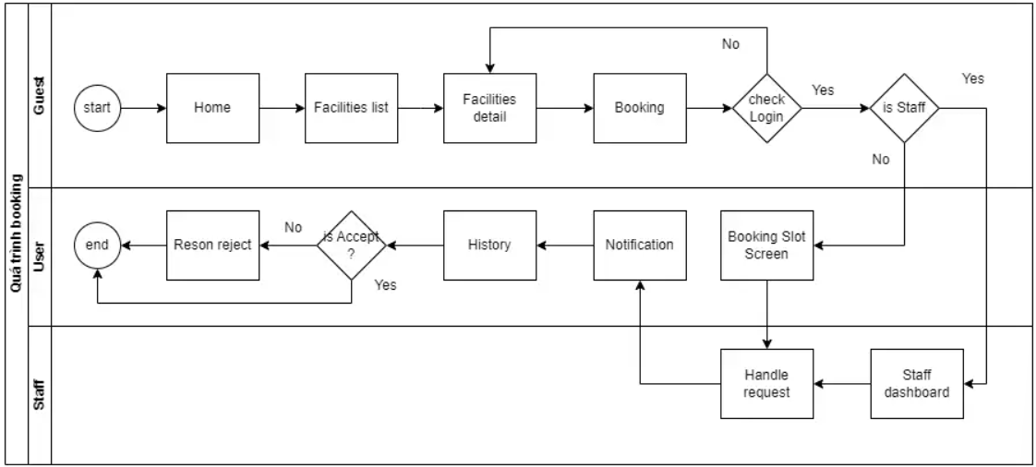

***Figure III.7****: Business flow*

#### ***3.1.1 Screens Flow***

3.1.1.1 Guest Flow

Figure III.8: Shows the guest screen flow of the system

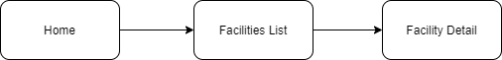

***Figure III.8****: Guest flow*

3.1.1.2 Admin Flow

Figure III.9: Shows the admin screen flow of the system

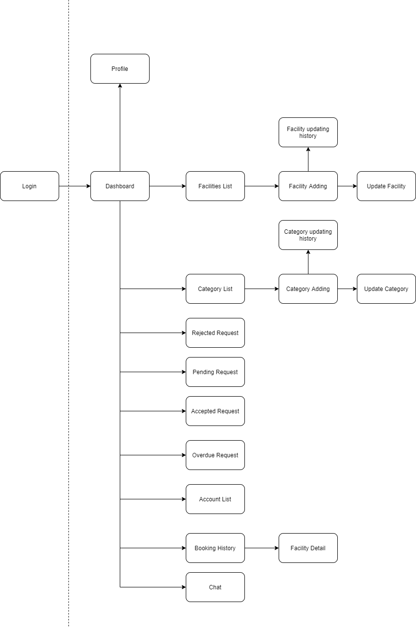

***Figure III.9****: Admin flow*

##### 

##### 

##### 

##### 

3.1.1.3 User Flow

Figure III.10: Shows the user screen flow of the system

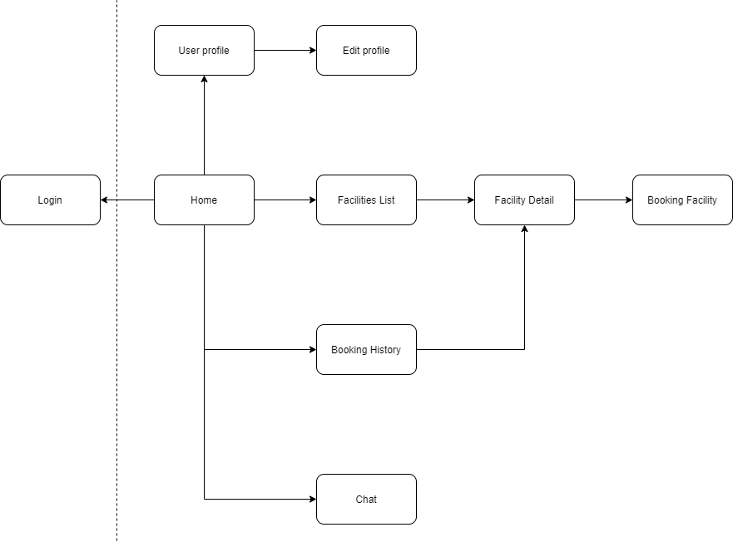

***Figure III.10****: User flow*

#### ***3.1.2 Screen Descriptions***

Table III.11: Shows the screen descriptions of the system

|  |  |  |  |
| --- | --- | --- | --- |
| **#** | **Feature** | **Screen** | **Description** |
| 1 | Login | User Login | User login by FPT gmail only |
| 2 | View Profile | User Profile | User can view their information in this screen |
| 3 | Edit Profile | User profile | Allow user update profile |
| 4 | View Facilities List | Facilities List | List all of facilities with some details |
| 5 | View Facility Detail | Facility Detail | Display specific detail of facility |
| 6 | Book Facility | Booking Facility | Allow user to create a booking request for a facility |
| 7 | Update Facility | Facility Updating | Allow Admin can update a specific facility |
| 8 | Add Facility | Facility Adding | Allow Admin to add a new facility to facilities list |
| 9 | View facility updating history | Facility Updating History | Admin can view record of change of a specific facility |
| 10 | View Booking Request | Booking History | User can view all of booking request |
| 11 | View Notification List | Notification List | User can view all of notifications |
| 12 | View Account List | Account List | Admin can view a list of all account in the system |
| 13 | View Category List | Category List | Admin can view all of category in the system |
| 14 | Add new Category | Category Adding | Admin can add new category into the system |
| 15 | Update Category | Category updating | Admin can update a specific category |
| 16 | View category updating history | Category Updating History | Admin can view record of change of a specific facility |
| 17 | View pending request | Pending request | Admin can view a list of pending request |
| 18 | View rejected request | Rejected request | Admin can view a list of rejected request |
| 19 | View accepted request | Accepted request | Admin can view a list of accepted request |
| 20 | View overdue request | Overdue request | Admin can view a list of overdue request |
| 21 | Chat | Chat | Allow Student/Teacher chat with Staff/Admin |
| 22 | View Statistic | Dashboard | Provide specific statistic to staff and admin for management process |

***Table.III.11****: Screen description*

#### ***3.1.3 Screen Authorization***

Table.III.12: Shows the screen authorizations of the system

|  |  |  |  |  |
| --- | --- | --- | --- | --- |
| **#** | **Screen** | **Guest** | **User** | **Admin** |
| 1 | Home page | x | x | x |
| 2 | Login |  | x | x |
| 3 | Profile |  | x | x |
| 4 | Facility List | x | x | x |
| 5 | Facility Detail | x | x | x |
| 6 | Facility updating history |  |  | x |
| 7 | Facility Adding |  |  | x |
| 8 | Update Facility |  |  | x |
| 9 | Category List |  |  | x |
| 10 | Category Adding |  |  | x |
| 11 | Category updating history |  |  | x |
| 12 | Update Category |  |  | x |
| 13 | Rejected Request |  |  | x |
| 13 | Pending Request |  |  | x |
| 14 | Accepted Request |  |  | x |
| 15 | Overdue Request |  |  | x |
| 16 | Account List |  |  | x |
| 17 | Booking History |  | x | x |
| 18 | Chat |  | x | x |
| 19 | Booking Facility |  | x | x |

***Table III.12****: Screen authorization*

#### ***3.1.4 Non-Screen Functions***

Table III.13: Shows the screen authorizations of the system

|  |  |  |  |
| --- | --- | --- | --- |
| **#** | **Feature** | **System Function** | **Description** |
| 1 | User management | Logout | User logout to system |
| 2 | Management | Search | User search for item |
| 3 | Notification | Send notification | Send notification to user and admin relate to booking process |

***Table III.13****: Non-Screen functions*

#### 

#### ***3.1.5 In/Out of scope***

Table III.14: Shows the goals set to upgrade the system after completing the functions outlined above.

|  |  |  |
| --- | --- | --- |
| **#** | **In of Scope** | **Out of Scope** |
| 1 | Manage Booking Schedule | HR Management |
| 2 | Manage Users | Financial Management |
| 3 | Statistics Reports | Inventory Management |
| 4 | Manage Bookings Room, Fields, .. | Mobile Application Development |
| 5 |  | Integration with Other Systems,... |

***Table III.14****: In/Out of scope*

### **3.2 Feature description**

#### ***3.2.1. Login***

Table III.15: Shows the Login feature description

|  |  |  |  |  |  |
| --- | --- | --- | --- | --- | --- |
| **USE CASE-01** | | | | | |
| **Use-case No.** | UC01 | **Use-case Version** | | | 1.0 |
| **Use-case Name** | Login | | | | |
| **Author** | … | | | | |
| **Date** | 07/09/2024 | **Priority** |  | High | |
| **Actor** | User, Admin | | | | |
| **Summary** | User login to use actor features on the system | | | | |
| **Goal** | Allow guest become user/admin of system | | | | |
| **Triggers** | Guest click on button “Đăng nhập“ on navigation bar | | | | |
| **Preconditions** | User not login and have FPT email | | | | |
| **Post Conditions** | User join system with their role and use all feature with permission | | | | |
| **Main Success Scenario** | | | | | |
| **Step** | **Actor Event** | |  | **System response** | |
| 1 | User click button “Đăng nhập” in navigation bar | |  | Redirect to google authentication service | |
| 2 | Login to google with FPT email | |  | Allow user join on the system and log the message | |
| **Alternative Scenario** | | | | | |
| **Step** | **Action** | | | | **Use case** |
| **Exceptions** | **Exception code** | **Message** |  | **Caught** | |
| 403 | Forbidden |  | User do not have permission on this page | |
| **Business Rules** | **Code** | **Rule** | | | |
| BR-01 | In first time login, account detail and user’s detail is added into database | | | |
|  |  | | | |

#### 

***Table III.15****: Login feature*

#### ***3.2.2. Logout***

Table III.16: Shows the Logout feature description

|  |  |  |  |  |
| --- | --- | --- | --- | --- |
| **USE CASE-02** | | | | |
| **Use-case No.** | UC02 | **Use-case Version** | | 1.0 |
| **Use-case Name** | Logout | | | |
| **Author** | … | | | |
| **Date** | 07/09/2024 | **Priority** | High | |
| **Actor** | User, Admin | | | |
| **Summary** | User logout system and back to guest's role | | | |
| **Goal** | Set role user to guest | | | |
| **Triggers** | User click on button “Đăng xuất“ | | | |
| **Preconditions** | User already logged in the system | | | |
| **Post Conditions** | User become guest | | | |
| **Main Success Scenario** | | | | |
| **Step** | **Actor Event** | | **System response** | |
| 1 | User click button “Đăng xuất” in | |  | |
| 2 |  | | Logout of the system | |
| **Alternative Scenario** | | | | |
| **Step** | **Action** | | | **Use case** |
| **Exceptions** | **Exception code** | **Message** | **Caught** | |
| N/A |  |  | |
| **Business Rules** | **Code** | **Rule** | | |
| N/A |  | | |

***Table III.16****: Logout feature*

#### ***3.2.3. View Profile***

Table III.17: Shows the view profile feature description

|  |  |  |  |  |
| --- | --- | --- | --- | --- |
| **USE CASE-03** | | | | |
| **Use-case No.** | UC03 | **Use-case Version** | | 1.0 |
| **Use-case Name** | View Profile | | | |
| **Author** | … | | | |
| **Date** | 09/09/2024 | **Priority** | High | |
| **Actor** | User, Admin | | | |
| **Summary** | Actor can view their information in this page | | | |
| **Goal** | Display user’s profile successfully | | | |
| **Triggers** | Click in “Hồ sơ của tôi” in avatar icon on navbar | | | |
| **Preconditions** | User has been login | | | |
| **Post Conditions** | Display all details of user | | | |
| **Main Success Scenario** | | | | |
| **Step** | **Actor Event** | | **System response** | |
| 1 | User click in “Hồ sơ của tôi” in avatar icon on navbar | | Redirect to user profile page | |
| 2 |  | | Display user’s detail | |
| **Alternative Scenario** | | | | |
| **#** | **Action** | | | **Use case** |
| **Exceptions** | **Exception code** | **Message** | **Caught** | |
| 401 | Unauthorised | User is not login yet | |
| **Business Rules** | **Code** | **Rule** | | |
| N/A |  | | |

***Table III.17****: View profile feature*

#### ***3.2.4. Edit Profile***

Table III.18: Shows the edit profile feature description

|  |  |  |  |  |
| --- | --- | --- | --- | --- |
| **USE CASE-04** | | | | |
| **Use-case No.** | UC04 | **Use-case Version** | | 1.0 |
| **Use-case Name** | Edit Profile | | | |
| **Author** | … | | | |
| **Date** | 09/09/2024 | **Priority** | Medium | |
| **Actor** | User, Admin | | | |
| **Summary** | Actor can update their information in this page | | | |
| **Goal** | Update user’s profile successfully | | | |
| **Triggers** | Fill in field | | | |
| **Preconditions** | Profile screen is available | | | |
| **Post Conditions** | New information is update into database | | | |
| **Main Success Scenario** | | | | |
| **Step** | **Actor Event** | | **System response** | |
| 1 | Fill your info in field | |  | |
| 2 | Click in button “Lưu” | | Validate user’s input | |
| 3 |  | | Save to database and log message | |
| **Alternative Scenario** | | | | |
| **#** | **Action** | | | **System response** |
| 3 | Update new user detail | | | User detail is invalid, log message |
| 4 | Click in button “Hủy” | | | Clear inputted data |
| **Exceptions** | **Exception code** | **Message** | **Caught** | |
| 401 | Unauthorised | User is not login yet | |
| **Business Rules** | **Code** | **Rule** | | |
| BR-02 | User’s detail must be valid | | |

***Table III.18*** *Edit profile feature*

#### ***3.2.5. View facility list***

Table III.19: Shows the view facility feature description

|  |  |  |  |  |
| --- | --- | --- | --- | --- |
| **USE CASE-05** | | | | |
| **Use-case No.** | UC05 | **Use-case Version** | | 1.0 |
| **Use-case Name** | View facility list | | | |
| **Author** | Mạnh + Kiệt | | | |
| **Date** | 15/09/2024 | **Priority** | High | |
| **Actor** | Guest, User, Admin | | | |
| **Summary** | User view list of facilities | | | |
| **Goal** | Display all of facilities with pagination, search and filter | | | |
| **Triggers** | Search or click in any category in Homepage | | | |
| **Preconditions** | Facilities List is available | | | |
| **Post Conditions** | All available facilities are displayed | | | |
| **Main Success Scenario** | | | | |
| **Step** | **Actor Event** | | **System response** | |
| 1 | Search or click in any category in Homepage | | Navigate to Facilities List and dísplay all of available facilities which matches with condition | |
| 2 | User search / filter | | Display facilities according to keyword or filter | |
| **Alternative Scenario** | | | | |
| **#** | **Action** | | | **Use case** |
| **Exceptions** | **Exception code** | **Message** | **Caught** | |
| N/A |  |  | |
| **Business Rules** | **Code** | **Rule** | | |
| N/A |  | | |

***Table III.19****: View facility feature*

#### ***3.2.6. View facilities detail***

Table III.20: Shows the view facilities detail feature description

|  |  |  |  |  |
| --- | --- | --- | --- | --- |
| **USE CASE-06** | | | | |
| **Use-case No.** | UC06 | **Use-case Version** | | 1.0 |
| **Use-case Name** | View facilities detail | | | |
| **Author** | Mạnh + Kiệt | | | |
| **Date** | 15/09/2024 | **Priority** | High | |
| **Actor** | Guest, User, Admin | | | |
| **Summary** | User view detail of a facility | | | |
| **Goal** | Display all details of a specific facility | | | |
| **Triggers** | User click on a specific facility | | | |
| **Preconditions** | Facility is available | | | |
| **Post Conditions** | Facility’s detail is displayed successfully | | | |
| **Main Success Scenario** | | | | |
| **Step** | **Actor Event** | | **System response** | |
| 1 | User click in a specific facility | | Navigate to Facilities Detail and dísplay all detail of facility | |
| **Alternative Scenario** | | | | |
| **#** | **Action** | | | **Use case** |
| **Exceptions** | **Exception code** | **Message** | **Caught** | |
| N/A |  |  | |
| **Business Rules** | **Code** | **Rule** | | |
| N/A |  | | |

***Table III.20****: View facilities detail feature*

#### ***3.2.7. Evaluate***

Table III.21: Shows the evaluate feature description

|  |  |  |  |  |
| --- | --- | --- | --- | --- |
| **USE CASE-07** | | | | |
| **Use-case No.** | UC07 | **Use-case Version** | | 1.0 |
| **Use-case Name** | Evaluate | | | |
| **Author** | Mạnh + Kiệt | | | |
| **Date** | 20/09/2024 | **Priority** | High | |
| **Actor** | User, Admin | | | |
| **Summary** | User can rating and comment for a facility | | | |
| **Goal** | Get feedback from user | | | |
| **Triggers** | Vote and enter comment | | | |
| **Preconditions** | Facility detail page is available. User used this facility before | | | |
| **Post Conditions** | Comment and rating of user is saved into database | | | |
| **Main Success Scenario** | | | | |
| **Step** | **Actor Event** | | **System response** | |
| 1 | Vote and enter comment | | Validate comment | |
| 2 |  | | Save to database and display user feedback | |
| **Alternative Scenario** | | | | |
| **#** | **Action** | | | **Use case** |
| **Exceptions** | **Exception code** | **Message** | **Caught** | |
| 403 | Forbidden | User do not have permission on this page | |
| **Business Rules** | **Code** | **Rule** | | |
|  |  | | |

***Table III.21****: Evaluate feature*

#### ***3.2.8. Create booking***

Table III.22: Shows the create booking feature description

|  |  |  |  |  |
| --- | --- | --- | --- | --- |
| **USE CASE-08** | | | | |
| **Use-case No.** | UC08 | **Use-case Version** | | 1.0 |
| **Use-case Name** | Create booking | | | |
| **Author** | Mạnh + Kiệt | | | |
| **Date** | 25/09/2024 | **Priority** | High | |
| **Actor** | User, Admin | | | |
| **Summary** | Actor can create booking request for a specific facilities | | | |
| **Goal** | Request is send to Admin | | | |
| **Triggers** | Click “Đặt phòng” and select slot | | | |
| **Preconditions** | Facility is available | | | |
| **Post Conditions** | Booking request and notification is send to admin | | | |
| **Main Success Scenario** | | | | |
| **Step** | **Actor Event** | | **System response** | |
| 1 | Click in “Đặt phòng” | |  | |
| 2 | Select a slot | |  | |
| 3 |  | | Send notification and request to admin and log message | |
| **Alternative Scenario** | | | | |
| **#** | **Action** | | | **Use case** |
|  | Booking processing | | | UC12 |
| **Exceptions** | **Exception code** | **Message** | **Caught** | |
| 401 | Unauthorized | User is not login yet | |
| 403 | Forbidden | User do not have permission on this page | |
| **Business Rules** | **Code** | **Rule** | | |
| N/A |  | | |

***Table III.22*** *Create booking feature*

#### ***3.2.9. View notification list***

Table III.23: Shows the view notification list feature description

|  |  |  |  |  |
| --- | --- | --- | --- | --- |
| **USE CASE-09** | | | | |
| **Use-case No.** | UC09 | **Use-case Version** | | 1.0 |
| **Use-case Name** | View notification list | | | |
| **Author** | Mạnh + Kiệt | | | |
| **Date** | 30/09/2024 | **Priority** | High | |
| **Actor** | User, Admin | | | |
| **Summary** | Actor can view all of notification | | | |
| **Goal** | Show notification of booking for user and admin | | | |
| **Triggers** | Click bell icon in navbar | | | |
| **Preconditions** | Notification list is available | | | |
| **Post Conditions** | All of notifications are showed | | | |
| **Main Success Scenario** | | | | |
| **Step** | **Actor Event** | | **System response** | |
| 1 | Click in bell icon | | Display all of notification | |
| **Alternative Scenario** | | | | |
| **#** | **Action** | | | **Use case** |
|  |  | | |  |
| **Exceptions** | **Exception code** | **Message** | **Caught** | |
| 401 | Unauthorised | User is not login yet | |
| 403 | Forbidden | User do not have permission on this page | |
| **Business Rules** | **Code** | **Rule** | | |
| BR-03 | Notification of user and admin have to mapping | | |

***Table III.23****: View notification feature*

#### ***3.2.10. Chat***

Table III.24 : Shows the chat feature description

|  |  |  |  |  |
| --- | --- | --- | --- | --- |
| **USE CASE-10** | | | | |
| **Use-case No.** | UC10 | **Use-case Version** | | 1.0 |
| **Use-case Name** | Chat | | | |
| **Author** | Mạnh + Kiệt | | | |
| **Date** | 02/10/2024 | **Priority** | High | |
| **Actor** | User, Admin | | | |
| **Summary** | Allow User and Admin chat with each others | | | |
| **Goal** | User can send message to Admin and Admin can reply User | | | |
| **Triggers** | Click message icon | | | |
| **Preconditions** | Chat page is available | | | |
| **Post Conditions** | Message is sent | | | |
| **Main Success Scenario** | | | | |
| **Step** | **Actor Event** | | **System response** | |
| 1 | User click in message icon | | Open chat box | |
| 2 | User Enter message and send | | Send message to Admin | |
| 3 |  | | Display message in chat screen of admin | |
| 4 | Admin reply message | | Send message to User | |
| 5 |  | | Display message in user chat box | |
| **Alternative Scenario** | | | | |
| **#** | **Action** | | | **Use case** |
|  |  | | |  |
| **Exceptions** | **Exception code** | **Message** | **Caught** | |
| 401 | Unauthorized | User is not login yet | |
| 403 | Forbidden | User do not have permission on this page | |
| **Business Rules** | **Code** | **Rule** | | |
| N/A |  | | |

***Table III.24****: Chat feature*

#### ***3.2.11. View booking list***

Table III.25: Shows the view booking list feature description

|  |  |  |  |  |
| --- | --- | --- | --- | --- |
| **USE CASE-11** | | | | |
| **Use-case No.** | UC11 | **Use-case Version** | | 1.0 |
| **Use-case Name** | View booking list | | | |
| **Author** | Toàn + An | | | |
| **Date** | 03/10/2024 | **Priority** | High | |
| **Actor** | Admin | | | |
| **Summary** | Allow admin view all of booking request | | | |
| **Goal** | Manage booking request | | | |
| **Triggers** | Click in “Duyệt yêu cầu đặt sân, phòng học” | | | |
| **Preconditions** | User has been login as role Admin | | | |
| **Post Conditions** | Display all booking request | | | |
| **Main Success Scenario** | | | | |
| **Step** | **Actor Event** | | **System response** | |
| 1 | Click in “Duyệt yêu cầu đặt sân, phòng học” | | Navigate to Booking request list | |
| 2 |  | | Display all of booking request | |
| **Alternative Scenario** | | | | |
| **#** | **Action** | | | **Use case** |
|  | Booking processing | | | UC12 |
| **Exceptions** | **Exception code** | **Message** | **Caught** | |
| 401 | Unauthorised | User is not login yet | |
| 403 | Forbidden | User do not have permission on this page | |
| **Business Rules** | **Code** | **Rule** | | |
| N/A |  | | |

***Table III.25****: View booking feature*

#### ***3.2.12. Booking processing***

Table III.26: Shows the booking processing feature description

|  |  |  |  |  |
| --- | --- | --- | --- | --- |
| **USE CASE-12** | | | | |
| **Use-case No.** | UC12 | **Use-case Version** | | 1.0 |
| **Use-case Name** | Booking processing | | | |
| **Author** | Toàn + An | | | |
| **Date** | 05/10/2024 | **Priority** | High | |
| **Actor** | Admin | | | |
| **Summary** | Execute booking request | | | |
| **Goal** | Response request from user | | | |
| **Triggers** | Click link “Chấp nhận” or “Từ chối” | | | |
| **Preconditions** | User has been login as role Admin | | | |
| **Post Conditions** | Update booking status and send notification to user | | | |
| **Main Success Scenario** | | | | |
| **Step** | **Actor Event** | | **System response** | |
| 1 | Click in “Chấp nhận” | | Change booking status | |
| 2 |  | | Send notification to user | |
| **Alternative Scenario** | | | | |
| **#** | **Action** | | | **System Response** |
| 1 | Click in “Từ chối” | | |  |
| 2 | Enter “Lý do từ chối” | | | Change booking status |
|  |  | | | Send notification to user |
| **Exceptions** | **Exception code** | **Message** | **Caught** | |
| 401 | Unauthorised | User is not login yet | |
| 403 | Forbidden | User do not have permission on this page | |
| **Business Rules** | **Code** | **Rule** | | |
|  |  | | |

***Table III.26****: Booking processing feature*

#### ***3.2.13. Block/Unblock Account***

Table III.27: Shows the Block/Unblock account feature description

|  |  |  |  |  |
| --- | --- | --- | --- | --- |
| **USE CASE-13** | | | | |
| **Use-case No.** | UC13 | **Use-case Version** | | 1.0 |
| **Use-case Name** | Block/Unblock Account | | | |
| **Author** | Toàn + An | | | |
| **Date** | 07/10/2024 | **Priority** | Medium | |
| **Actor** | Admin | | | |
| **Summary** | Allow admin block/unblock user account | | | |
| **Goal** | Block/Unblock user from the system | | | |
| **Triggers** | Click link “Active” or “Inactive” | | | |
| **Preconditions** | Account List page is available | | | |
| **Post Conditions** | Change account status | | | |
| **Main Success Scenario** | | | | |
| **Step** | **Actor Event** | | **System response** | |
| 1 | Click “Inactive” | | Change account status and block account | |
| **Alternative Scenario** | | | | |
| **#** | **Action** | | | **Use case** |
| 1 | Click “Active” | | | Change account status and unblock account |
| **Exceptions** | **Exception code** | **Message** | **Caught** | |
| 401 | Unauthorised | User is not login yet | |
| 403 | Forbidden | User do not have permission on this page | |
| **Business Rules** | **Code** | **Rule** | | |
|  |  | | |

***Table III.27****: Block/ Unblock feature*

#### ***3.2.14. View Statistic***

Table III.28: Shows the view statistic feature description

|  |  |  |  |  |
| --- | --- | --- | --- | --- |
| **USE CASE-14** | | | | |
| **Use-case No.** | UC14 | **Use-case Version** | | 1.0 |
| **Use-case Name** | View statistic | | | |
| **Author** | Toàn + An | | | |
| **Date** | 10/10/2024 | **Priority** | High | |
| **Actor** | Admin | | | |
| **Summary** | Admin can view all statistic of the system | | | |
| **Goal** | Show statistic by chart | | | |
| **Triggers** | Click ”Thống kê” in sidebar of Dashboard | | | |
| **Preconditions** | Dashboard is available | | | |
| **Post Conditions** | Display statistic by chart | | | |
| **Main Success Scenario** | | | | |
| **Step** | **Actor Event** | | **System response** | |
| 1 | Click in “Thống kê” | | Display statistic by chart | |
| 2 | Choose optional filter | | Display statistic mapping with filter | |
| **Alternative Scenario** | | | | |
| **#** | **Action** | | | **Use case** |
|  |  | | |  |
| **Exceptions** | **Exception code** | **Message** | **Caught** | |
| 401 | Unauthorised | User is not login yet | |
| 403 | Forbidden | User do not have permission on this page | |
| **Business Rules** | **Code** | **Rule** | | |
| BR-04 | Statistic and chart have to mapping with database | | |

##### 

***Table III.28****: View statistic feature*

#### ***3.2.15. Create Facility***

Table III.29: Shows the create facility feature description

|  |  |  |  |  |
| --- | --- | --- | --- | --- |
| **USE CASE-15** | | | | |
| **Use-case No.** | UC15 | **Use-case Version** | | 1.0 |
| **Use-case Name** | Create Facility | | | |
| **Author** | An+Mạnh | | | |
| **Date** | 13/10/2024 | **Priority** | High | |
| **Actor** | Admin | | | |
| **Summary** | Allow admin create a new facility | | | |
| **Goal** | A new facility is created | | | |
| **Triggers** | Click in + button in facilities list screen | | | |
| **Preconditions** | Facility Adding screen is available | | | |
| **Post Conditions** | A new facility is created and save to DB | | | |
| **Main Success Scenario** | | | | |
| **Step** | **Actor Event** | | **System response** | |
| 1 | Click in + button in facilities list screen | | Display Facility Adding screen | |
| 2 | Fill all the field | |  | |
| 3 | Select “Thêm” | | Validate inputted data | |
| 4 |  | | Create new facility and log message | |
| **Alternative Scenario** | | | | |
| **#** | **Action** | | | **System response** |
| 3 | Select “Thêm” | | Validate inputted data | |
| 4 |  | | Return error and require input data again | |
| 5 | Re-input data and select “Thêm” | | Validate inputted data | |
| **Exceptions** | **Exception code** | **Message** | **Caught** | |
| 401 | Unauthorised | User is not login yet | |
| 403 | Forbidden | User do not have permission on this page | |
| **Business Rules** | **Code** | **Rule** | | |
| BR-05 | New facility can’t be duplicate with existed facilities | | |

***Table III.29****: Create facility feature*

#### ***3.2.16. Update Facility***

Table III.30: Shows the update facility feature description

|  |  |  |  |  |
| --- | --- | --- | --- | --- |
| **USE CASE-16** | | | | |
| **Use-case No.** | UC16 | **Use-case Version** | | 1.0 |
| **Use-case Name** | Update | | | |
| **Author** | Toàn + An | | | |
| **Date** | 15/10/2024 | **Priority** | High | |
| **Actor** | Admin | | | |
| **Summary** | Allow admin update facility’s detail | | | |
| **Goal** | Facility’s detail is updated and save to DB | | | |
| **Triggers** | Click in “Cập nhật” in Facilities List | | | |
| **Preconditions** | Facility is available. Logged in with role admin | | | |
| **Post Conditions** | Facility's detail is updated and save in database | | | |
| **Main Success Scenario** | | | | |
| **Step** | **Actor Event** | | **System response** | |
| 1 | Click in “Cập nhật | | Display facility’s detail | |
| 2 | Enter new facility’s detail | |  | |
| 3 | Click “Cập nhập” | | Validate inputted data | |
| 4 |  | | Update new facility’s detail, save to database and log message | |
| 5 |  | | Save record of change into Logs | |
| **Alternative Scenario** | | | | |
| **#** | **Action** | | | **System Response** |
| 3 | Click “Hủy” | | | Back to facilities list |
| **Exceptions** | **Exception code** | **Message** | **Caught** | |
| 401 | Unauthorised | User is not login yet | |
| 403 | Forbidden | User do not have permission on this page | |
| **Business Rules** | **Code** | **Rule** | | |
| BR-06 | New facility’s detail can’t duplicate with other facilities | | |

***Table III.30****: Update facility feature*

#### ***3.2.17. View facility updating history***

Table III.31: Shows the view facility updating history feature description

|  |  |  |  |  |
| --- | --- | --- | --- | --- |
| **USE CASE-17** | | | | |
| **Use-case No.** | UC17 | **Use-case Version** | | 1.0 |
| **Use-case Name** | View facility updating history | | | |
| **Author** | Toàn + An | | | |
| **Date** | 20/10/2024 | **Priority** | High | |
| **Actor** | Admin | | | |
| **Summary** | Allow admin can view the change of facility | | | |
| **Goal** | Display record of change | | | |
| **Triggers** | Click in “Xem” in column “Lịch sử cập nhật” | | | |
| **Preconditions** | User has been login as role Admin | | | |
| **Post Conditions** | Display all the change of facilities | | | |
| **Main Success Scenario** | | | | |
| **Step** | **Actor Event** | | **System response** | |
| 1 | Click in “Xem” | | Display record of change | |
| **Alternative Scenario** | | | | |
| **#** | **Action** | | | **Use case** |
|  |  | | |  |
| **Exceptions** | **Exception code** | **Message** | **Caught** | |
| 401 | Unauthorised | User is not login yet | |
| 403 | Forbidden | User do not have permission on this page | |
| **Business Rules** | **Code** | **Rule** | | |
| N/A |  | | |

***Table III.31****: View facility feature*

#### ***3.2.18. Active/Inactive facility***

Table III.32: Shows the active/inactive feature description

|  |  |  |  |  |
| --- | --- | --- | --- | --- |
| **USE CASE-18** | | | | |
| **Use-case No.** | UC18 | **Use-case Version** | | 1.0 |
| **Use-case Name** | Active/Inactive facility | | | |
| **Author** | Toàn + An | | | |
| **Date** | 23/10/2024 | **Priority** | High | |
| **Actor** | Admin | | | |
| **Summary** | Active/Inactive a specific category | | | |
| **Goal** | Change status of facilities and save into database | | | |
| **Triggers** | Click button “Active” or “Inactive” | | | |
| **Preconditions** | Facility is available. Logged in with role admin | | | |
| **Post Conditions** | Facility’s status is change | | | |
| **Main Success Scenario** | | | | |
| **Step** | **Actor Event** | | **System response** | |
| 1 | Click “Active” | | Show a notice | |
| 2 | Admin confirm | | Change status of facility into inactive | |
| **Alternative Scenario** | | | | |
| **#** | **Action** | | | **System Response** |
| 2 | Admin decline | | | Back to facilities list |
| **Exceptions** | **Exception code** | **Message** | **Caught** | |
| 401 | Unauthorised | User is not login yet | |
| 403 | Forbidden | User do not have permission on this page | |
| **Business Rules** | **Code** | **Rule** | | |
| BR-07 | When inactive a facilities, all the pending request will be decline with reason “Cơ sở này không còn khả dụng” | | |

***Table III.32****: Active/Inactive facility feature*

#### ***3.2.19. Create category***

Table III.33: Shows the create category feature description

|  |  |  |  |  |
| --- | --- | --- | --- | --- |
| **USE CASE-19** | | | | |
| **Use-case No.** | UC19 | **Use-case Version** | | 1.0 |
| **Use-case Name** | Create category | | | |
| **Author** | Toàn + An | | | |
| **Date** | 25/10/2024 | **Priority** | High | |
| **Actor** | Admin | | | |
| **Summary** | Allow admin create a new category | | | |
| **Goal** | A new category is created | | | |
| **Triggers** | Click in + button in categories list screen | | | |
| **Preconditions** | Category Adding screen is available | | | |
| **Post Conditions** | A new category is created and save to DB | | | |
| **Main Success Scenario** | | | | |
| **Step** | **Actor Event** | | **System response** | |
| 1 | Click in + button in categories list screen | | Display Category Adding screen | |
| 2 | Fill all the field | |  | |
| 3 | Select “Thêm” | | Validate inputted data | |
| 4 |  | | Create new category and log message | |
| **Alternative Scenario** | | | | |
| **#** | **Action** | | | **System Response** |
| 3 | Select “Thêm” | | Validate inputted data | |
| 4 |  | | Return error and require input data again | |
| 5 | Re-input data and select “Thêm” | | Validate inputted data | |
| **Exceptions** | **Exception code** | **Message** | **Caught** | |
| 401 | Unauthorised | User is not login yet | |
| 403 | Forbidden | User do not have permission on this page | |
| **Business Rules** | **Code** | **Rule** | | |
| BR-08 | New category can’t be duplicate with existed categories | | |

***Table III.33****: Create category feature*

#### ***3.2.20. Update category***

Table III.34: Shows the update category feature description

|  |  |  |  |  |
| --- | --- | --- | --- | --- |
| **USE CASE-20** | | | | |
| **Use-case No.** | UC20 | **Use-case Version** | | 1.0 |
| **Use-case Name** | Update category | | | |
| **Author** | Toàn + An | | | |
| **Date** | 26/10/2024 | **Priority** | High | |
| **Actor** | Admin | | | |
| **Summary** | Allow admin update category’s detail | | | |
| **Goal** | Category’s detail is updated and save to DB | | | |
| **Triggers** | Click in “Cập nhật” in Category List | | | |
| **Preconditions** | Category is available. Logged in with role admin | | | |
| **Post Conditions** | Category’s detail is updated and save in database | | | |
| **Main Success Scenario** | | | | |
| **Step** | **Actor Event** | | **System response** | |
| 1 | Click in “Cập nhật | | Display category’s detail | |
| 2 | Enter new facility’s detail | |  | |
| 3 | Click “Cập nhập” | | Validate inputted data | |
| 4 |  | | Update new category’s detail, save to database and log message | |
| 5 |  | | Save record of change into Logs | |
| **Alternative Scenario** | | | | |
| **#** | **Action** | | | **System Response** |
| 3 | Click “Hủy” | | | Back to facilities list |
| **Exceptions** | **Exception code** | **Message** | **Caught** | |
| 401 | Unauthorised | User is not login yet | |
| 403 | Forbidden | User do not have permission on this page | |
| **Business Rules** | **Code** | **Rule** | | |
| BR-09 | New facility’s detail can’t duplicate with other facilities | | |

***Table III.34****: Update category feature*

#### ***3.2.21. View category updating history***

Table III.35: Shows the view category feature description

##### 

|  |  |  |  |  |
| --- | --- | --- | --- | --- |
| **USE CASE-21** | | | | |
| **Use-case No.** | UC21 | **Use-case Version** | | 1.0 |
| **Use-case Name** | View category updating history | | | |
| **Author** | Toàn + An | | | |
| **Date** | 27/10/2024 | **Priority** | High | |
| **Actor** | Admin | | | |
| **Summary** | Allow admin can view the change of category | | | |
| **Goal** | Display record of change | | | |
| **Triggers** | Click in “Xem” in column “Lịch sử cập nhật” | | | |
| **Preconditions** | User has been login as role Admin | | | |
| **Post Conditions** | Display all the change of facilities | | | |
| **Main Success Scenario** | | | | |
| **Step** | **Actor Event** | | **System response** | |
| 1 | Click in “Xem” | | Display record of change | |
| **Alternative Scenario** | | | | |
| **#** | **Action** | | | **Use case** |
|  |  | | |  |
| **Exceptions** | **Exception code** | **Message** | **Caught** | |
| 401 | Unauthorised | User is not login yet | |
| 403 | Forbidden | User do not have permission on this page | |
| **Business Rules** | **Code** | **Rule** | | |
| N/A |  | | |

***Table III.35****: View category feature*

## **4. Non-Functional Requirements**

### **4.1 External Interfaces**

#### ***4.1.1. User interfaces***

* UI-01: The website shall display correctly without glitches on popular browsers including Chrome, Firefox, Safari and Edge.
* UI-02: FMS screen displays shall conform to the Process Impact Internet Application User Interface Standard.
* UI-03: Audit form interface: An interface that enables auditors to input data related to safety inspections, including checklist items, observations, photographs, and comments.
* UI-04: The system should responsively in mobile device

#### ***4.2.2 Security interfaces***

* SI-01: Access control interface: An interface that enforces role-based access control, defining user permissions and restrictions based on their roles within the system.

### **4.2 Quality Attributes**

#### ***4.2.1 Usability***

* US-01: The system will be designed with simple and friendly user interfaces.
* US-02: Users shall become familiar and productive at main operations after a short time using the application.
* US-03: Clear and informative error messages should be provided to guide users in resolving any issues or mistakes encountered during system use.

#### ***4.2.2 Reliability***

* RE-01: The system should be highly available, ensuring minimal downtime to support continuous access and use by auditors and stakeholders.
* RE-02: All data entered by the user is validated before sending it to the server

#### ***4.2.3 Performance***

* PE-01: The system should respond promptly to user actions, ensuring minimal delay when loading pages, saving data, or generating reports.
* PE-02: The system should be able to handle an increasing number of concurrent users and data volumes without significant degradation in performance.
* PE-03: The system should utilize system resources, such as memory and processing power, efficiently to deliver optimal performance.

#### ***4.2.4 Security***

* SE-01: The system should ensure that sensitive data, such as audit reports and user information, is protected from unauthorised access or disclosure.
* SE-02: The system should prevent unauthorized modification or tampering of data, ensuring that audit records remain accurate and reliable.
* SE-03: Robust mechanisms should be implemented to verify the identity of users and grant appropriate access privileges based on their roles and responsibilities.

## **5. Requirement Appendix**

### **5.1 Business Rules**

Table III.36: Description rule definition of the system

| **ID** | **Rule Definition** |
| --- | --- |
| BR-01 | In first time login, account detail and user’s detail is added into database |
| BR-02 | User’s detail must be valid |
| BR-03 | Notification of user and admin have to mapping |
| BR-04 | Statistic and chart have to mapping with database |
| BR-05 | New facility can’t be duplicate with existed facilities |
| BR-06 | New facility’s detail can’t duplicate with other facilities |
| BR-07 | When inactive a facilities, all the pending request will be decline with reason “Cơ sở này không còn khả dụng” |
| BR-08 | New category can’t be duplicate with existed categories |
| BR-09 | New facility’s detail can’t duplicate with other facilities |

***Table III.36****: Business rules*

### **5.2 Application Messages List**

Table III.37: Shows the application messages list of the system

|  |  |  |  |  |
| --- | --- | --- | --- | --- |
| **#** | **Message code** | **Message Type** | **Context** | **Content** |
| 1 | MSG01 | In red, above the button sign-in google | You have to you FPT email | Bạn phải sử dụng email FPT |
| 2 | MSG02 | In line, inside table | There is not any search result | Không có dữ liệu |
| 3 | MSG03 | Popup message | Successfully | Thành công |
| 4 | MSG04 | Popup message | Error | Lỗi |
| 5 | MSG05 | Popup message | Notice | Hành động này sẽ từ chối hết tất cả các pending request của facility này |
| 6 | MSG07 | Inline, under the text box | Not fill in required field | This field is required |

***Table III.37****: Messages List*

# 

# 

# **IV. Software Design Description**

## **1. System Design**

### **1.1 System Architecture**

* Figure IV.1 shows the software system architecture of the Facilities Management system.

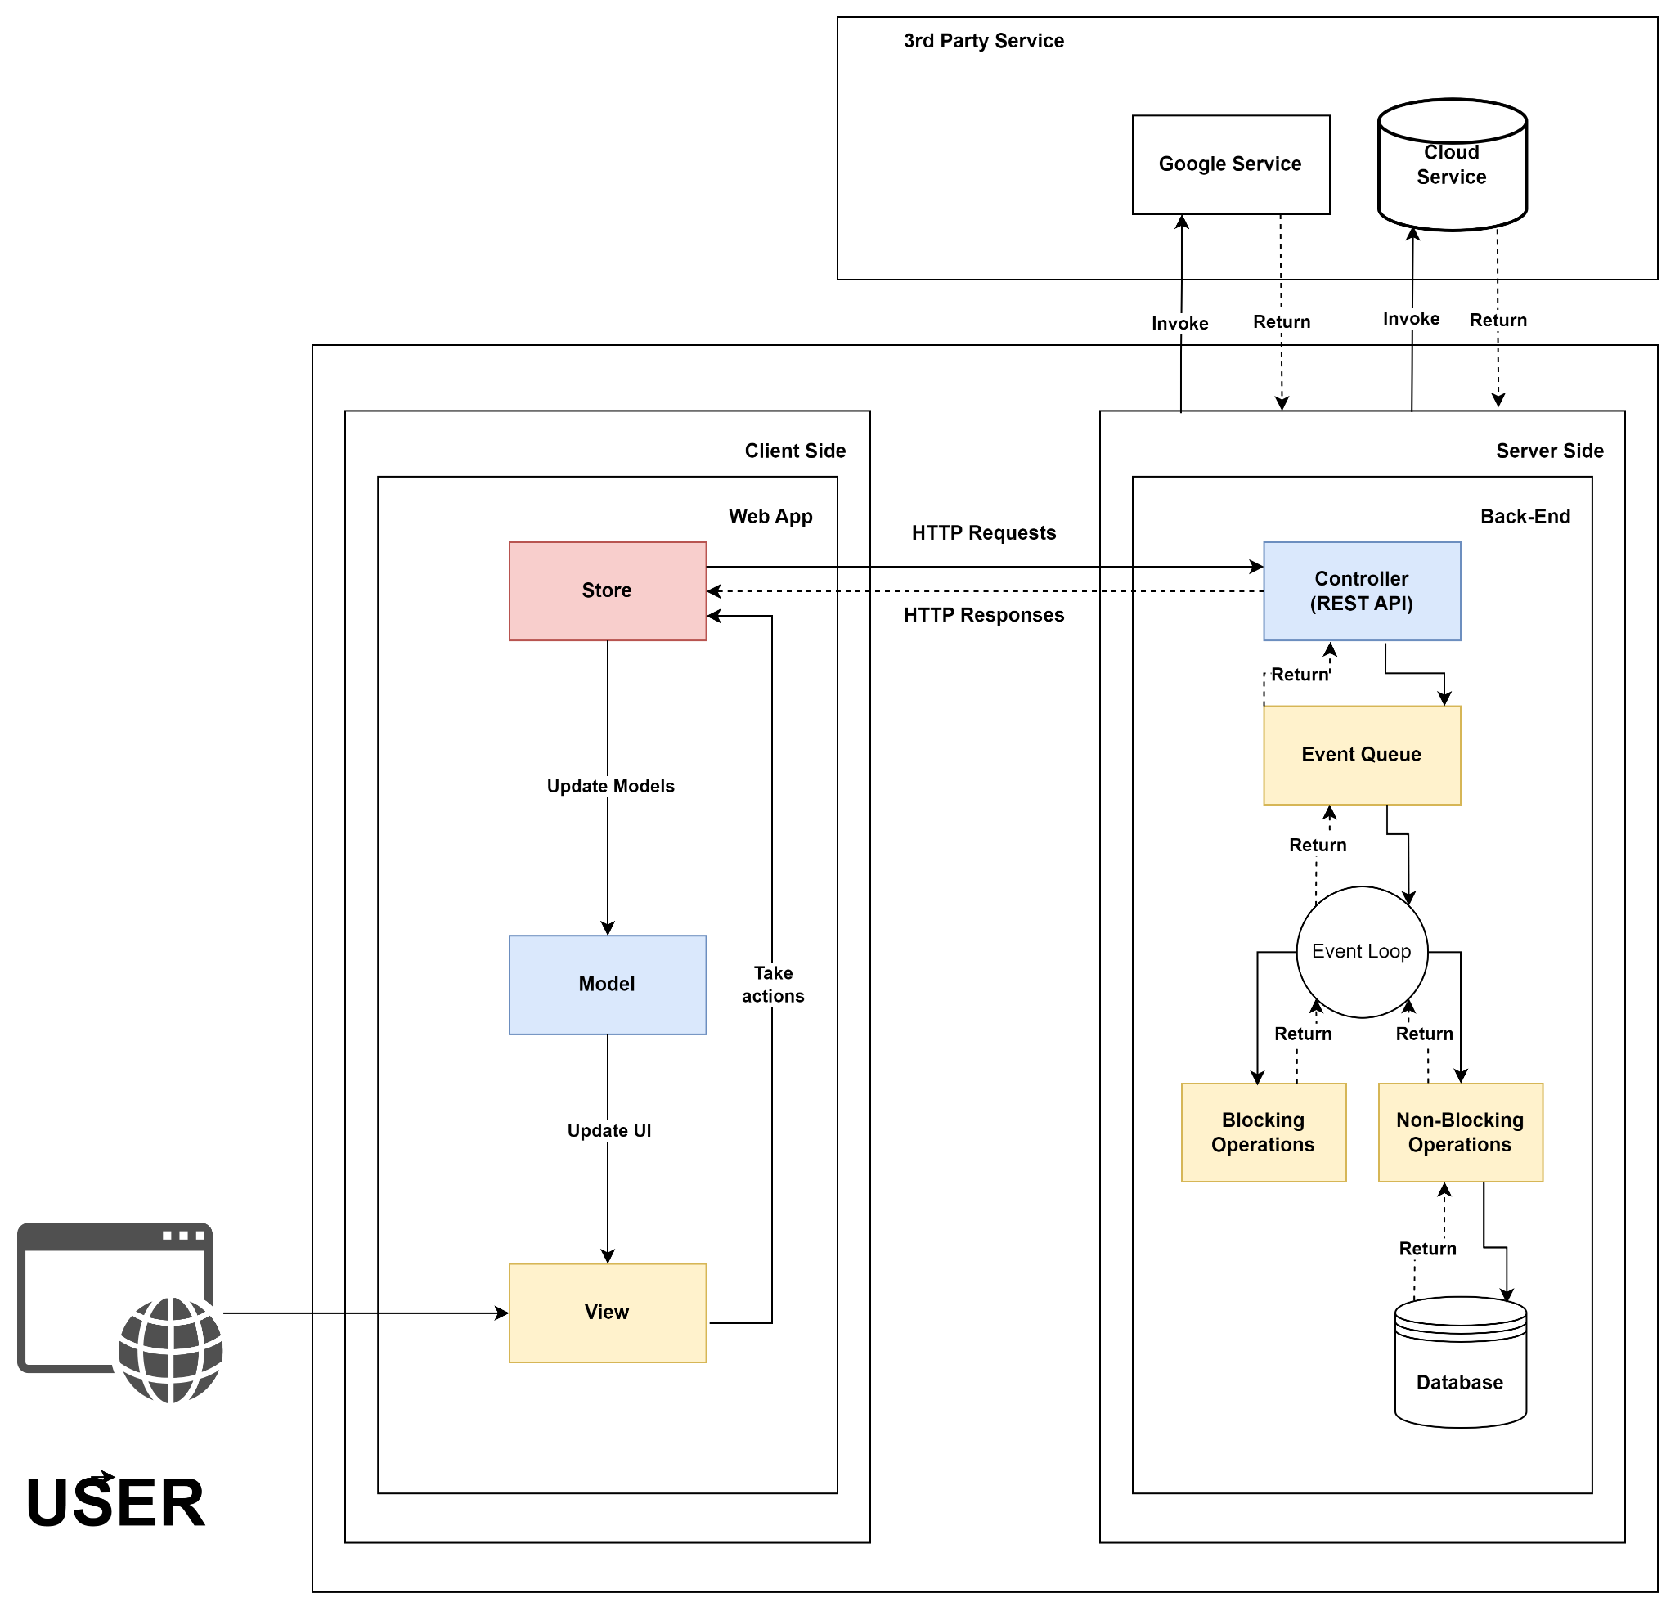***Figure IV.1****: System architecture*

### **1.2 Package Diagram**

Figure IV.2 represents the organization of packages for Front-end code

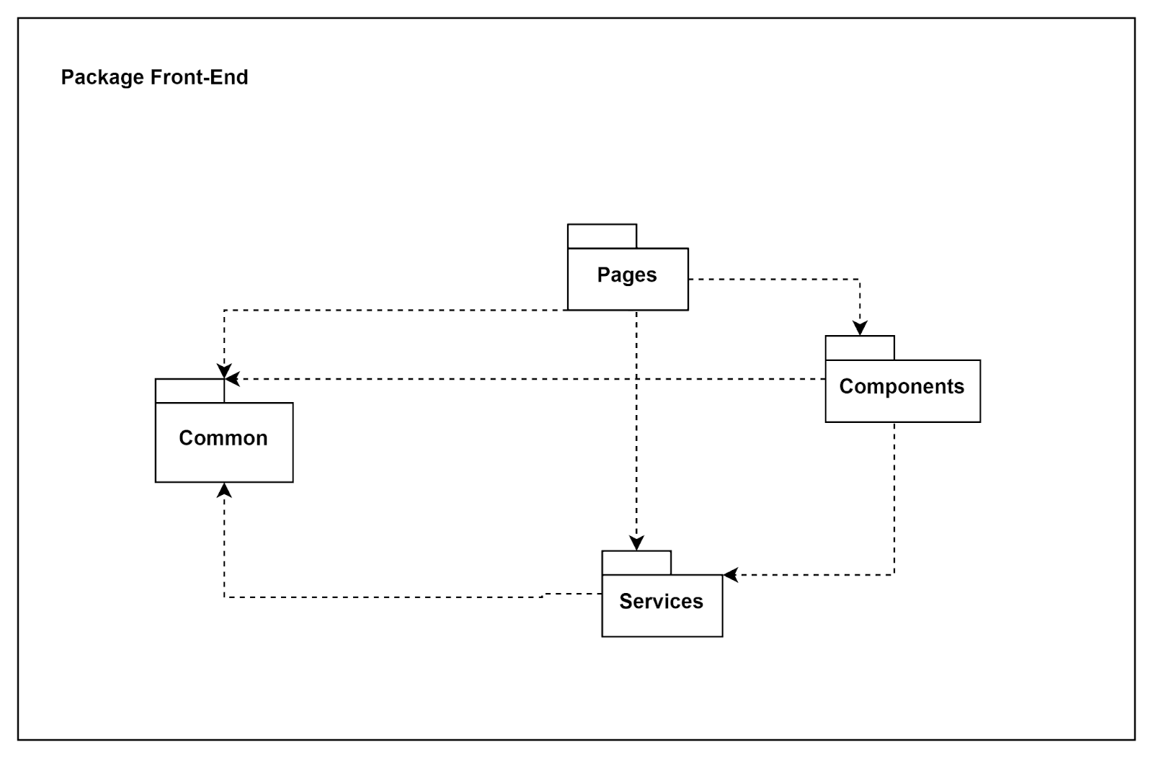

***Figure IV.2****: Package Front-end*

Figure IV.3 thể hiện tổ chức các package NODEJS

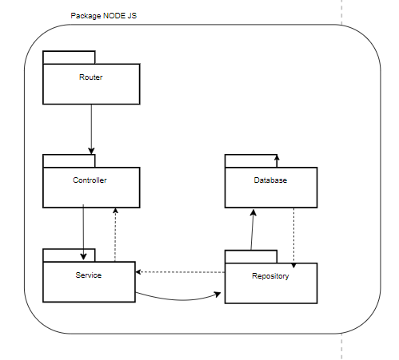

***Figure IV.3****: Package back-end NODEJS*

***Package Descriptions***

Table IV.4 Shows the Packages contained in the project and describes what those packages do in the project

|  |  |  |  |
| --- | --- | --- | --- |
| **No** | **Project** | **Package** | **Description** |
| 01 | Core | Configure  Service | Configure service |
| 02 | Constants | Constants of system |
| 03 | Entities | Base for entities model |
| 04 | Enum | Enum of system |
| 05 | ExecuteResult | Define response result |
| 06 | Extensions | Extensions |
| 07 | Helper | System helper |
| 08 | Model | System models |
| 09 | Repository | Base for repositories |
| 10 | Services | Base for services |
| 11 | Struc | Define the return result of method |
| 12 | Entities | Entities | Representation class of entity in database |
| 13 | Mapping | Mapping between C# object and database object |
| 14 | Repository | Context | Database context |
| 15 | Interface | Define methods of repositories |
| 16 | Impl | Implementation class of repositories |
| 17 | Models | Data transfer object |
| 18 | Web | Configuration | Web config |
| 19 | Controllers | System controllers |
| 20 | Handlers | Handle internal system |
| 21 | Helper | Service helper |
| 22 | Identity | Identity configure |
| 23 | Localization | Localizer extensions |
| 24 | Models | View models |
| 25 | Resources | Multiple language |
| 26 | Scripts | Web |
| 27 | Styles | Web css |
| 28 | Views | Web UI |

***Table IV.4****: Package description*

## **2. Database Design**

Figure IV.5 is a database schema design for a Facilities Management system (Classrooms/Fields)

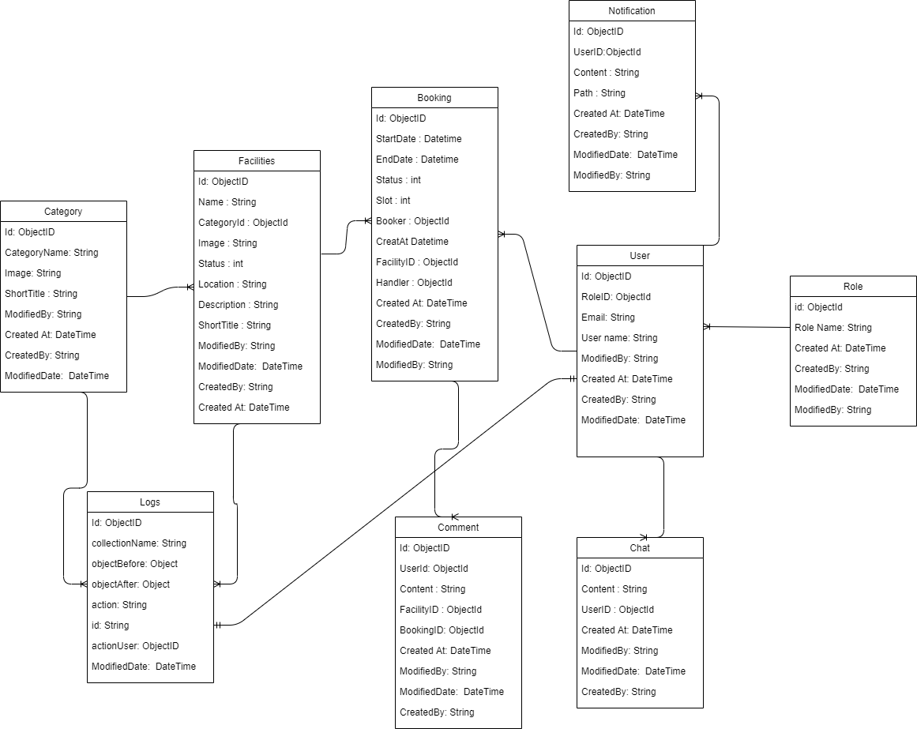

***Figure IV.5****: Database schema*

***Table Descriptions***

Table IV.6 Represents Entity entities and descriptions..

|  |  |  |
| --- | --- | --- |
| **No** | **Table** | **Description** |
| 1 | Role | User with different role has different jurisdiction |
| 2 | User | Store user’s detail such as role, email, name,... |
| 3 | Booking | Booking detail will be store in this entity |
| 4 | Facilities | Store facility detail and its status |
| 5 | Category | Is used to classify facilities |
| 6 | Notification | Contain notification detail |
| 7 | Chat | Is used for conversation between student/teacher with admin/staff |
| 8 | Comment | Store user’s comment for their evaluation |
| 9 | Logs | Store history change of categories and facilities |

***Table IV.6****: Describe entity database*

## **3. Detailed Design**

Figure IV.7 Notation for UML diagram

**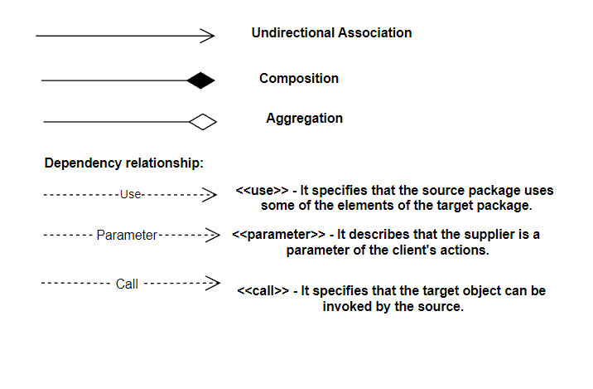*Figure IV.7****: Notation UML diagram*

### **3.1 Login**

3.1.1 Class Diagram

Figure IV.8: Shows the Login class diagram

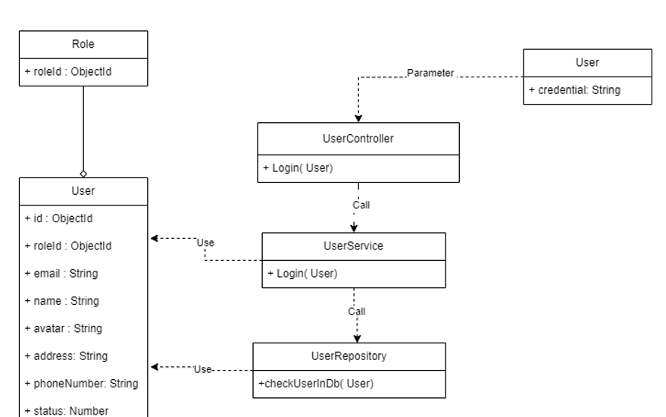

***Figure IV.8****:Login Class Diagram*

3.1.2. Sequence Diagram

Figure IV.9: Shows the sequence diagram

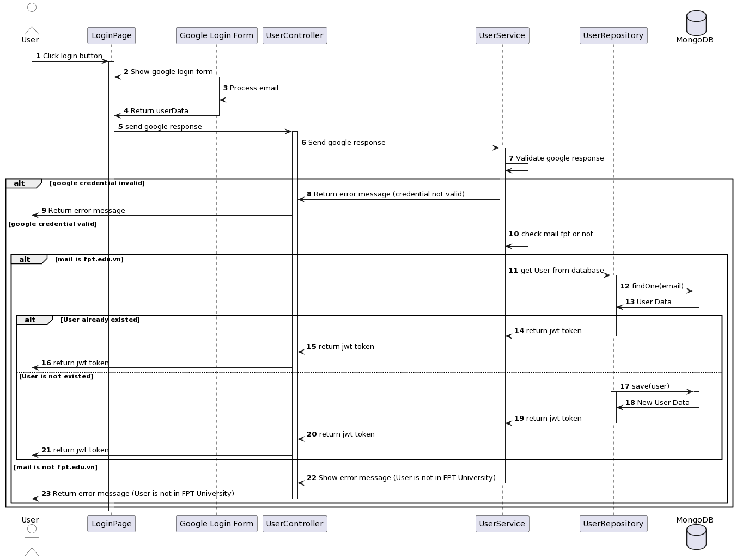

***Figure IV.9****:Login Sequence Diagram*

### **3.2 Manage User**

#### ***3.2.1 View User***

3.2.1.1 *Class Diagram*

Figure IV.10: Shows the view user class diagram

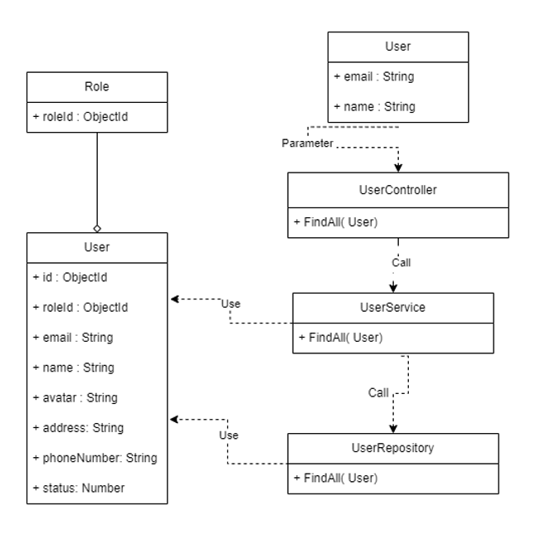

***Figure IV.10****:View User Class Diagram*

3.2.1.2 *Sequence Diagram*

Table IV.11: Shows the view user sequence diagram

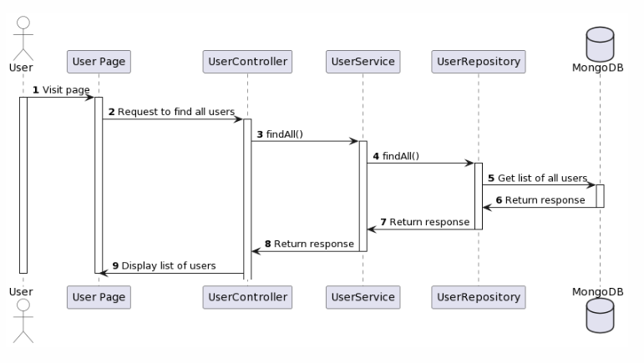

***Figure IV.11****:View User Sequence Diagram*

#### ***3.2.2 Update User***

3.2.2.1 *Class Diagram*

Figure IV.12: Shows the update user class diagram

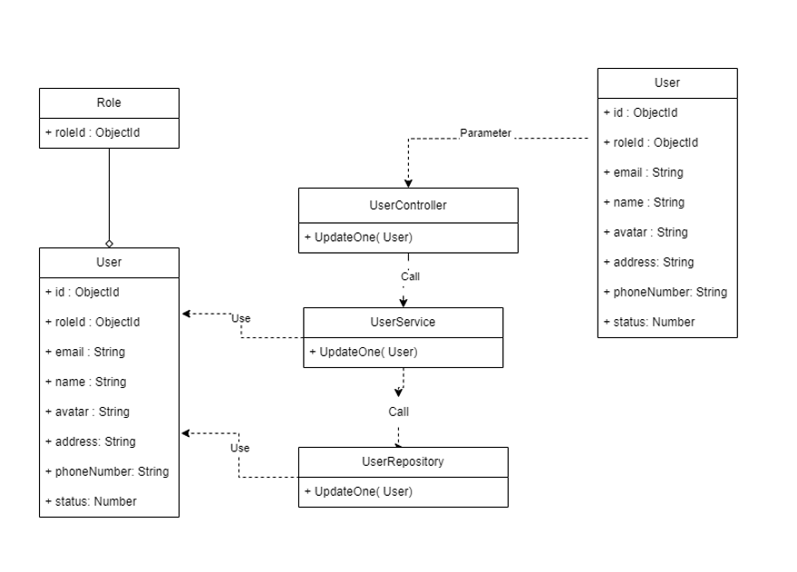

***Figure IV.12****:Update User Class Diagram*

3.2.2.2 *Sequence Diagram*

Figure IV.13: Shows the update user sequence diagram

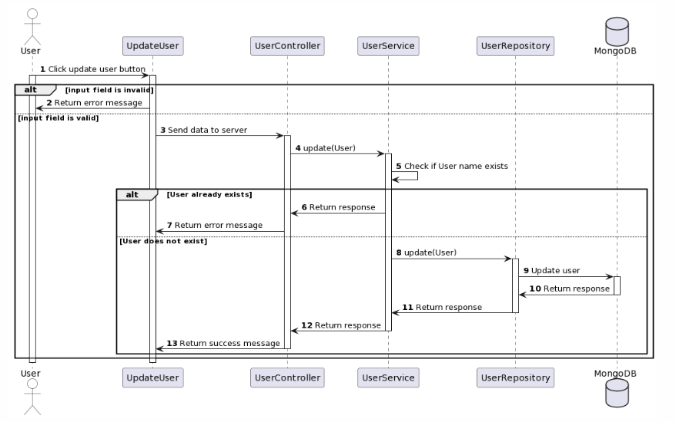

***Figure IV.13****:Update User Sequence Diagram*

#### ***3.2.3 View user profile***

3.2.3.1 *Class Diagram*

Figure IV.14: Shows the view user profile class diagram

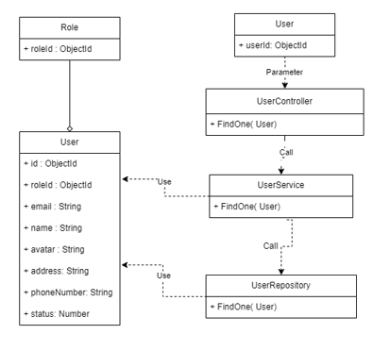

***Figure IV.14****:View User Profile Class Diagram*

3.2.3.2 *Sequence Diagram*

Figure IV.15: Shows the view user profile sequence diagram

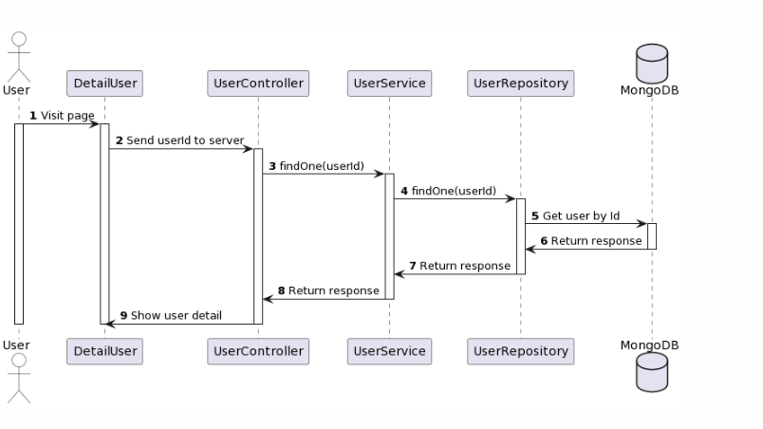

***Figure IV.15****:View User Profile Sequence Diagram*

#### ***3.2.4 Search Account***

3.2.4.1 *Class Diagram*

Figure IV.16: Shows the search account class diagram

##### 

***Figure IV.16****:Search Account Class Diagram*

3.2.4.2 *Sequence Diagram*

Figure IV.17: Shows the search account sequence diagram

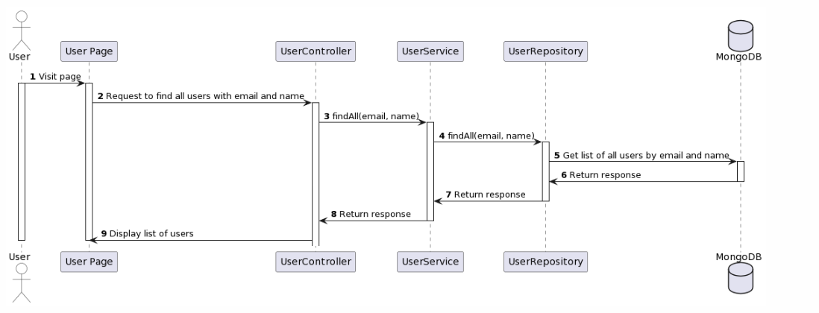

***Figure IV.17****:Search Account Sequence Diagram*

### **3.2 Manage Booking**

#### ***3.2.1 View Booking***

3.2.1.1 *Class Diagram*

Figure IV.18: Shows the view booking class diagram

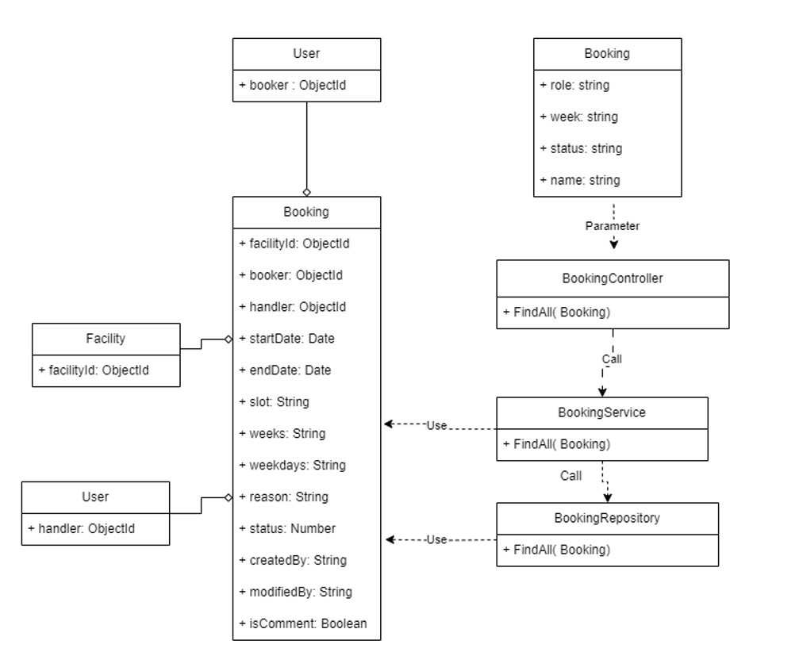

***Figure IV.18****:View Booking Class Diagram*

3.3.1.2 *Sequence Diagram*

Figure IV.19: Shows the view booking sequence diagram

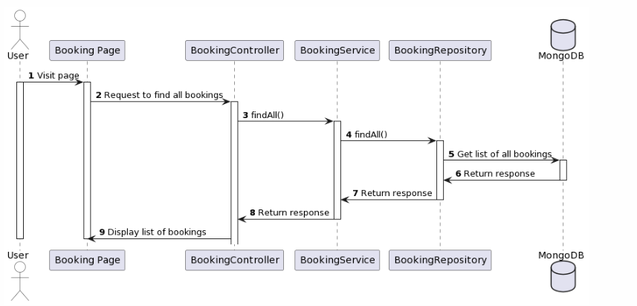

***Figure IV.19****:View Booking Sequence Diagram*

#### ***3.2.2 Find booking by user and facility***

3.2.2.1 *Class Diagram*

Figure IV.20: Shows the find booking by user and facility class diagram

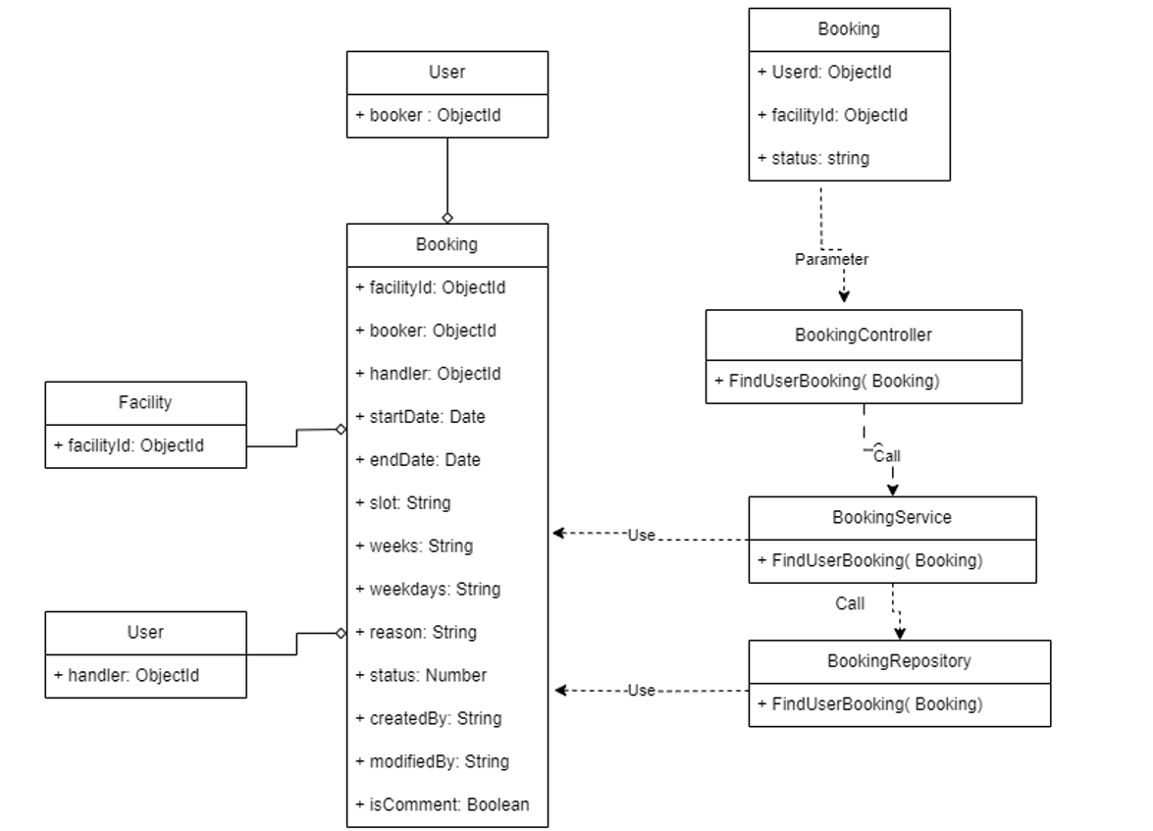

***Figure IV.20****:Find booking by user and facility Class Diagram*

3.3.2.3 *Sequence Diagram*

Figure IV.21: Shows the find booking by user facility sequence diagram

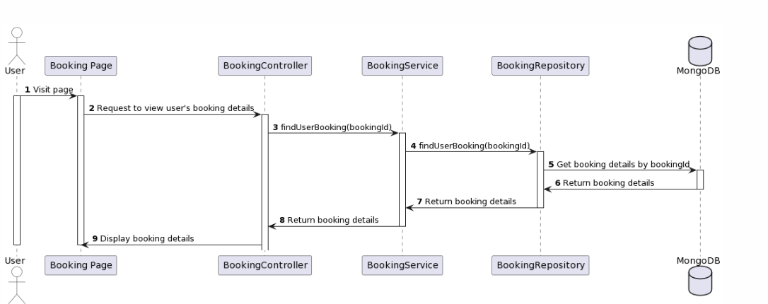

***Figure IV.21****:Find booking by user and facility Sequence Diagram*

#### ***3.2.3 Update Booking***

3.2.3.1 *Class Diagram*

Figure IV.22: Shows the update booking class diagram

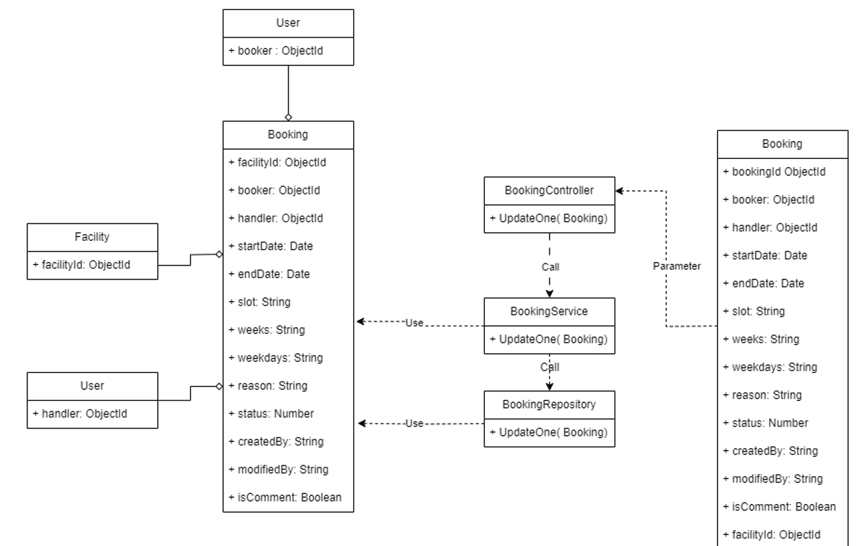

***Figure IV.22****:Update Booking Class Diagram*

3.2.3.2 *Sequence Diagram*

Figure IV.23: Shows the update booking sequence diagram

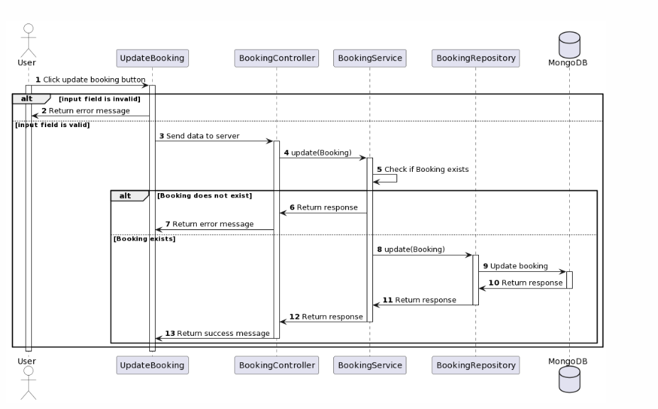

***Figure IV.23****:Update Booking Sequence Diagram*

#### ***3.2.4 Create Booking***

3.2.4.1 *Class Diagram*

Figure IV.24: Shows the create booking class diagram

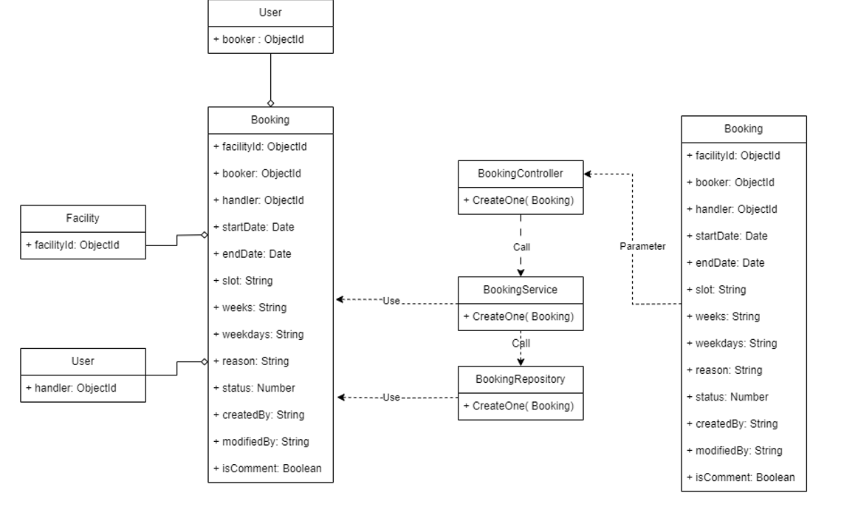

***Figure IV.24****:Create Booking Class Diagram*

##### 

##### 

##### 

##### 

##### 

##### 

##### 

##### 

##### 

##### 

##### 

##### 

##### 

##### 

3.2.4.2 *Sequence Diagram*

Figure IV.25: Shows the create booking sequence diagram

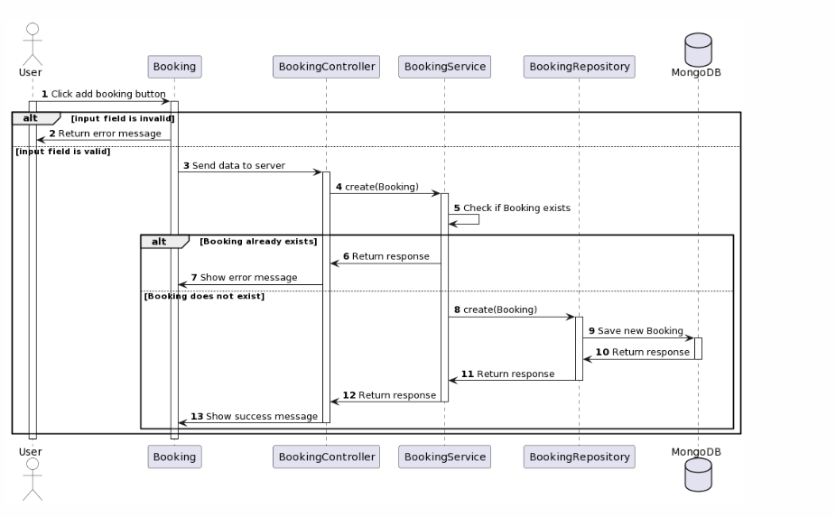

***Figure IV.25****:Create Booking Sequence Diagram*

#### ***3.2.5 Status Booking***

3.2.5.1 *Class Diagram*

Figure IV.26: Shows the status booking class diagram

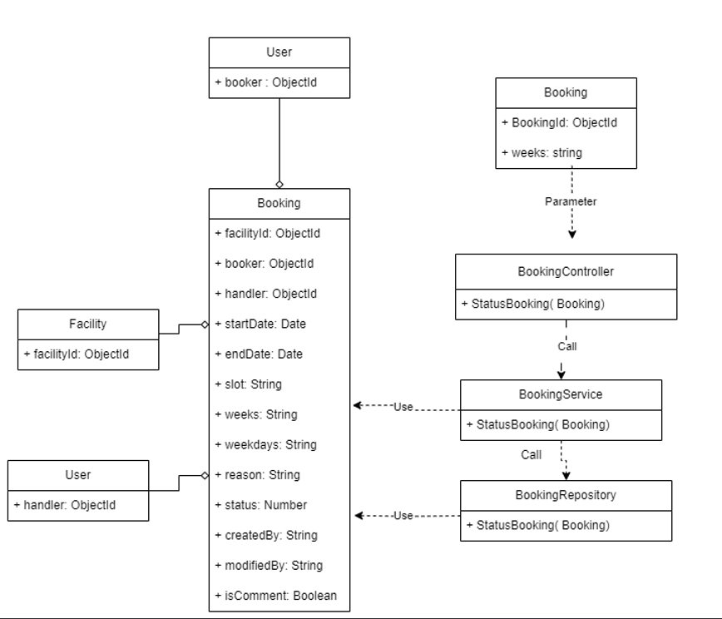

***Figure IV.26****:Status Booking Class Diagram*

3.2.5.2 *Sequence Diagram*

Figure IV.27: Shows the status booking sequence diagram

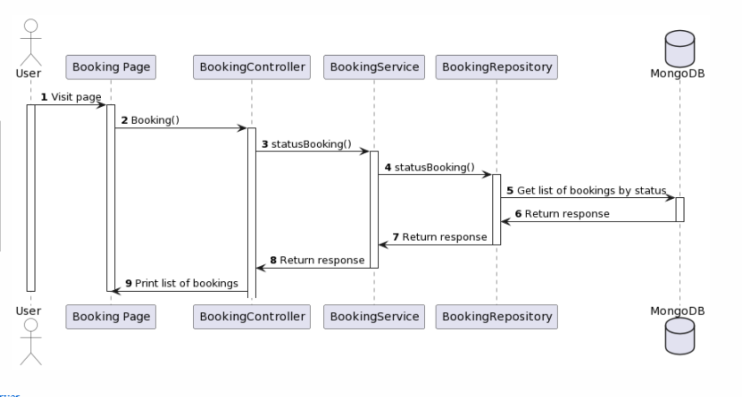

***Figure IV.27****:Status Booking Sequence Diagram*

#### ***3.2.6 Dashboard by year***

3.2.6.1 *Class Diagram*

Figure IV.28: Shows the dashboard by year class diagram

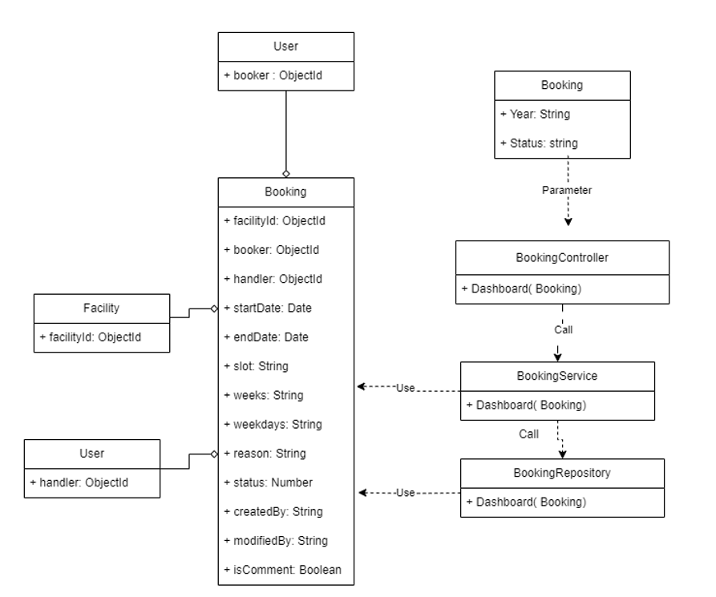

***Figure IV.28****:Dashboard by year Class Diagram*

3.2.6.2 Sequence Diagram

Figure IV.29: Shows the dashboard by year sequence diagram

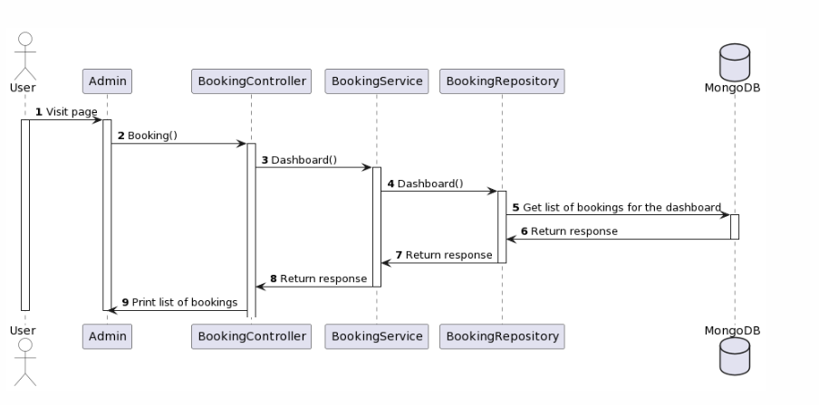

***Figure IV.29****:Dashboard by year Sequence Diagram*

#### ***3.2.7 Dashboard by week***

3.2.7.1 Class Diagram

Figure IV.30: Shows dashboard by week class diagram

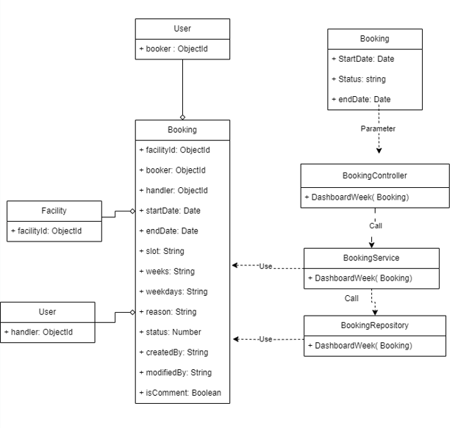

***Figure IV.30****:Dashboard by week Class Diagram*

3.2.7.2 Sequence Diagram

Figure IV.31: Shows the dashboard by week sequence diagram

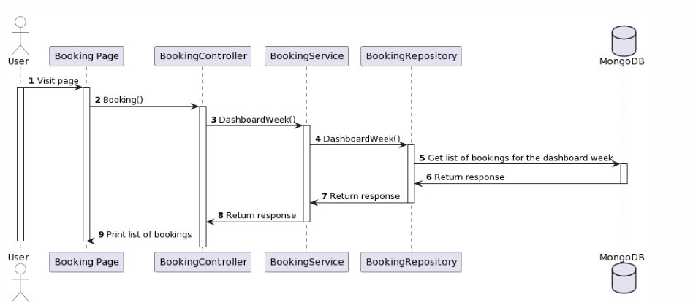

***Figure IV.31*** *Dashboard by week Sequence Diagram*

### **3.3 Manage Facility**

#### ***3.3.1 View Facility***

3.3.1.1 *Class Diagram*

Figure IV.32: Shows the view facility class diagram

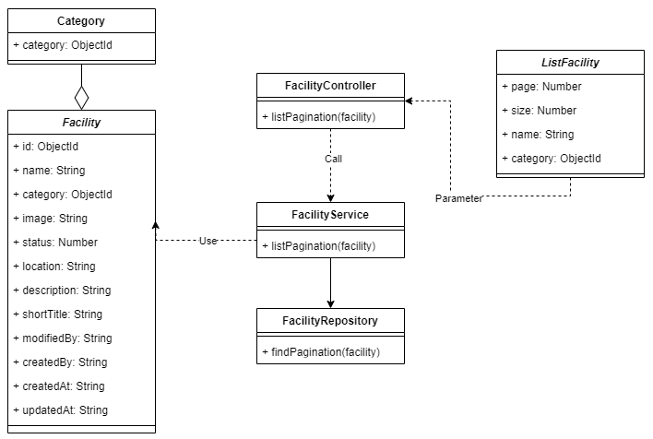

***Figure IV.32****:View Facility Class Diagram*

3.3.1.2 *Sequence Diagram*

Figure IV.33: Shows the view facility sequence diagram

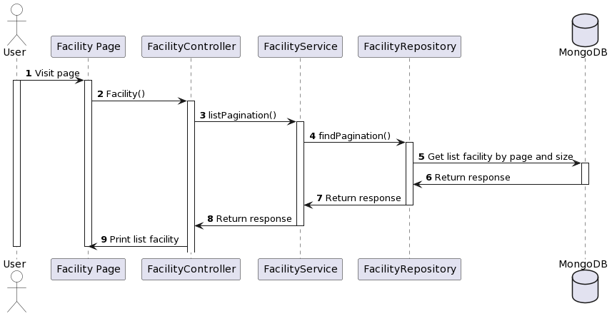

***Figure IV.33****:View Facility Sequence Diagram*

#### ***3.3.2 Create Facility***

3.3.2.1 *Class Diagram*

Figure IV.34:: Shows the create facility class diagram

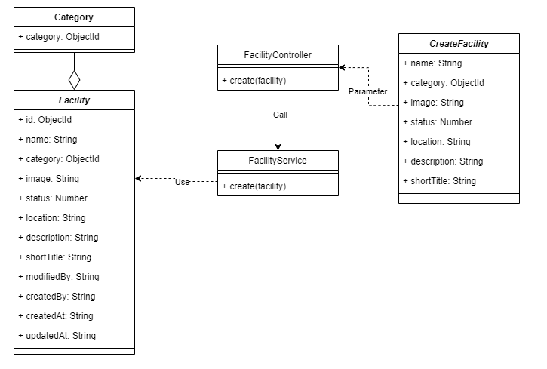

***Figure IV.34****:Create Facility Class Diagram*

3.3.2.2 *Sequence Diagram*

Figure IV.35: Shows the create facility sequence diagram

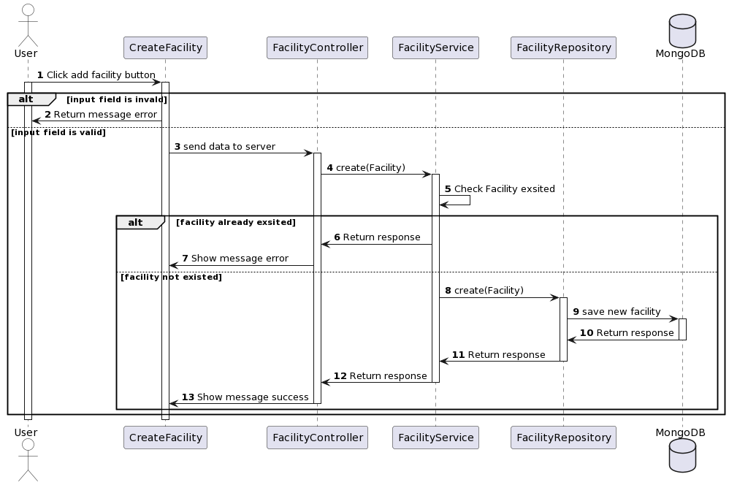

***Figure IV.35****:Create Facility Sequence Diagram*

#### ***3.3.3 Update Facility***

3.3.3.1 *Class Diagram*

Figure IV.36: Shows the update facility class diagram

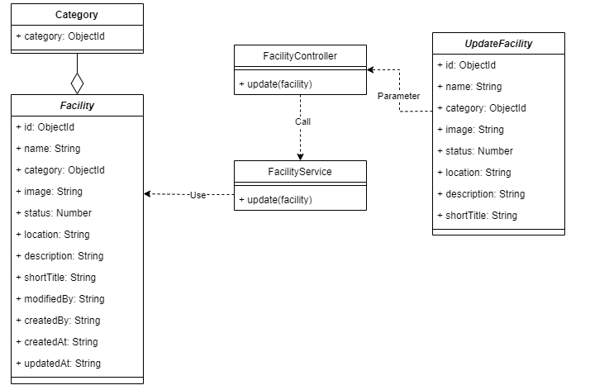

***Figure IV.36****:Update Facility Class Diagram*

3.3.3.2 *Sequence Diagram*

Figure IV.37: Shows the update facility sequence diagram

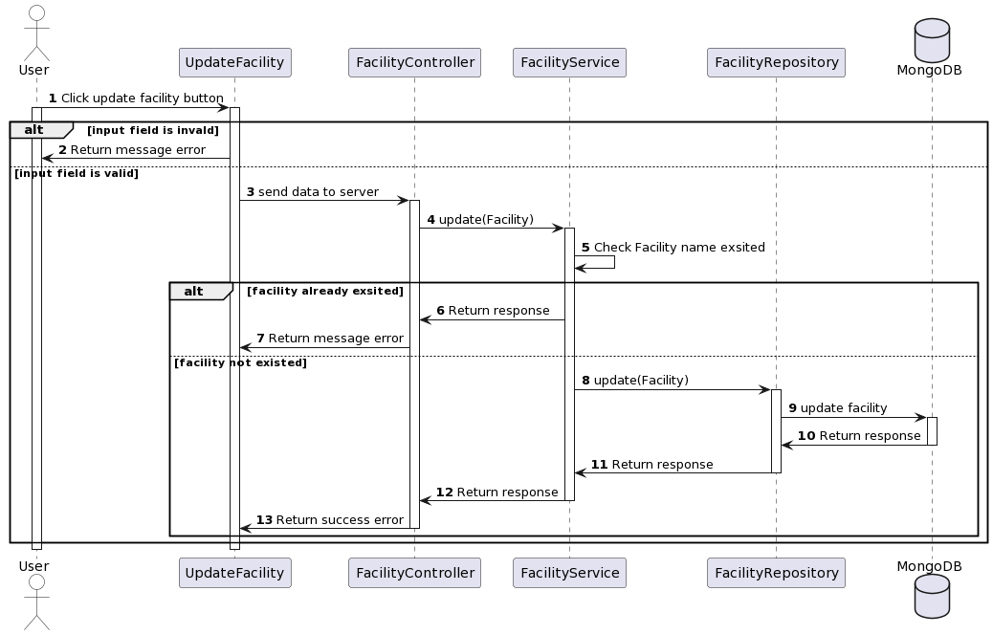

***Figure IV.37****:Update Facility Sequence Diagram*

#### ***3.3.4 Change Status Facility***

3.3.4.1 *Class Diagram*

Figure IV.38: Shows the change status facility class diagram

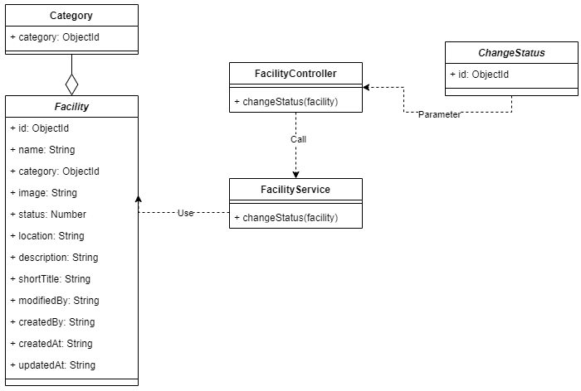

***Figure IV.38****:Change Status Facility Class Diagram*

3.3.4.2 *Sequence Diagram*

Figure IV.39: Shows the change status facility sequence diagram

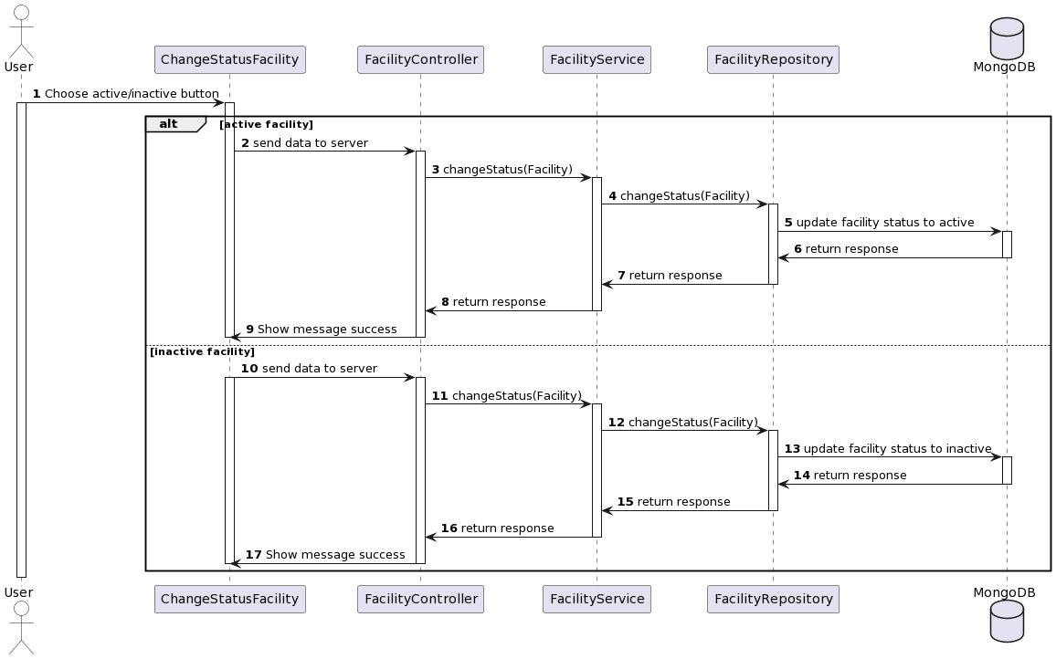

***Figure IV.39****:Change Status Facility Sequence Diagram*

#### ***3.3.5 View Detail Facility***

3.3.5.1 *Class Diagram*

Figure IV.40: Shows the view detail facility class diagram

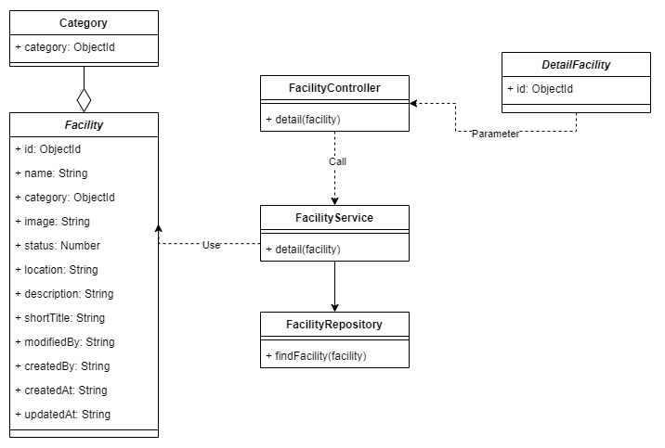

***Figure IV.40****:View Detail Facility Class Diagram*

3.3.5.2 *Sequence Diagram*

Figure IV.41: Shows the view detail facility sequence diagram

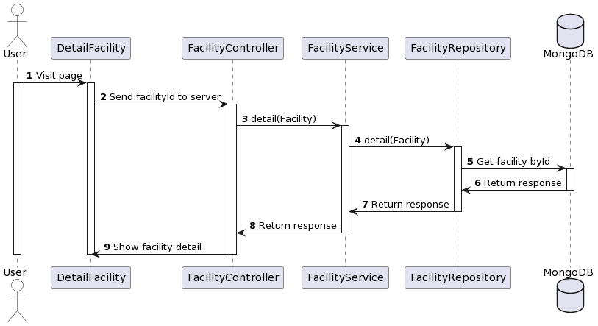

***Figure IV.41.*** *View Detail Facility Sequence Diagram*

### **3.4 Manage Category**

#### ***3.4.1 View Category***

3.4.1.1 *Class Diagram*

Figure IV.42: Shows the view category class diagram

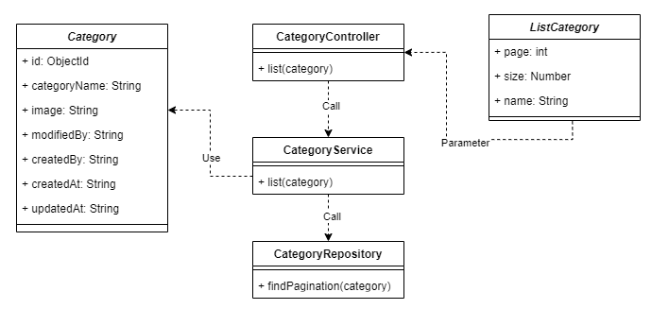

***Figure IV.42****:View Category Class Diagram*

3.4.1.2 *Sequence Diagram*

Figure IV.43: Shows the view category sequence diagram

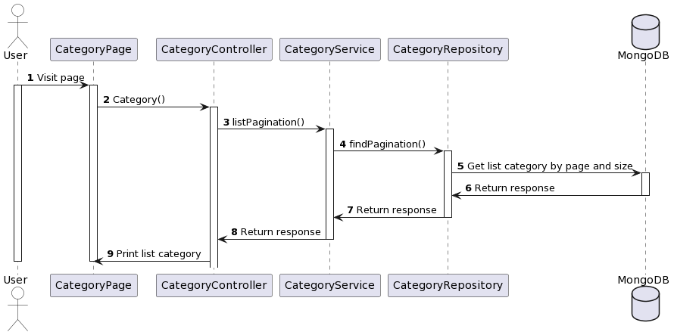

***Figure IV.43****:View Category Sequence Diagram*

#### ***3.4.2 Create Category***

3.4.2.1 *Class Diagram*

Figure IV.44: Shows the create category class diagram

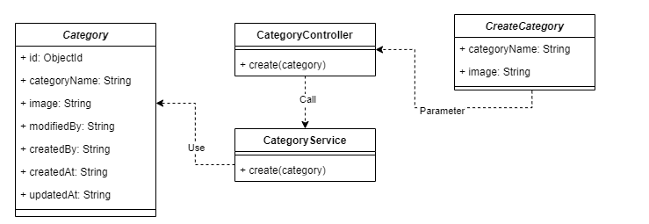

***Figure IV.44****:Create Category Class Diagram*

3.4.2.2 *Sequence Diagram*

Figure IV.45: Shows the create category sequence diagram

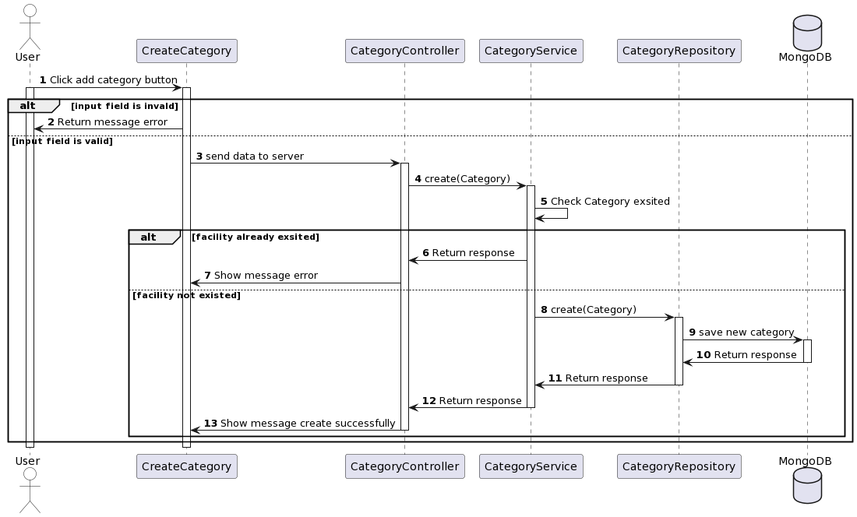

***Figure IV.45****:Create Category Sequence Diagram*

#### ***3.4.3 Update Category***

3.4.3.1 *Class Diagram*

Figure IV.46: Shows the update category class diagram

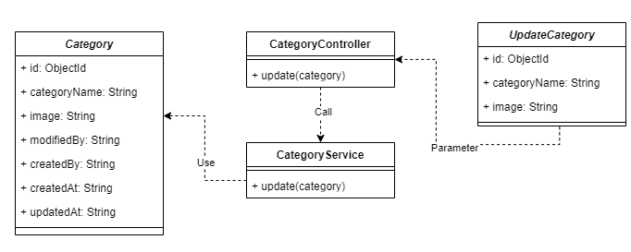

***Figure IV.46****:Update Category Class Diagram*

3.4.3.2 *Sequence Diagram*

Figure IV.47: Shows the update category sequence diagram

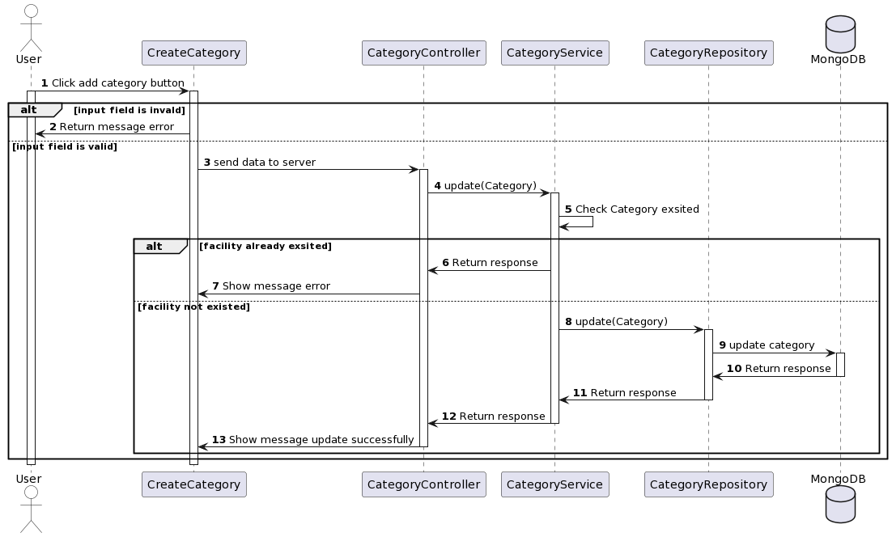

***Figure IV.47****:Update Category Sequence Diagram*

### **3.5 Manage Comments**

#### ***3.5.1 View Comment***

3.5.1.1 *Class Diagram*

Figure IV.48: Shows the view comet class diagram

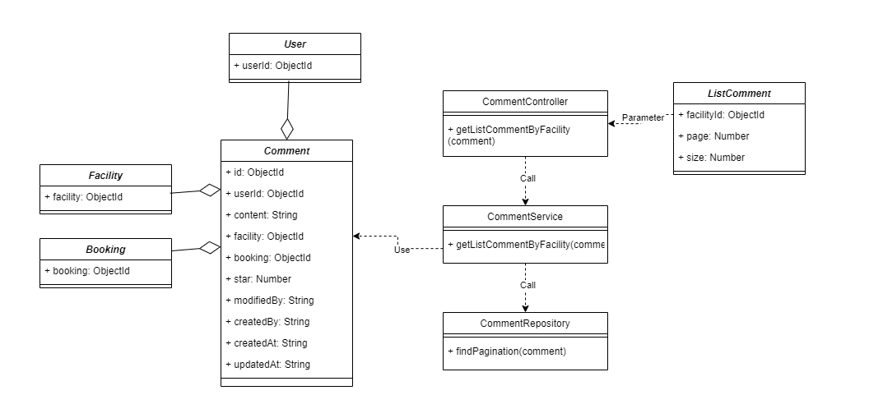

***Figure IV.48****:View Comment Class Diagram*

3.5.1.2 *Sequence Diagram*

Figure IV.49: Shows the view comment sequence diagram

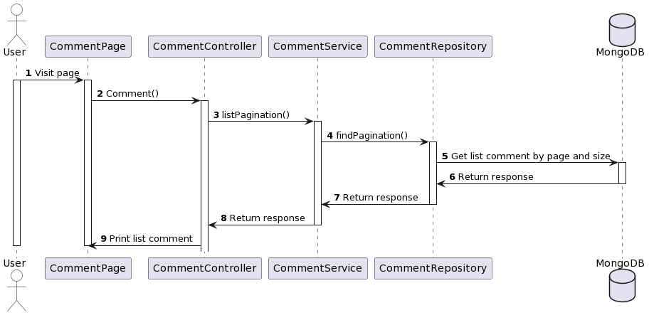

***Figure IV.49****:View Comment Sequence Diagram*

#### ***3.5.2 Create Comment***

3.5.2.1 *Class Diagram*

Figure IV.50: Shows the create comment class diagram

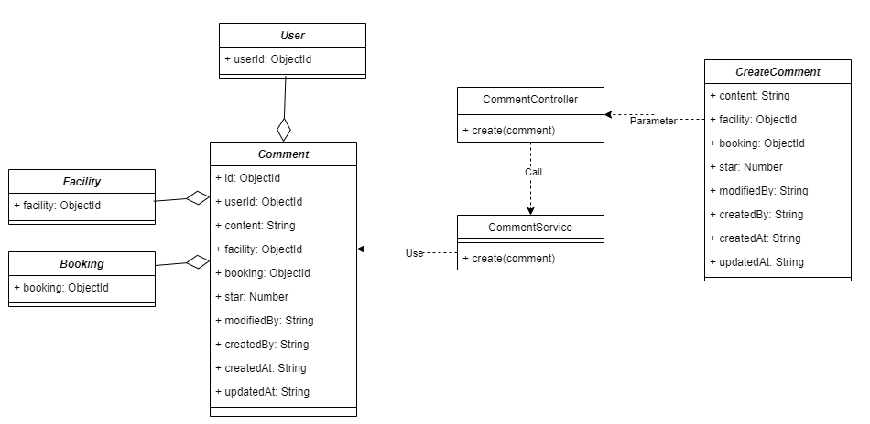

***Figure IV.50****:Create Comment Class Diagram*

3.5.2.2 *Sequence Diagram*

Figure IV.51: Shows the create comment sequence diagram

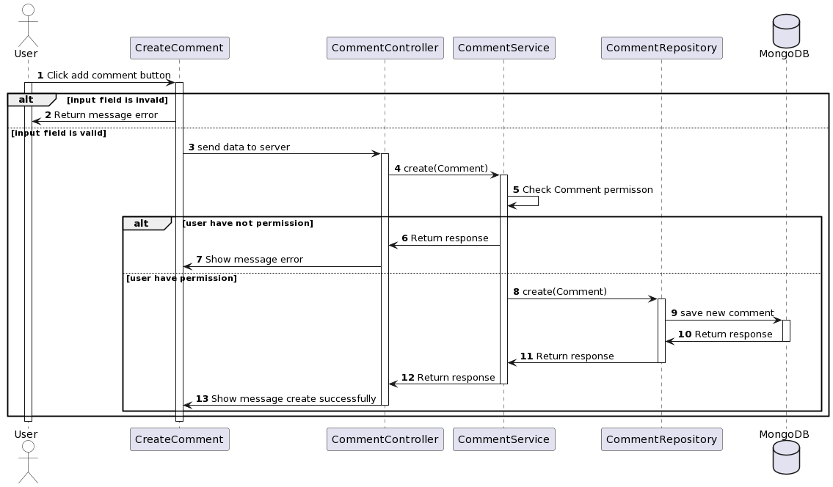

***Figure IV.51****:Create Comment Sequence Diagram*

#### ***3.5.3 Check Comment Permission***

3.5.3.1 *Class Diagram*

Figure IV.52: Shows the check comment permission class diagram

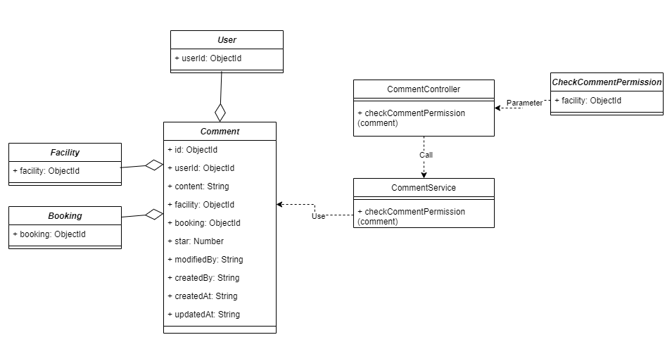

***Figure IV.52****:Check Comment Permission Class Diagram*

3.5.3.2 *Sequence Diagram*

Figure IV.53: Shows the check comment permission sequence diagram

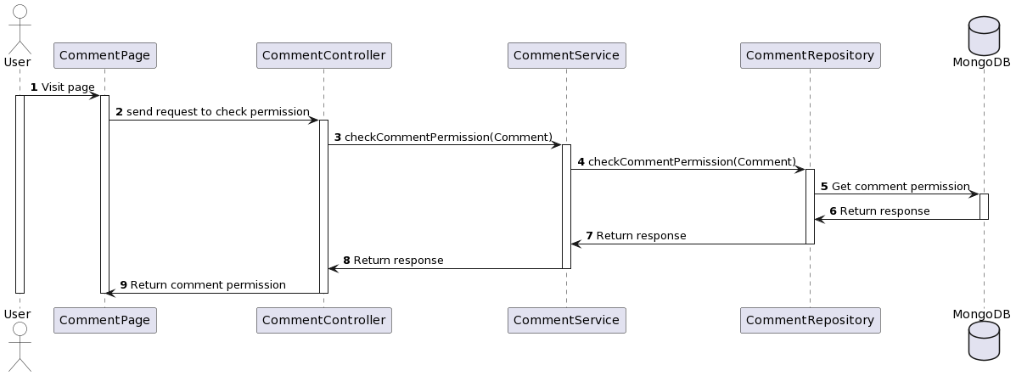

***Figure IV.53****:Check Comment Permission Sequence Diagram*

### **3.6 Manage Notification**

#### ***3.6.1 View notification***

3.6.1.1 *Class Diagram*

Figure IV.54: Shows the view notification class diagram

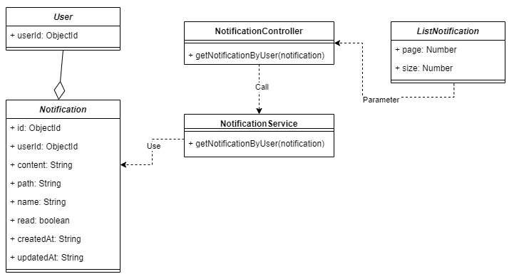

***Figure IV.54*** *View notification Class Diagram*

3.6.1.2 *Sequence Diagram*

Figure IV.55: Shows the view notification sequence diagram

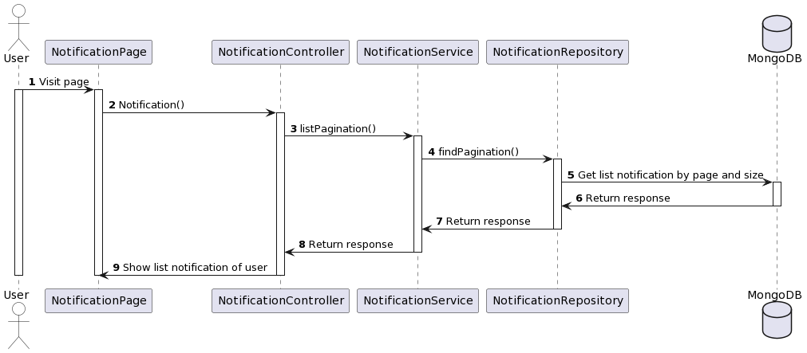

***Figure IV.55****:View notification Sequence Diagram*

#### ***3.6.2 Update Notification***

3.6.2.1 *Class Diagram*

Figure IV.56: Shows the update notification class diagram

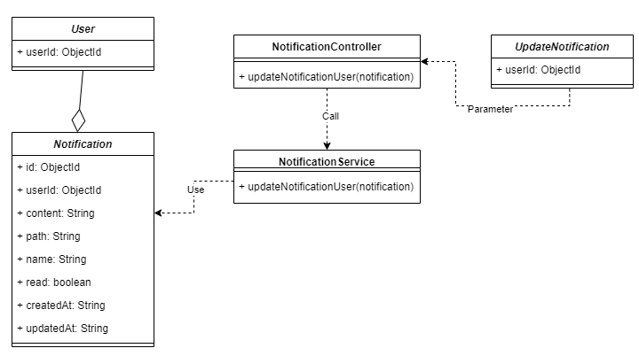

***FigureIV.56****:Update Notification Class Diagram*

3.6.2.2 *Sequence Diagram*

Figure IV.57: Shows the update notification sequence diagram

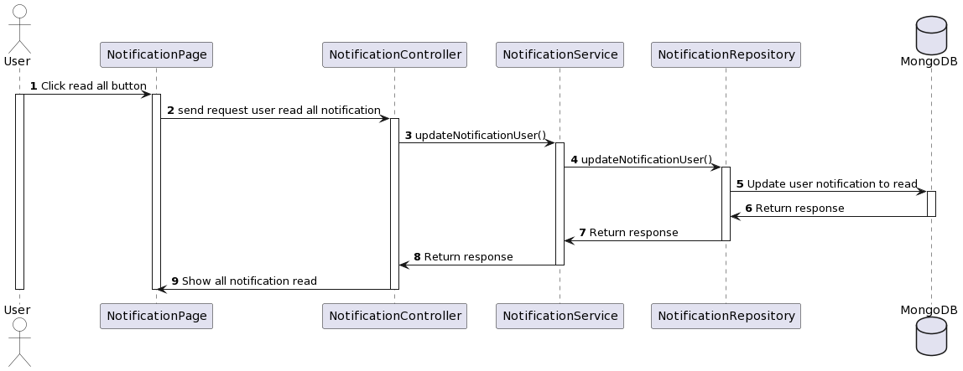

***Figure IV.56*** *Update Notification Sequence Diagram*

# **V. Software Testing Documentation**

## **1. Scope of Testing**

### 1.1. Testing Stages

Figure V.1: Description of testing stages V-model

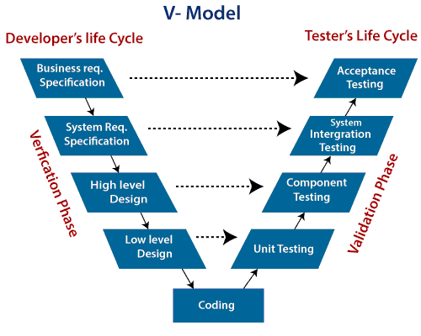

*Figure V.1: Test stages base on V-Model*

In this project, there are 4 phases in the testing process: Unit testing, Integration testing, System testing and Acceptance testing.

Figure V.2: Description of testing stages

|  |  |  |
| --- | --- | --- |
| No. | Test Stages | Description |
| 1 | Unit Testing | Unit testing, a testing technique using which individual modules are tested to determine if there are any issues by the developer himself. It is concerned with functional correctness of the standalone modules. |
| 2 | Integration Testing | Integration testing is done to test the modules/ components when integrated to verify that they work as expected to test the modules which are working fine individually does not have issues when integrated. |
| 3 | System Testing | System testing means testing the system as a whole. All the modules/ components are integrated in order to verify if the system works as expected or not. |
| 4 | Acceptance Testing | Acceptance testing is a type of testing where client/ business/ customer test the software with real time business scenarios. This is the last phase of testing, after which the software goes into production. |

*Table V.2: Description of test stages*

### 1.2. Range of Testing

All functions defined in the System Requirement Specification will be performed with the last version.

## **2. Test Strategy**

### **2.1 Testing Types**

The test team has to test the following type on Google Chrome browser:

* GUI Testing
* Functional Testing
* Regression Testing

Figure V.3: Description of testing types

|  |  |  |
| --- | --- | --- |
| No. | Test Stages | Description |
| 1 | GUI Testing | GUI Testing is a software testing type that checks the Graphical User Interface of the software. The purpose is to ensure the functionalities of software application work as per specifications by checking screens and controls like menus, buttons, icons, etc. |
| 2 | Functional  Testing | Functional testing is a kind of black-box testing that is performed to confirm that the functionality of an application or system is behaving as expected. |
| 3 | Regression Testing | Regressing testing is a type of testing that is done to verify that a code change in the software does not impact the existing functionality of the product. This is to ensure that the product works fine with new functionality, bug fixes or any changes to the existing feature. |

*Table V.3: Description of testing types*

### **2.2 Test Levels**

Figure V.4: Description of testing levels

| **Type of Tests** | **Test Level** | | | |
| --- | --- | --- | --- | --- |
| **Unit** | **Integration** | **System** | **Acceptance** |
| GUI Testing |  | X | X | X |
| Functional Testing | X |  |  | X |

### *Table V.4: Description of testing levels*

### **2.3 Supporting Tools**

* Microsoft Excel: manages test cases and data index



*Figure V.4: Microsoft Excel Office*

* Microsoft Excel Online: manage bugs and status of fixed



*Figure V.5: Microsoft Excel Online*

* Jira: manage time to keep test plan



*Figure V.6: Jira*

* Google Chrome Browser: the interface to test



*Figure V.7: Google Chrome Browser*

## **3. Test Plan**

### **3.1 Human Resources**

Figure V.8: Description of human resources

|  |  |  |
| --- | --- | --- |
| **Worker/Doer** | **Role** | **Specific Responsibilities/Comments** |
| ManhPD | Team member | * Create test cases and perform unit tests. * Fix bugs back-end |
| KietHT | Team member | * Create a test plan. * Create test cases and perform integration tests. * Create test cases and perform system tests. * Create test cases, checklists and perform acceptance tests. * Summaries test reports. |
| ToanDT | Team member | * Fix bugs front-end |

*Table V.8: Description of human resource*

### **3.2 Test Environment**

Figure V.9: Description of testing environment

|  |  |  |  |
| --- | --- | --- | --- |
| **Purpose** | **Tool** | **Provider** | **Version** |
| Unit Testing | Visual Studio Code 2022 | Microsoft Corporation | 17.3.4 |
| Integration Testing | Chrome | Google | 115.0.5790.171(Official Build) (64-bit) |
| System Testing | Chrome | Google | 115.0.5790.171(Official Build) (64-bit) |
| Acceptance Testing | Chrome | Google | 115.0.5790.171(Official Build) (64-bit) |

*Table V.9: Description of testing environments*

# 

# **VI. Release Package & User Guides**

## **1. Deliverable Package**

Figure VI.1: Description of deliverables

| **No.** | **Deliverable Item** | **Description** |
| --- | --- | --- |
| 1 | Source Codes | Facility-Management-System.zip |
| 2 | Database Script(s) | Data.zip |
| 3 | SRS | Software Requirement Specification.docx |
| 4 | SDS | Software Design Document.docx |
| 5 | Final Report | Final Project Report.docx |
| 6 | Unit Test | G3_Unit_Test Case.xlsx |

*Table VI.1: Deliverable package*

## **2. Installation Guides**

### **2.1 System Requirements**

Below are system requirements necessary to support the web application and help us to deploy the code easily:

* CPU: 2.5GHZ
* RAM: 8GB
* Minimum disk space: 10GB
* Network: Internet connection

### **2.2 Hosting requirement**

1. Extract Facility-Management-System.zip
2. Open folder Client and Server in VS Code
3. Open terminal and run “npm i” for both folder
4. Extract Data.zip
5. Open MongoDB and import json file into Collection
6. Ìn folder Server, run “npm start”
7. Ìn folder Client. run “npm run dev”
8. Open your browse with link “http://localhost:3000/”

## **3. User Manual**

### **3.1 Overview**

* The Facilities Management System was born based on the need of facilities management in FPT Education. FPT Education is very large with 10 campuses and nearly 150,000 students. Facilities in FPT are used and booked everyday which is really hard to manage and follow by using paper. With high demands to manage facilities more effectively, the campuses within the FPT education system require an efficient management system to support their daily operations.

### **3.2 Role User**

* Access the home page.
* Users can login by clicking on **“Đăng nhập”** at the header.

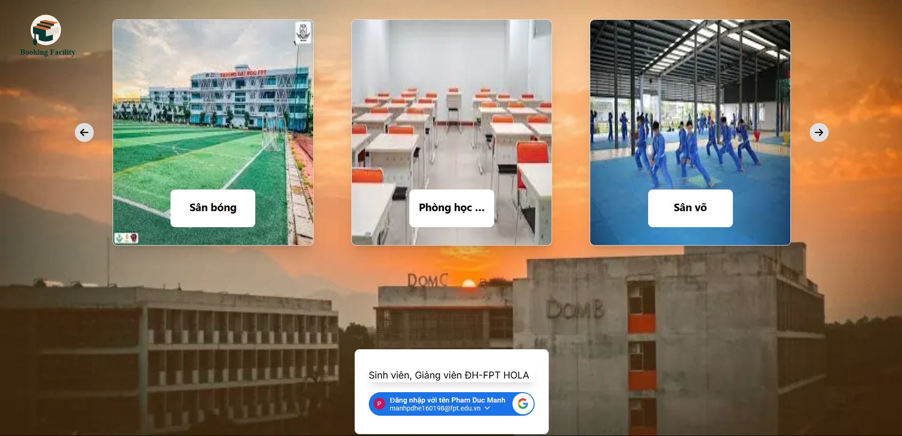

* Users can login to the system by clicking on **“Đăng nhập”**, users will go to the login page and login to the system by google account with FPT email.

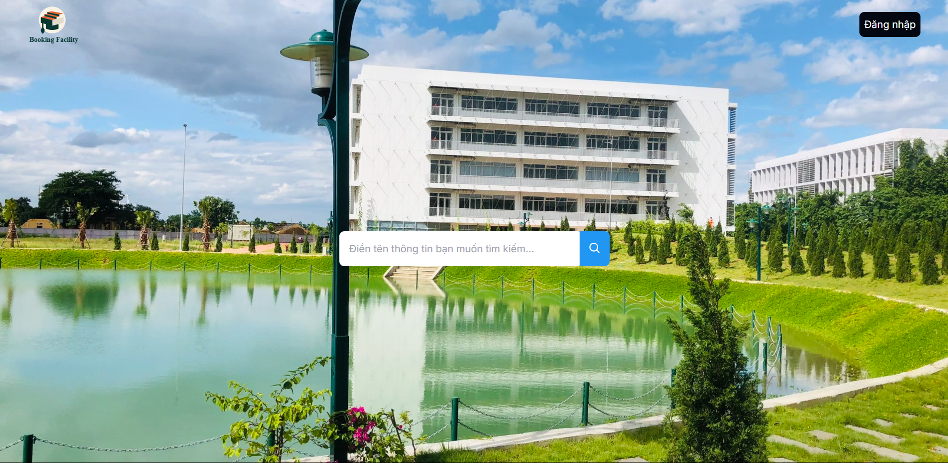

* After login, user will be navigated to homepage
* In the home page, users will see the list of categories, top 8 of facilities

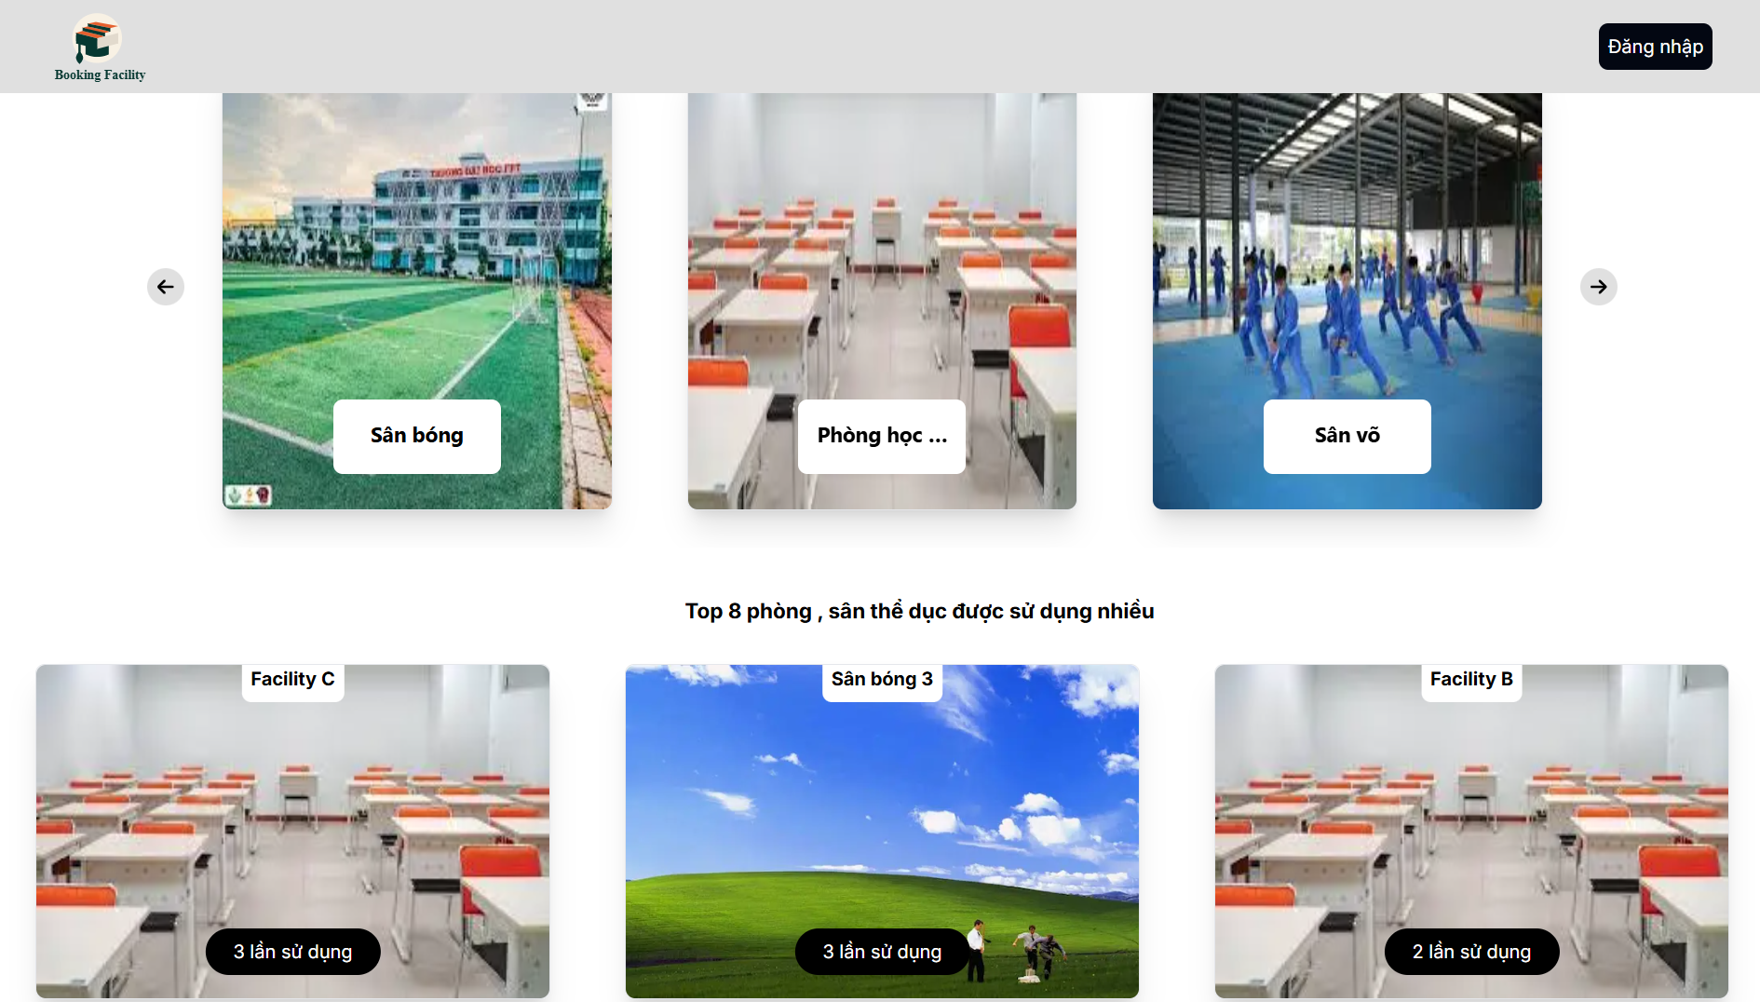

* When click in a category, it will facilities list of the category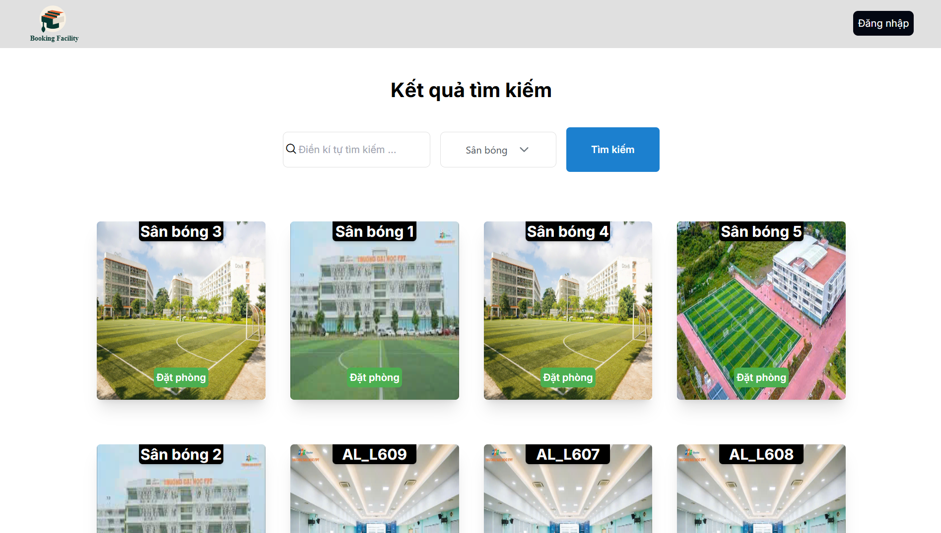
* When you click on a specific facilities, you will be navigated to the facilities detail page

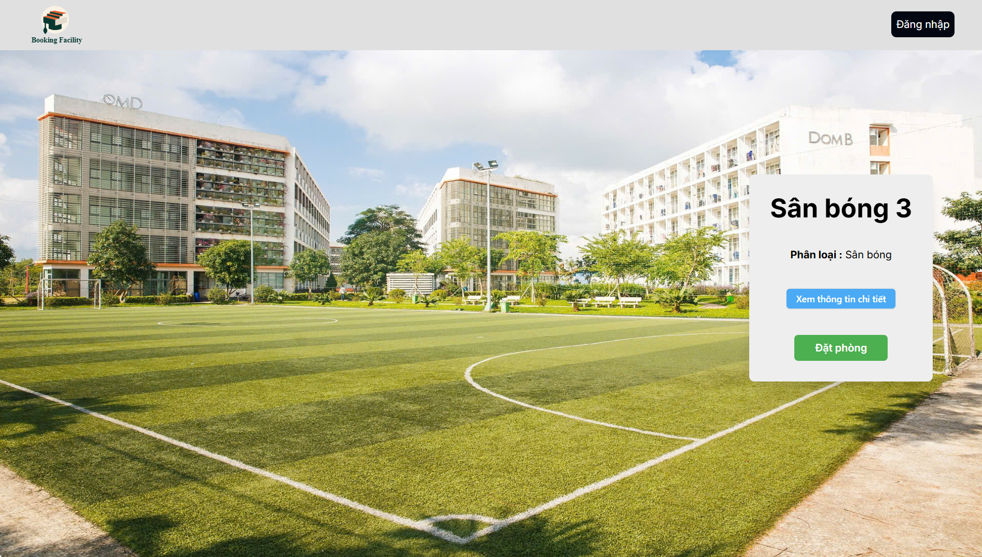

* Click in “Đặt phòng” to create a booking request for a facilities. After click in “Đặt phòng”, a schedule will be displayed with different status and notation for each status. Then click “Đặt” to create booking request for specific slot of facility (notice that you can book the slot before current time at least 2 hours and you can not booking slot in the pass)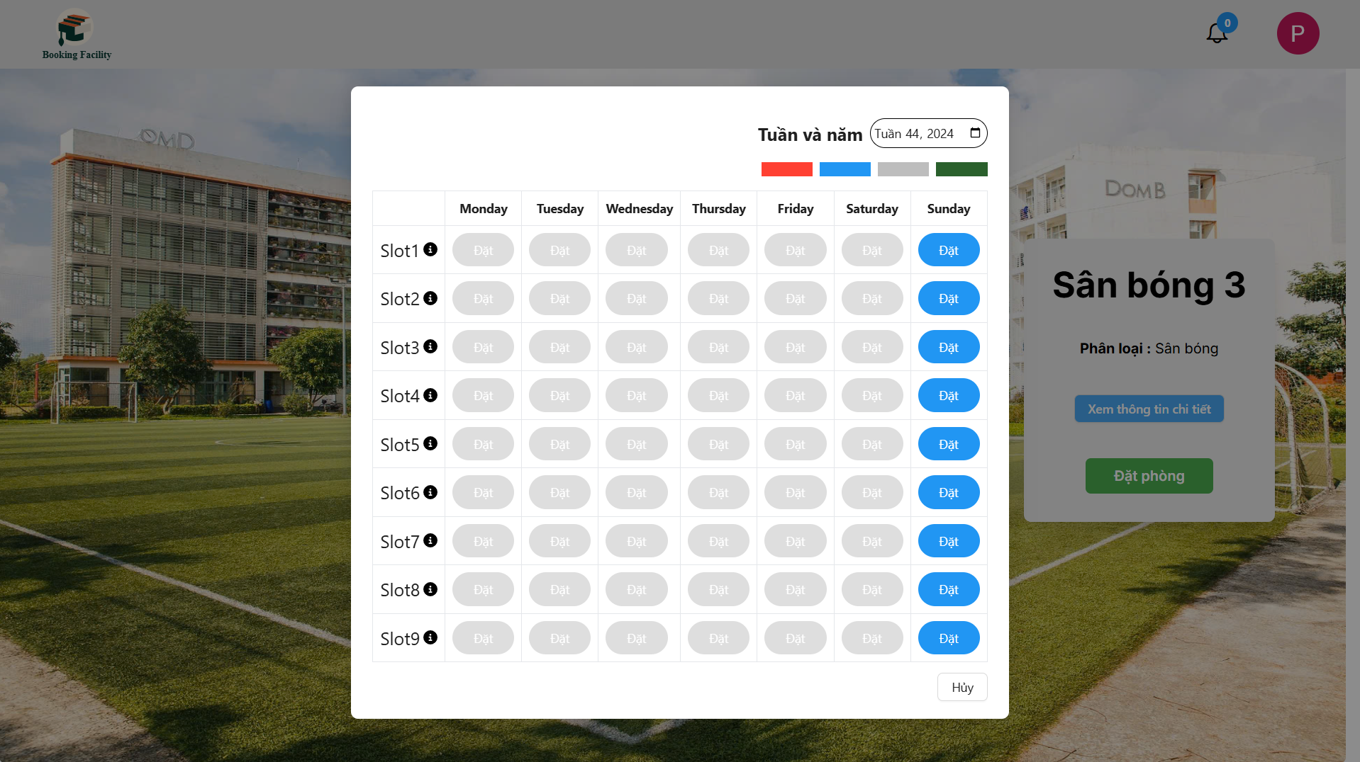
* Click the avatar in the header, you can see a drop-down list. Select “Lịch sử đặt phòng” to view all of booking request and their status. You can search facilities by name in here

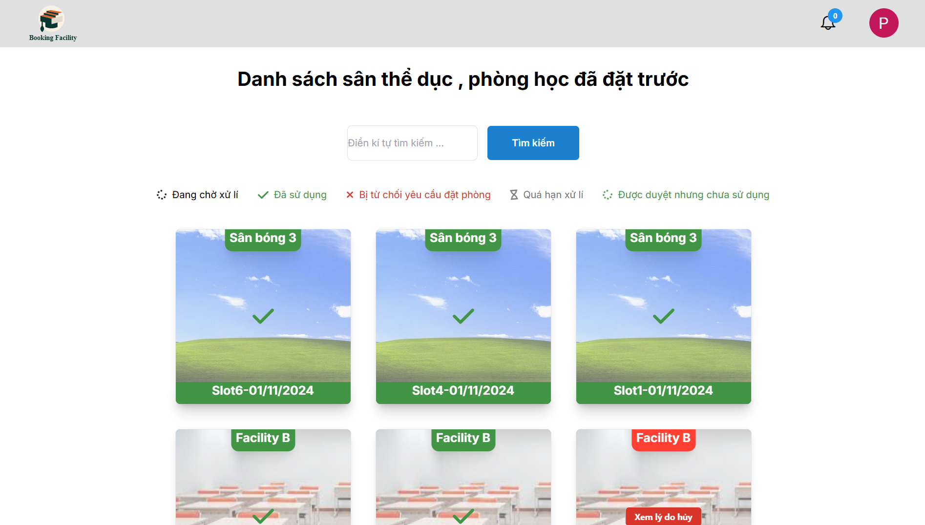

* You can see notification about your booking request when you click in bell icon in the header

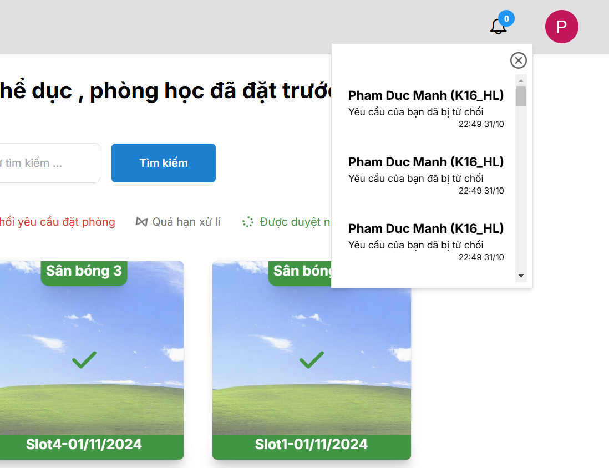

* In homepage, you can click the icon to open chat box and send your message to admin

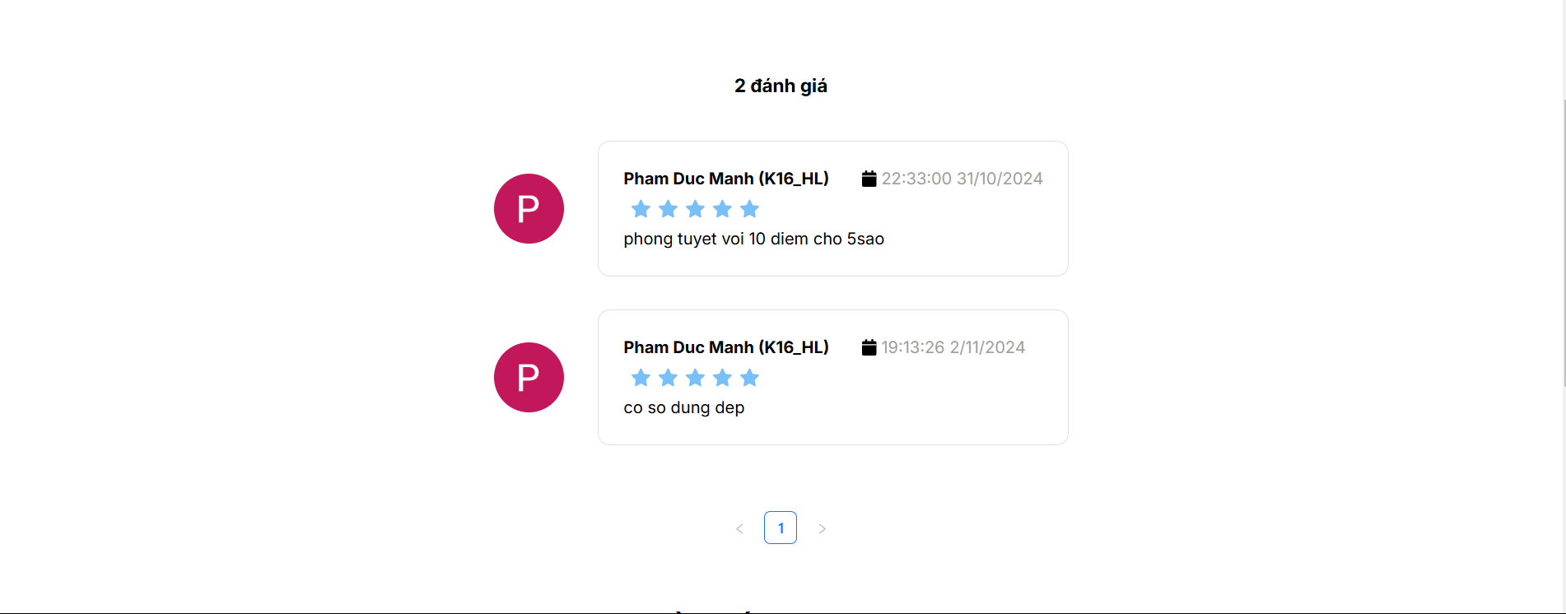

* After you use a facility, you can evaluate for that facility by voting and comment in facility detail page

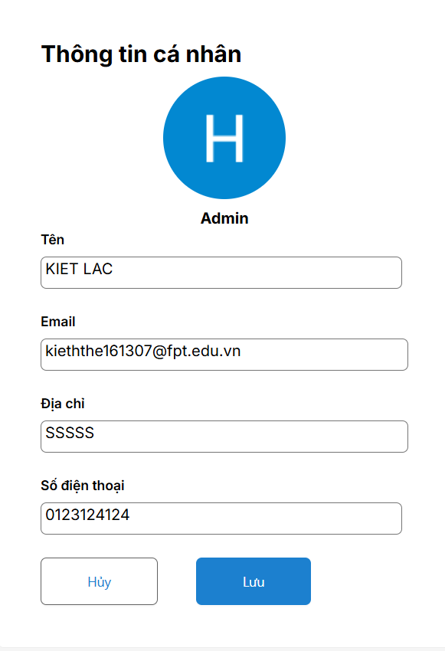

* Click the avatar in the header and choose “Hồ sơ của tôi” to open your Profile and update if you want. You can choose “Đăng xuất” also to log out

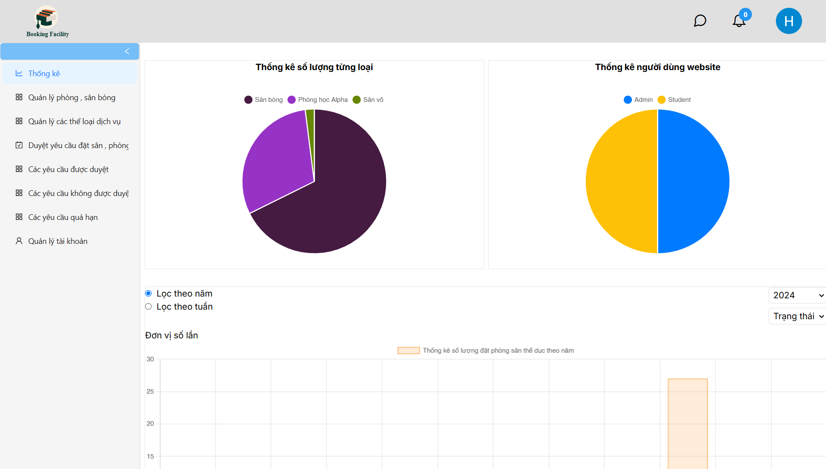

### **3.3 Admin Role**

* Users login to the system with an account with the role **“Admin”**. Users can see the Dashboard for **“Admin”**.

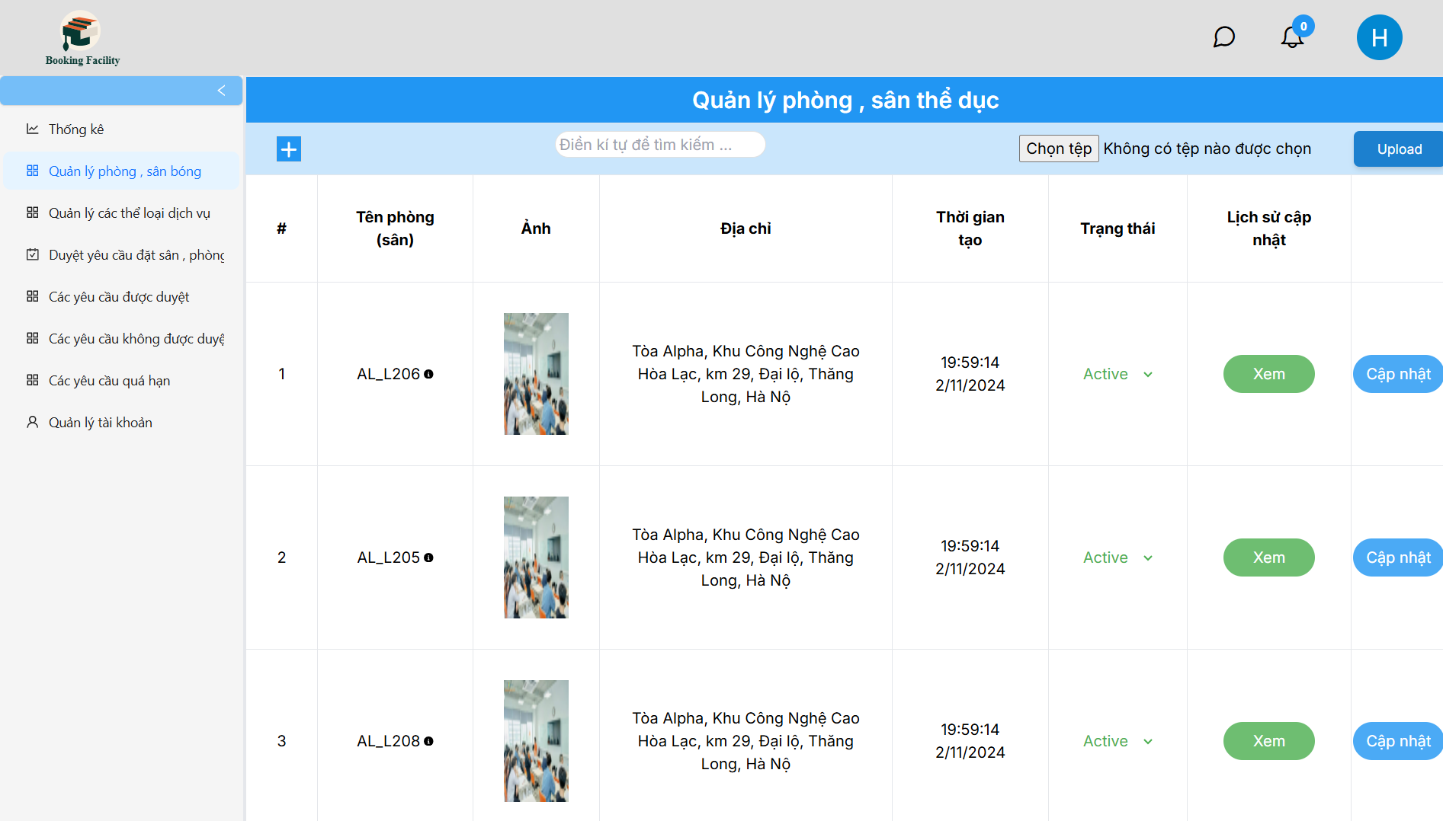

* Click “Quản lý phòng, sân bóng” to view facilities list

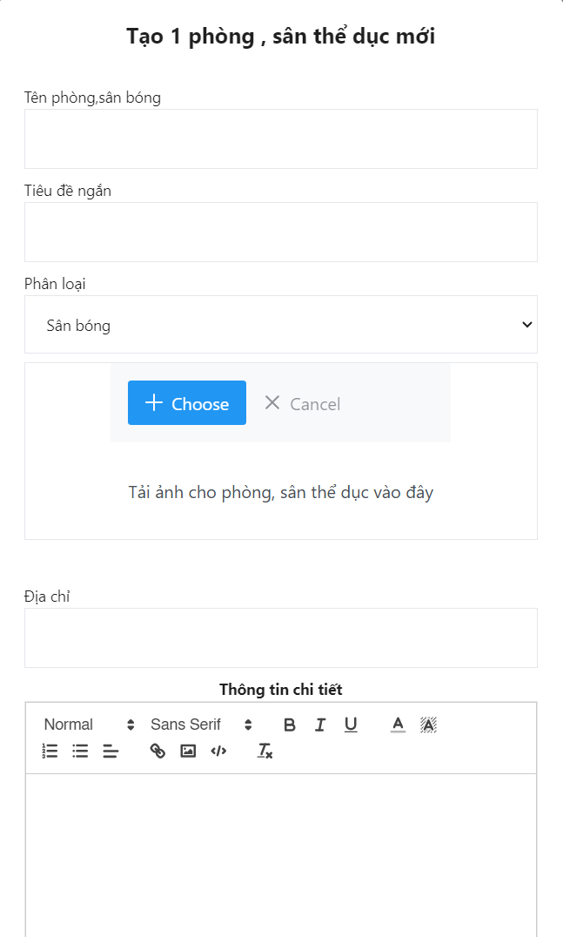

* From facilities list page:

+, Click in + button to create a new facilities

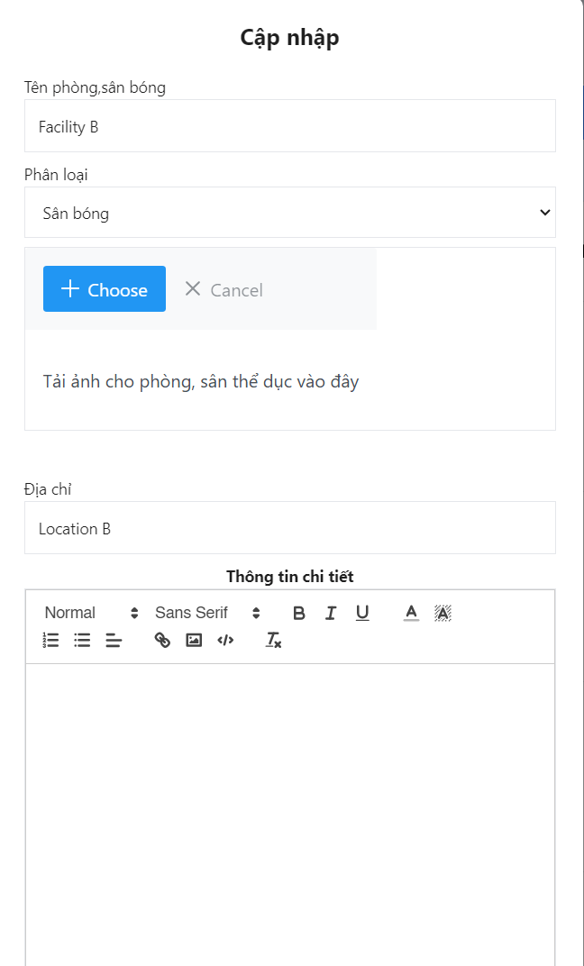

+, Click in “Cập nhật” to update facility

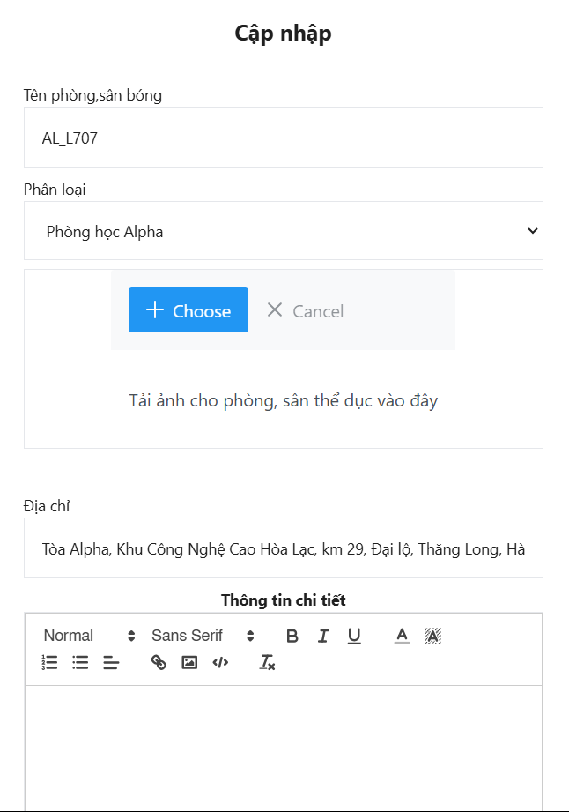

+,Click in “Xem” to view record of change of facility

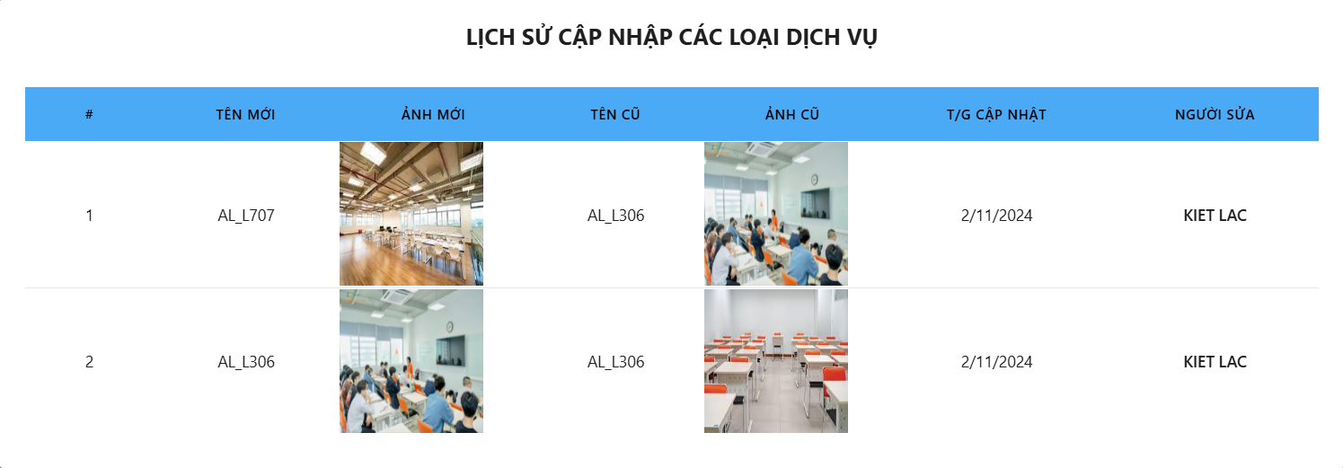

+, Change Active/Inactive to change status of facility

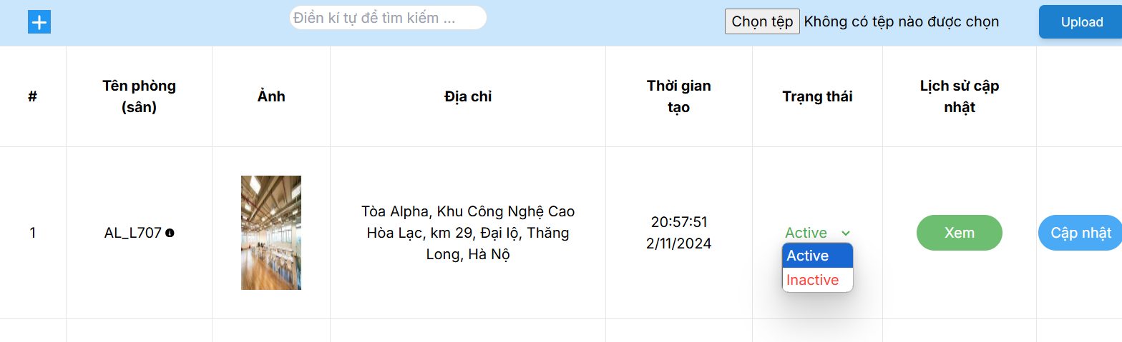

* Similar to Category List

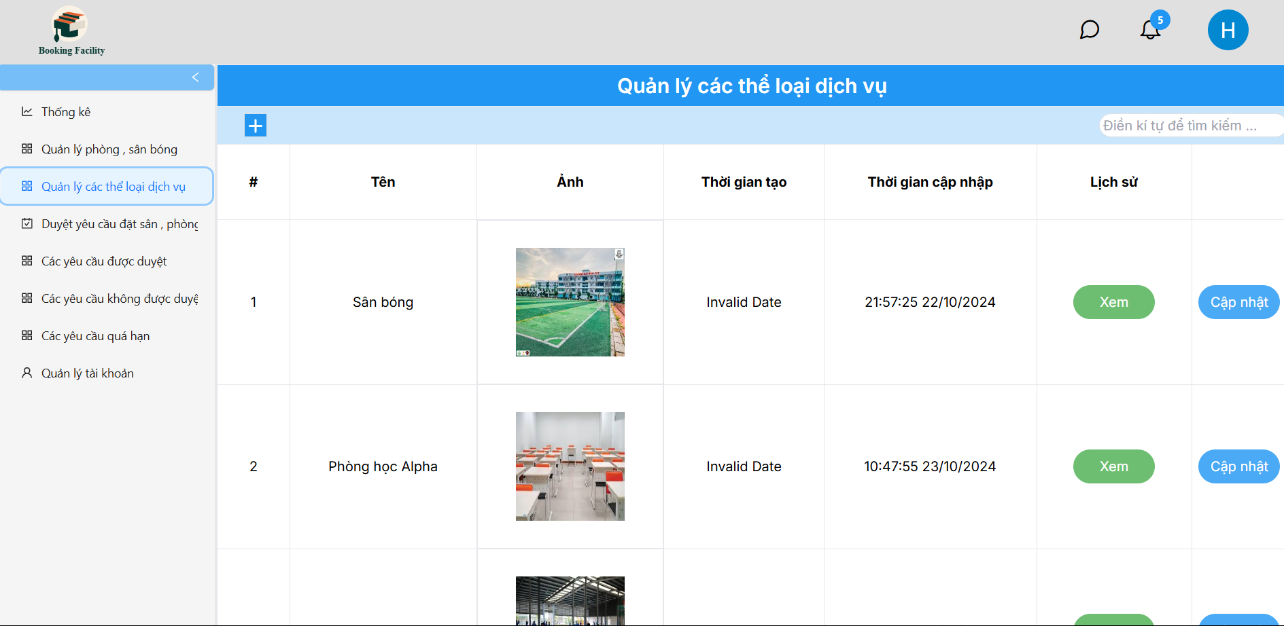

* Click in “Duyệt yêu cầu đặt sân, phòng học” to view booking request list

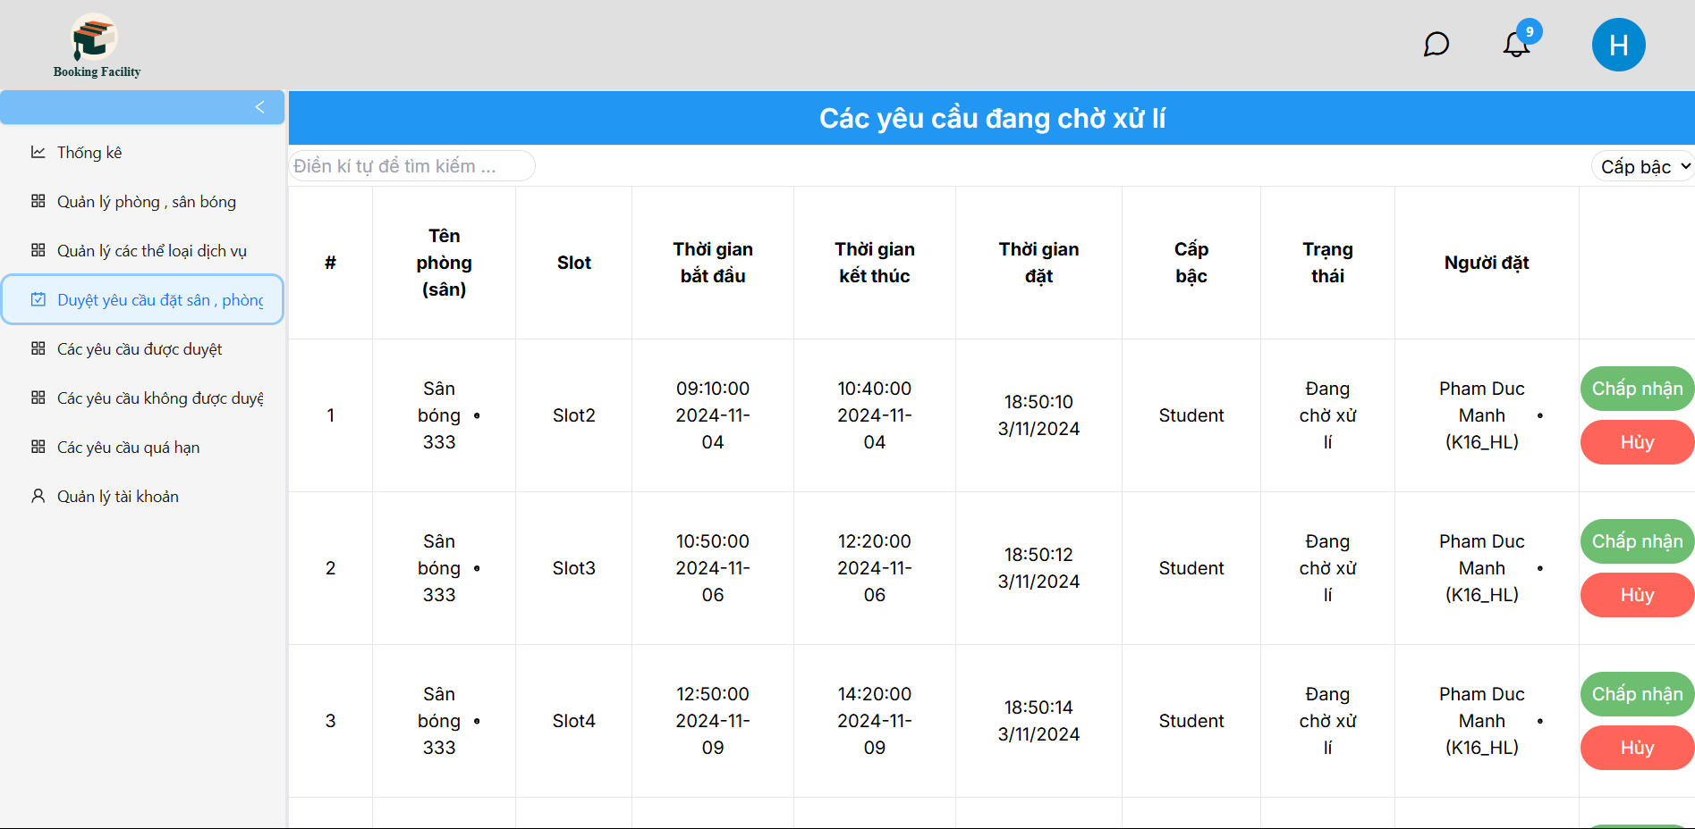

Then admin can choose “Chấp nhận” to approve or “Hủy” to disapprove with reason

* “Các yêu cầu được duyệt” display all accepted request

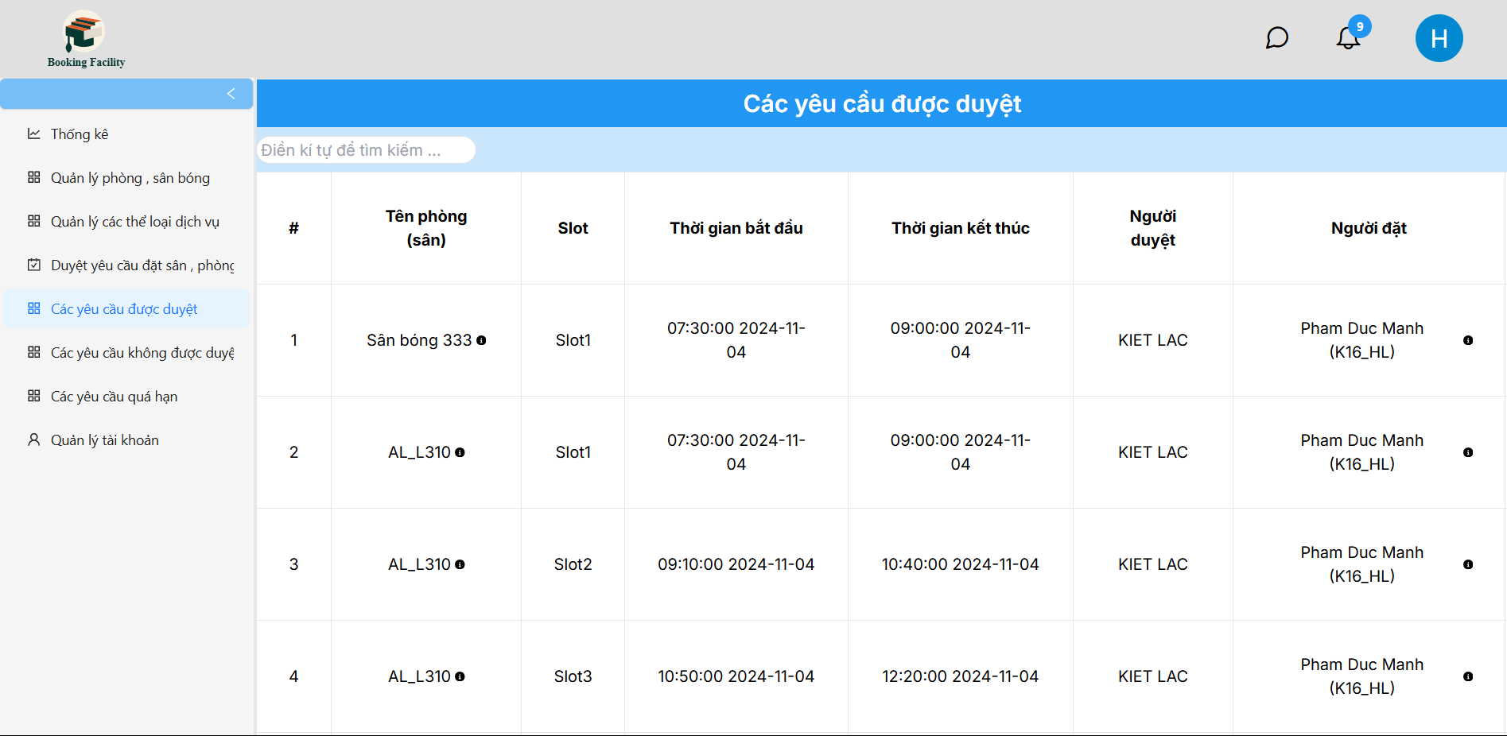

* “Các yêu cầu không được duyệt” display all rejected request

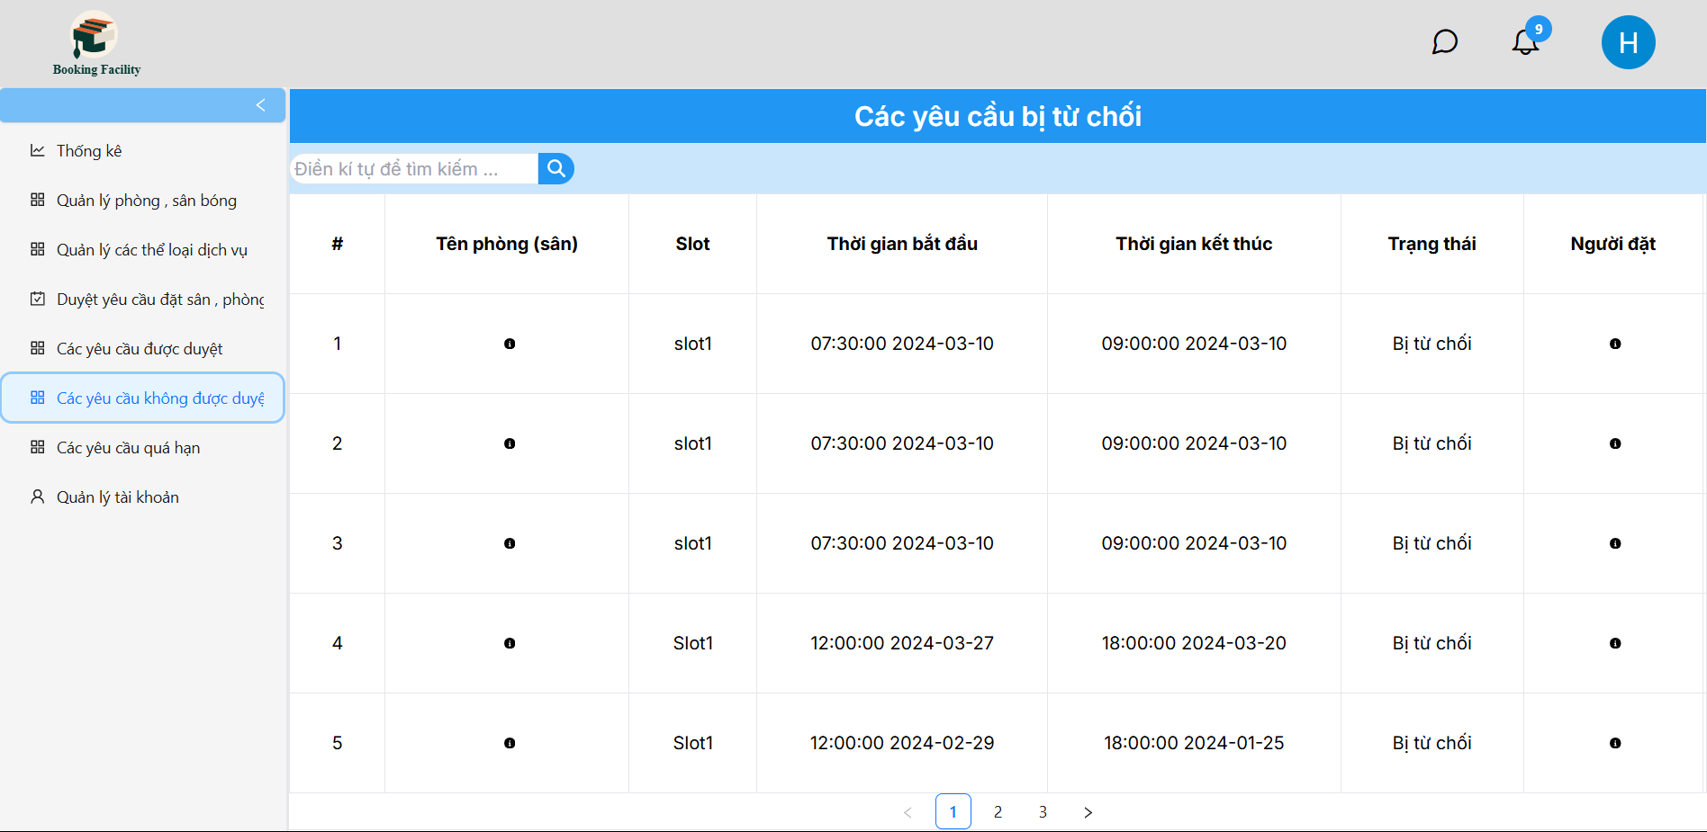

* “Các yêu cầu quá hạn” display all overdue request

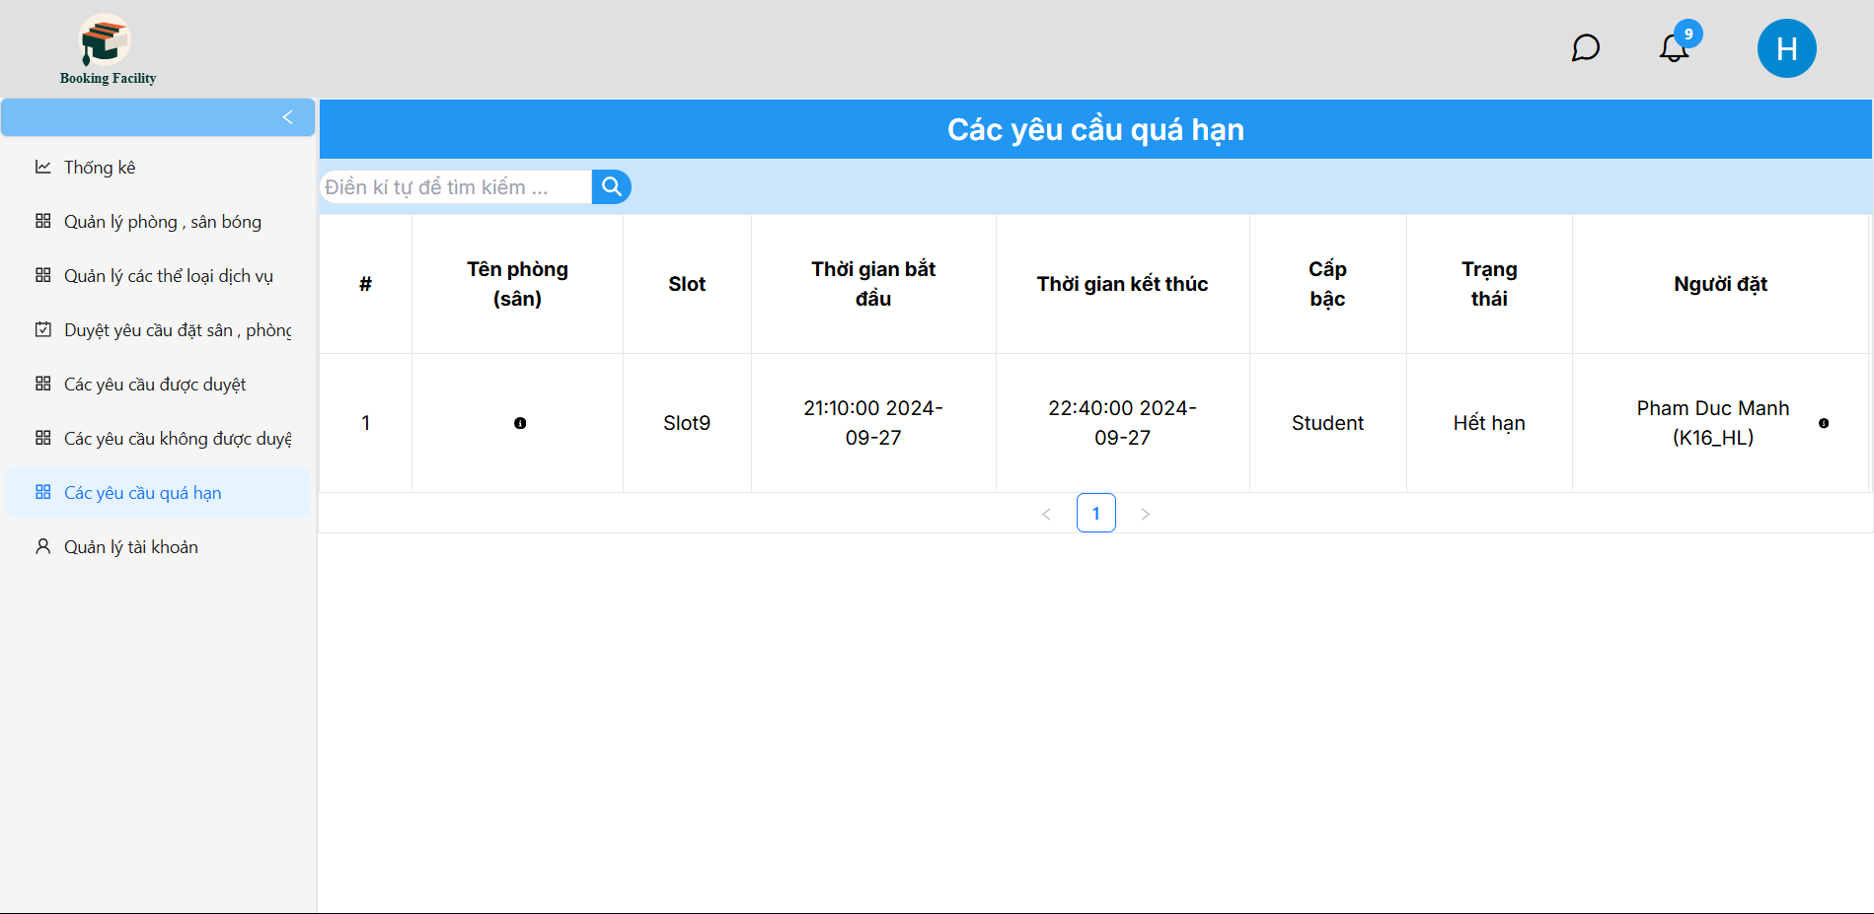

* “Quản lý tài khoản” displays an account list in the system. Admin can also change account status Active/Inactive of Student only

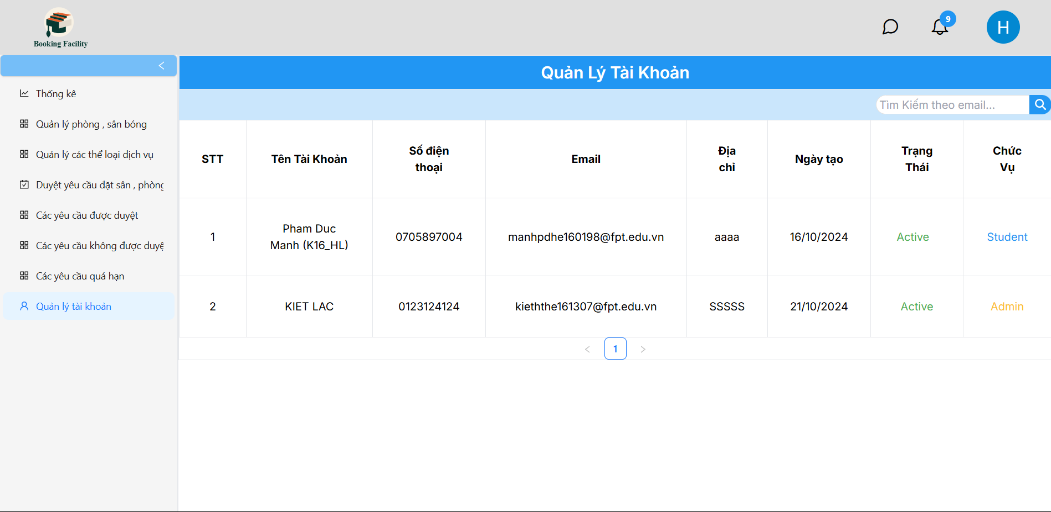

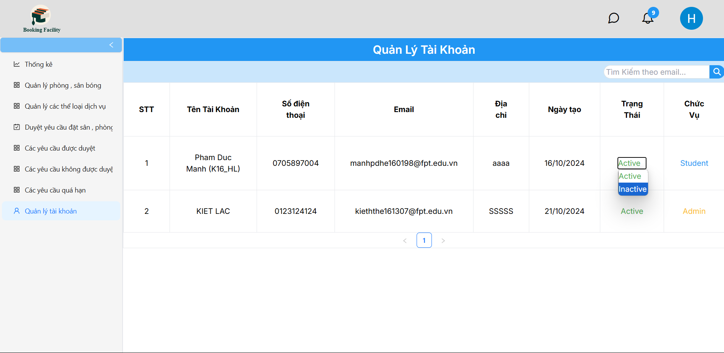

* Click the message icon in the header to open the chat screen. You can chat with user in this page

